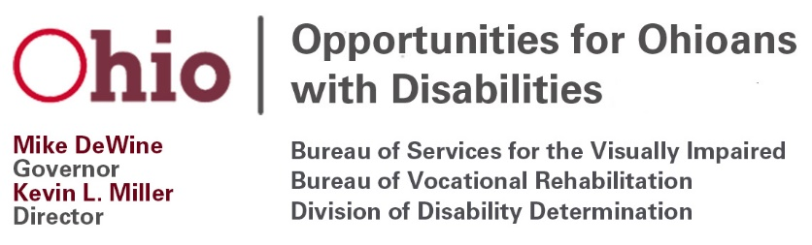
November 18, 2020
The Honorable Mike DeWine The Honorable Mark Schultz, Commissioner
Governor Rehabilitation Services Administration
Riffe Center, 30th Floor
77 South High Street Washington, D.C. 20202
Columbus, OH 43215-6117

Dear Governor DeWine and Commissioner Schultz:

It gives me great pleasure to transmit to you this letter outlining the outstanding progress and work completed by the Opportunities for Ohioans with Disabilities (OOD) Council with the assistance of the dedicated staff of Opportunities for Ohioans with Disabilities under the leadership of Kevin Miller, Director for the year 2020. The work of the Council reflects the great success Ohio has had in furthering the goal of increasing employment success for all Ohioans with disabilities. Even with the challenge of coronavirus this year, 2020 has seen the Council meetings transition from in-person meetings to virtual meetings over the internet. It also has seen the active implementation of the subcommittee plan to broaden the participation of the Council members providing another forum for input from consumers, community members, and Council members.
The Workforce Innovation and Opportunity Act (WIOA) subcommittee drafted the required input for OOD’s Vocational Rehabilitation portion of Ohio’s WIOA Combined State Plan. The full Council approved this narrative, which was included in the plan. This plan has since been approved and implemented on July 1, 2020. The Vocational Rehabilitation Policy subcommittee held its first meeting on July 8, and in consultation with OOD VR leadership, they conducted a review of the individualized plan for employment and self-employment policies, rehabilitation technology policy as well as the pre-employment transition services, and transition services policy. The value of the Council's makeup was very evident in this discussion. Members were able to bring the concerns of their constituencies to their comments and suggestions regarding these policies. The Annual Report subcommittee met to develop this letter and again demonstrated that the variety of expertise on the Council ensures robust, helpful assistance to the professional staff in preparing the annual report.
Of special note, the OOD Council provided important input into the actual instrument developed by OOD to elicit participant feedback as it concerns customer satisfaction. This was seen as a key opportunity for the Council to be of service to OOD and the people of Ohio with disabilities. The OOD Council is looking forward to the opportunities provided in 2021 to bring our broadening experience to the service of OOD as we work together on the Comprehensive Statewide Needs Assessment.
In order to better serve the Council and through them, the people of Ohio with disabilities, Doctor Carolyn Peters, chair of the OOD Council, has faithfully participated in the National Coalition of State Rehabilitation Councils networking/informational phone calls as well as represented Ohio at the National Convention of State Rehabilitation Councils.
The OOD Council is honored and pleased to transmit this letter giving a brief accounting of the work conducted by the Council. We would like thank all the Council members, the chair, Doctor Carolyn Peters, the dedicated staff of OOD, Director Kevin Miller and the people of Ohio for giving us this opportunity to be of service.
Yours very truly,

Dr. Carolyn Peters, Chair
Opportunities for Ohioans with Disabilities Council

c: OOD Council Members
OOD Director Kevin Miller

Attachments: OOD Annual Report
OOD Council Roster

