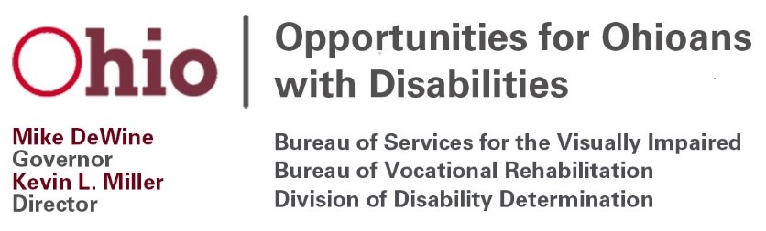
Opportunities for Ohioans with Disabilities Council Meeting
January 20, 2021
10:00 a.m. – 1:00 p.m.
Agenda
The OOD Council meeting will be held using Microsoft Teams.
https://teams.microsoft.com/l/meetup-join/19%3ameeting_YjQ1NjQyNjgtNTI5ZS00N2Y4LWI4YjMtMDViODlhMjgyNjFm%40thread.v2/0?context=%7b%22Tid%22%3a%2250f8fcc4-94d8-4f07-84eb-36ed57c7c8a2%22%2c%22Oid%22%3a%222074f3d0-74e9-4067-a0ea-d8bea75e441e%22%2c%22IsBroadcastMeeting%22%3atrue%7d

- Welcome and Introductions, Dr. Carolyn Peters, Chair

- Approval of November 18, 2020 Meeting Minutes, OOD Council Members

- Written Public Comments, OOD Council Members
  - Public comments or correspondence should be submitted to Shirley.Marchi@ood.ohio.gov by close of business on Friday, January 15, 2021.

- Council Subcommittees:
  - Approval of Council Members to One of the Subcommittees (WIOA, VR Policies, Annual Report)

- OOD Status Update, OOD Director Kevin Miller
  - Budget

- OOD RSA 722 Report- State Comparison, Matt Lampke, Chief Legal Counsel

- Vocational Rehabilitation Program Update, Greg Dormer, Deputy Director, Bureau of Services for the Visually Impaired & Susan Pugh, Deputy Director, Bureau of Vocational Rehabilitation
  - Customer Satisfaction Survey Report
  - Upcoming VR Policy Public Comment
  - Informed Choice Policy Update
  - Plans for Summer Programming for Students with Disabilities
  - Expansion of Youth Leadership Forums

- Employer and Innovation Services Update, Kristen Ballinger, Deputy Director, Division of Employer and Innovation Services
  - 2021 Virtual Hiring Events
  - The Employers’ ADA Handbook 5-part Webinar Series
  - Comprehensive Statewide Needs Assessment (CSNA) Survey of Individuals with Disabilities Component

- Chair’s Comments, Dr. Carolyn Peters
  - Council Members Reapply with Governor’s Boards & Commissions

- Council Members Discussion/Comments, Council Members

- Public Comment, Dr. Carolyn Peters, Chair

- Adjourn, Council Members

If you have questions or need an accommodation, please contact Shirley Marchi at 614-438-1477 or shirley.marchi@ood.ohio.gov

MATERIALS FOR THIS MEETING WILL BE AVAILABLE ON THE OOD WEBSITE: https://ood.ohio.gov/wps/portal/gov/ood/about-us/ood-council/ood-councils-meetings

The mission of Opportunities for Ohioans with Disabilities is empowering Ohioans with disabilities through employment, disability determinations, and independence.

