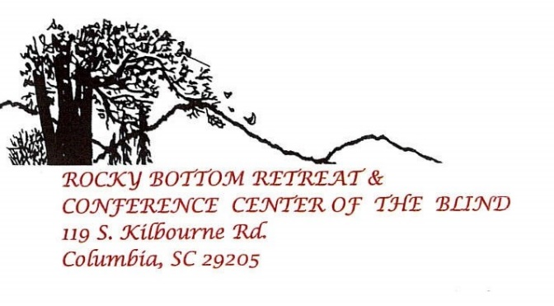
Believe in YOU! Try Something New!
2021 Rocky Bottom Retreat and Conference Center of the Blind Children’s Summer Camp
Rocky Bottom Retreat and Conference Center of the Blind is a year-round facility available free of charge to any blind South Carolinian and his or her family. Rocky Bottom Retreat and Conference Center of the Blind is pleased to announce the Annual Children’s Summer Camp for legally blind children ages 12 and under who are fully potty trained and have some independence with bathing and dressing. The camp session for your child will be June 26th – July 1st, 2021.
This camp is free of charge and there are limited spots available. Rocky Bottom Retreat and the Conference Center of the Blind along with The National Federation of the Blind of South Carolina cannot guarantee that you’re your child will remain Covid 19 free and cannot be held responsible for any exposure or contracting Covid 19. To help keep your children and our volunteers safe, we will be following CDC and the American Camp Association Guidelines for Covid 19. Supervised recreational activities including, arts and crafts, mountain hiking, water slides, games, swimming, cookouts, field trips, Braille activities and more will be offered. Parents will provide information leading up to the camp to help you prepare for your child’s stay at the camp. As in the past, senior and junior counselors and administrative personnel will be primarily legally blind individuals. This is a unique and important feature of the Rocky Bottom program. Family members are requested to accompany their child to Rocky Bottom on Saturday June 26th and also to return to camp on the evening of Thursday July 1st to pick up their child. Limited spots are available for campers. Transportation may be provided as needed. Designated pickup points will be assigned later.
To apply, please complete the online application at https://www.tfaforms.com/4894438 by May 28th, 2021. Applicants will receive acknowledgement of acceptance and additional information. If you have additional questions, please contact Jennifer Bazer, Director of the Rocky Bottom Children’s Camp of the Blind.
Cordially,
Jennifer Bazer
Children’s Camp Director
803-960-9977
jennifer@successforlives.org

