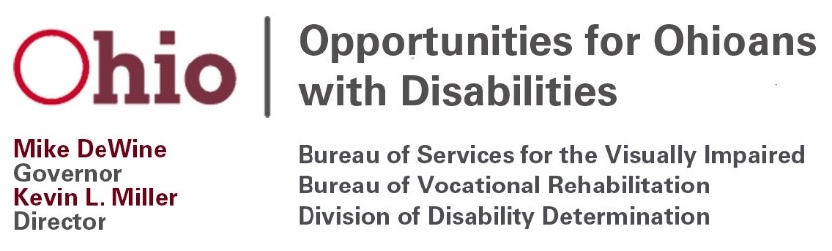
Opportunities for Ohioans with Disabilities Council Meeting
April 21, 2021
10:00 a.m. – 1:00 p.m.
Agenda
To join the meeting, click the below link:
https://teams.microsoft.com/l/meetup-join/19%3ameeting_YWM4OGI5NGMtNjBkZC00MzNkLWI4N2EtNWNhY2U2OTc1Y2I5%40thread.v2/0?context=%7b%22Tid%22%3a%2250f8fcc4-94d8-4f07-84eb-36ed57c7c8a2%22%2c%22Oid%22%3a%222074f3d0-74e9-4067-a0ea-d8bea75e441e%22%2c%22IsBroadcastMeeting%22%3atrue%7d
Or call
+1 614-721-2972 and enter Conference ID: 200 202 781#

- Welcome and Introductions, Dr. Carolyn Peters, Chair

- Approval of January 20, 2021 Meeting Minutes, OOD Council Members

- Written Public Comments, OOD Council Members
  - Public comments or correspondence should be submitted to Shirley.Marchi@ood.ohio.gov by close of business on Friday, April 16, 2020.

- OOD Council VR Policy Subcommittee Report, Lisa Hickman & Alison McKay, Co-chairs
    - Approval of February 10, 2021 Minutes, VR Policy Subcommittee Members

- OOD Status Update, OOD Director Kevin Miller

- Vocational Rehabilitation Program Update, Susan Pugh, Deputy Director, Bureau of Vocational Rehabilitation & Greg Dormer, Deputy Director, Bureau of Services for the Visually Impaired
  - Follow Up on VR Policies Under Review (Informed Choice)
    - Informed Choice Recommendations Report
    - Selection of a Provider Informational Sheet
  - Current Policies Under Review (Application and Intake, Eligibility and Order of Selection)
  - Administrative Rules Update
    - Administrative Rules Effective April 19 (3304-2-54, Eligibility determination; 3304-2-56, The individualized plan for employment; 3304-2-58, Training; 3304-2-59, Scope of services)
    - Revising 3304-1-15, Employee access to confidential information; 3304-2-63, Confidentiality of Information; 3304-5-01, Independent living services for older individuals who are blind;
    - Rescinding 3304-1-03, Open meetings; 3304-2-55, Vocational rehabilitation counseling and guidance, referral
  - Customer Satisfaction Survey Report
  - Upcoming Participant Focus Group Topic- College Students with Disabilities

- Employer and Innovation Services Update, Kristen Ballinger, Deputy Director, Division of Employer and Innovation Services
  - Virtual Hiring Events
  - Inclusive Employer Toolkit
  - “OOD Level Up” Proposal for the U.S. Department of Education’s Disability Innovation Fund – Career Advancement Initiative Model Demonstration Project
  - The Employers’ ADA Handbook Webinar Series
  - Comprehensive Statewide Needs Assessment (CSNA)

- Chair’s Comments, Dr. Carolyn Peters, Chair
  - Chair’s Interview with Ohio Developmental Disabilities Council
  - Research on the Impact of COVID-19 on VR Services - Request of State Rehabilitation Councils

- Council Members Discussion/Comments, Council Members

- Public Comment, Dr. Carolyn Peters, Chair

- Adjourn, Council Members

If you have questions or need an accommodation, please contact Shirley Marchi at 614-438-1477 or shirley.marchi@ood.ohio.gov

MATERIALS FOR THIS MEETING WILL BE AVAILABLE ON THE OOD WEBSITE: https://ood.ohio.gov/wps/portal/gov/ood/about-us/ood-council/ood-councils-meetings

The mission of Opportunities for Ohioans with Disabilities is empowering Ohioans with disabilities through employment, disability determinations, and independence.

