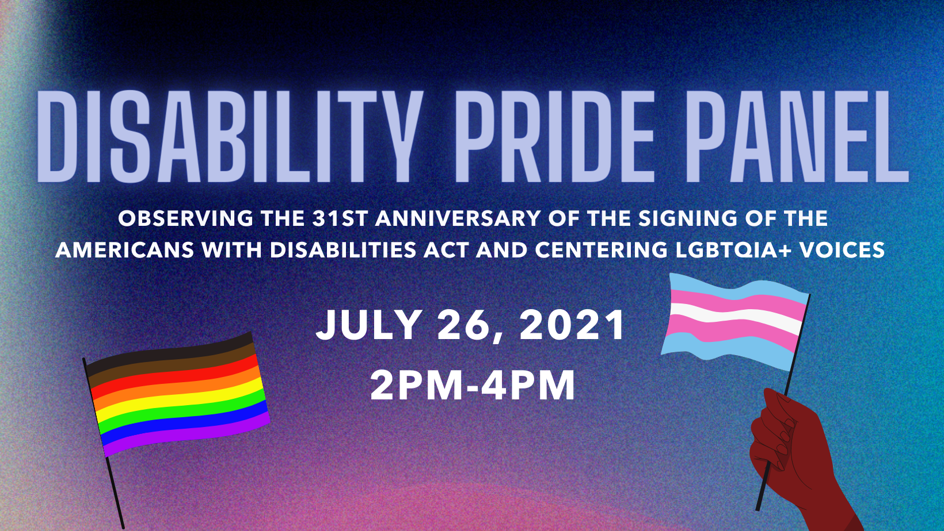

You Are Invited: Virtual Recognition of the 31st Anniversary of the ADA

In recognition of the 31st Anniversary of the Americans with Disabilities Act (ADA) we are excited to celebrate, with you, Disability PRIDE!!!

This Event will be VIRTUAL and held via Zoom. We will recognize, and celebrate with PRIDE, the intersection of the Disability and LGBTQIA+ Communities!

Please join us for a candid discussion with a diverse panel of Disability Rights Activists, Advocates, Community Organizers, and Leaders. The panel discussion will be hosted by Ramona Peel, Lead Trainer for The Equitas Health Institute.

The signing of the Americans with Disabilities Act (ADA) is a landmark example of how people, from every race – color – gender – religion – culture – etc., united in power and created a piece of legislation that is the foundation of equality for all individuals. One voice chanted loud and proud and demanded change for ALL Americans with Disabilities. The ADA is a civil rights law that prohibits discrimination against individuals with disabilities in all areas of public life, including jobs, schools, transportation, and all public and private places that are open to the general public. But, with every law, there are problems and still more work to be done.

We invite you to join our virtual celebration of this landmark legislation.

If you have questions for our presenters PLEASE email them in advance to: maria.matzik@acils.com

Questions will NOT be taken live due to our time limits. I will ask as many questions as I can given the limited amount of time.

We will have a ASL interpreters live during the event. Audience members will need to pin the interpreter’s window to their individual computer screen for easy viewing. A C-Print Captionist we will streaming live as well. The IP address for viewing the captioning is: 74.143.81.136

Monday July 26th, 2021
2 PM to 4 PM (EST)
When: Jul 26, 2021 02:00 PM Eastern Time
Topic: Americans with Disabilities Act (ADA) Recognition Day - 31 years!
Register in advance for this webinar:
https://us02web.zoom.us/webinar/register/WN_pjbkdmfES_u2oSgQ3XZt6w
After registering, you will receive a confirmation email containing information about joining the webinar.

Agenda:

- Jeremy Caffee, Access Center Executive Director
Pronouns: He/Him
Welcome and Opening Remarks

- Maria Matzik, Access Center Education & Advocacy Specialist
Pronouns: She/Her/Hers
Presenter and Panelist Introductions

- City of Dayton Mayor Nan Whaley
Video Address

- Kyle Glozier: Disability Rights Activist
Video, Personal Story

- Anita Cameron: Disability Rights Activist
Pronouns: She/Her/Hers
Keynote Speaker

- Panelist: (See Attached Bios):

- Ramona Peel: Lead Trainer for The Equitas Health Institute
Pronouns: She/Her/Hers

- Anita Cameron: Disability Rights Activist
Pronouns: She/Her/Hers

- Veralucia Mendoza: Disability Rights Advocate
Pronouns: She/Her/They/Them

- Germaine Martin: Disability Rights Advocate
Pronouns: any pronouns except for it and they

- Sheena Barnes: Executive Director of Equality Toledo

Pronouns: (She/Her)

- Conclusion:
- City of Dayton Commissioner Darryl Fairchild - ADA Day Speech and Proclamation

