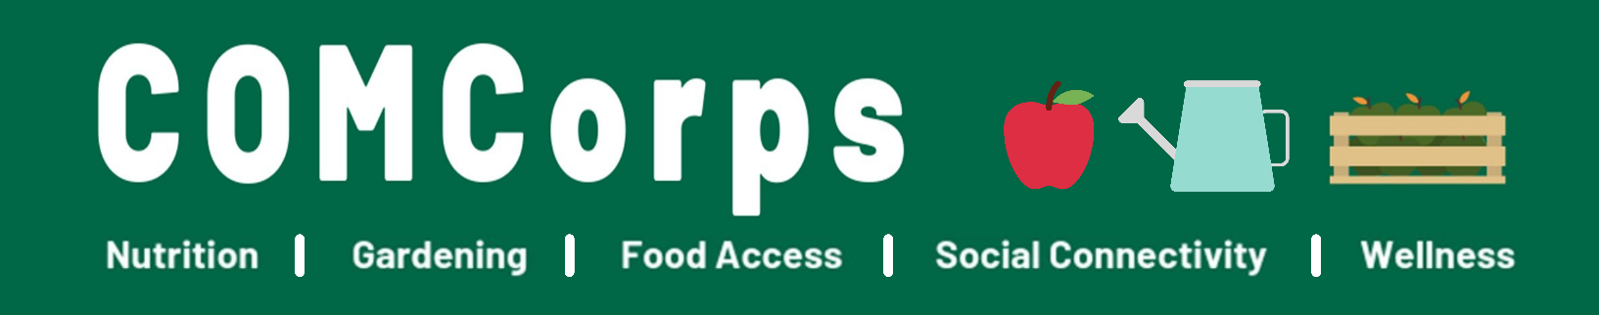
Seeking individuals with LIFE EXPERIENCE WITH DISABILITIES for the following PAID positions to share lived experience and perspective for the program to create inclusive environments.
- Trainers (3)
- Site Assessor (1)
- Program Consultants (3)
*All positions will be independent contractors through Ohio University
COMCorps is an AmeriCorps program run through Ohio University. The COMCorps mission is to “Create and support social and physical environments that promote good health and wellness for all.” COMCorps has 17 AmeriCorps members who are placed at Athens County schools, nonprofits, and government agencies. Through the direction of their host-site, members create and support social and physical environments that promote good health through activities that address the social determinants of health by providing life-enhancing resources: healthy food supply, gardening, social connectivity, and knowledge of healthy habits. Members promote a sense of community (social networks, social support, social participation, and/or community leadership) and increase access to programs that address poverty, childhood development, food insecurity, social exclusion, addiction, food, transportation, and health services. Members serve for one year with the option to renew their contract once to serve a second year.
The COMCorps program uses both Trauma-Informed Care concepts and the Social Determinants of Health framework to train members on “why” and “how” their program activities are relevant, important, and necessary for intervention.

3 Independent Contractor Trainers
Deliver a 3-hour training to 19 or more AmeriCorps members and staff that promotes inclusive thinking during the service term and beyond so participants can build more inclusive spaces in their life post COMCorps. These trainings would include sharing your story and perspective, training members on topics related to disability inclusion, ableism, community access, barriers for people with disabilities and other related topics of your choice.

1 Independent Contractor Site Assessor
Conduct site assessments at three of our partner sites and make recommendations on how they can be more disability friendly. The assessment can include a variety of accessibility topics from physical barriers to helping sites assess sensory barriers, visual and hearing barriers and other disability related barriers that can be adjusted to make our sites more inclusive.

3 Independent Contractor Program Consultants
These consultant positions will consult with COMCorps program staff to look at materials, volunteer and service opportunities, and help design a more inclusive program for service recipients and service members and volunteers. Your life experience as a person with a disability is needed to help our team build a stronger sense of community helping our program become more disability friendly.

 | Trainers | Site Assessor | Program Consultants
Time Commitment | 6 hours | 30 hours | 8 hours
Time Details | 3 hours planning, 3 hours implementation | 3 days of site assessment and follow up | 4 2-hour meetings through the year
Compensation | $50/hr | $50/hr | $50/hr
Additional Comments | A supply allowance is available for up to $20 per participant in the training. | Mileage is available for travel.

Specifics
- These paid positions will serve as independent contractors paid through Ohio University. Individuals will need to complete necessary paperwork in order for compensation.
- Currently serving COMCorps members cannot apply.
- Applications will be accepted in all forms however must address each question.
- Questions, and clarification are welcomed, please reach out.

List of COMCorps Host Sites for the 2021-2022 Program Year
- Athens City-County Health Department
- Athens City Schools
- Athens County Children Services
- Athens Photo Project
- Community Food Initiatives
- Hopewell Health Centers
- Integrate Athens
- Live Healthy Appalachia
- Rural Action
- Sojourners Care Network
- Women for Recovery: Serenity Grove
Contact/Questions
Lauren Borovicka
COMCorps Program Staff
borovick@ohio.edu
(740) 593-2293

*This project is made possible by a grant from the ATCO Legacy Fund.

APPLICATION – DUE Sunday August 15th
You can fill this application out in this word doc, or complete it as a form online that can be found by visiting: https://ohio.qualtrics.com/jfe/form/SV_9nK3FtqTtYuncmG
Any method of submission that answers the questions fully will be accepted. Send any alternate forms to the contact listed above. Please let us know if you require any accommodations to participate in the application fully.

Which Independent Contractor Position are you applying for?
You are welcome to apply to multiple positions. Please specify if you have a preference.
☐Trainer
☐Site Assessor
☐Program Consultant

What made you interested in applying?

Tell us about your lived experience and what you hope to share about your experience with COMCorps members, staff, and partners?

Describe your ideas for the position(s).

What should we consider when thinking about hiring you for a position?

Do you require any accommodations we can help with?

How can we reach you if you are selected for this position?

Thank you for your interest in this position.
We appreciate your application and we look forward to connecting!

