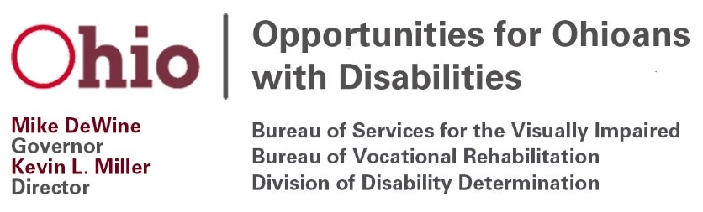
Opportunities for Ohioans with Disabilities Council Meeting
August 18, 2021
10:00 a.m. – 1:00 p.m.
Agenda

- Welcome and Introductions, Dr. Carolyn Peters, Chair

- Approval of April 18, 2021 Meeting Minutes, OOD Council Members

- Written Public Comments, OOD Council Members
  - Public comments or correspondence should be submitted to Shirley.Marchi@ood.ohio.gov by close of business on Friday, August 13, 2021.

- OOD Council VR Policy Subcommittee Report, Lisa Hickman & Alison McKay, Co-chairs
    - Approval of July 14, 2021 Minutes, VR Policy Subcommittee Members

- Survey of VR Providers, OOD Council Members

- OOD Status Update, OOD Director Kevin Miller

- Vocational Rehabilitation Program Update, Susan Pugh, Deputy Director, Bureau of Vocational Rehabilitation & Greg Dormer, Deputy Director, Bureau of Services for the Visually Impaired

BVR Updates:
- Return to the office
- Administrative Rules
  - 3304-2-53, Qualifications and Standards for Service Providers and Vendors
  - 3304-2-52, START Up
- VR Policies
  - Informed Choice Policy (implemented, including the Vocational Rehabilitation Selection of a Provider Information Sheet)
  - Policies recently out for public comment (comment period ended 7/28/21):
    - Vocational Rehabilitation Provider Management Policy
    - Post-Employment Services Policy
- Policies coming up for public comment next Quarter (comment period 10/14/21-10/23/21):
  - VR Fee Schedules Policy
- Participant Feedback- Post-Secondary Education (report included in your materials)
- Upcoming Participant Focus Group Topics

BSVI Updates

- Employer and Innovation Services Update, Kristen Ballinger, Deputy Director, Division of Employer and Innovation Services
  - Introduce new Employer Services Managers: Angelik Smith and Michelle Rinehart
  - Virtual Hiring Events
  - Employer Webinars
  - Inclusive Employer Award
  - Comprehensive Statewide Needs Assessment (CSNA)

- Chair’s Comments, Dr. Carolyn Peters, Chair
  - OOD Council Chair Position
  - OOD Council Vice-Chair Position
  - Ethics Training to be completed by December 31, 2021

- Council Members Discussion/Comments, Council Members

- Public Comment, Dr. Carolyn Peters, Chair

- Adjourn, Council Members

Next OOD Council Meeting: November 17, 2021

The mission of Opportunities for Ohioans with Disabilities is empowering Ohioans with disabilities through employment, disability determinations, and independence.

