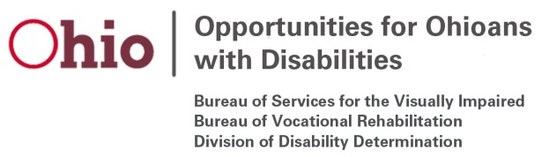

Vocational Rehabilitation (VR) Participant Focus Groups
Federal Fiscal Year (FFY) 2022

Planned topics to be covered via VR Participant Focus Groups in FFY 2022 will be as follows:

Month/Year | Focus Area | Notes
October 2021 | Individuals who are Blind or Visually Impaired | Statewide Focus Group for participants who are blind or visually impaired. To be conducted via phone survey by OOD staff.
January 2022 | Individual Placement and Support (IPS) | Statewide Focus Group for IPS participants. To be conducted via phone survey by OOD staff.
April 2022 | Jobs for Recovery (JFR) | Statewide Focus Group for JFR participants. To be conducted via phone survey by OOD staff.
July 2022 | Hybrid Model – Customer Service | Statewide Focus Group for participants who have received services through OOD’s hybrid model (virtual and in-person). To be conducted via phone survey by OOD staff.

Topics subject to change

