**SERVICES FOR INDEPENDENT LIVING (SIL)**

**invites you to apply to the Fall/Winter 2021 Session of**

***“SIL’S LEADERSHIP ACADEMY”***

**AN EIGHT-WEEK COURSE DESIGNED TO HELP INDIVIDUALS WITH DISABILITIES DEVELOP SKILLS NEEDED to participate on NONPROFIT BOARDS, COMMUNITY COALITIONS, TASK FORCES, AND SYSTEM CHANGE COMMITTEES IN A MEANINGFUL WAY**

**WHEN: October 19, 2021 – December 14, 2021; Tuesday afternoons, 1:00 - 4:00 pm**

(October 19; 26; November 2, 9, 16, 30; December 7, 14)

**TOPICS:** During the training sessions, participants will develop a basic working knowledge and understanding about topics related to serving on a board, coalition, task force or committee. Training topics include the following:

1. Community Leadership
2. Disability History & Disability Advocacy
3. Functions of a Nonprofit Board
4. Government Committees, Nonprofit Committees, Commissions, Task Forces & Councils
5. Communications, Confidentiality & Board Ethics
6. Networking and Developing Community Contacts

*Upon completion of the Leadership Academy, SIL will work with participants to identify areas of interest and potential leadership opportunities in the community.*

**WHERE:** To be held virtually.

**WHO SHOULD APPLY:** Any person with a disability who wants to learn how to make a difference and how to gain confidence and leadership experience in community decision-making on issues important to him or her.Priority given to Cuyahoga, Geauga, and Lake County residents.

**HOW TO APPLY:** Please contact Laura Gold for an application by emailing [lgold@sil-oh.org](mailto:lgold@sil-oh.org) or calling 216-815-0015 (please leave a detailed message). The deadline for applications is October 8, 2021. **Because space is limited, we encourage you to apply early.** If you need help filling out the application, please let Laura know.

*If accommodations are needed to attend or participate in the virtual meetings, please contact Laura Gold with all requests at least two weeks in advance if possible.*

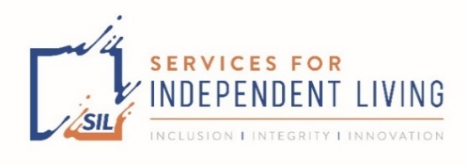 

*This project was supported, in part by the Ohio Developmental Disabilities Council, under grant number 2001OHSCDD from the U.S. Administration for Community Living, Department of Health and Human Services, Washington, D.C. 20201. Grantees undertaking projects with government sponsorship are encouraged to express freely their findings and conclusions. Points of view or opinions do not, therefore, necessarily represent official ACL policy.*

**Services for Independent Living, Inc. * 26250 Euclid Avenue, Suite 801 * Euclid, OH 44132**

**216-731-1529 (Telephone) * 216-731-3083 (Fax) * sil-oh.org (Website)**