“Beyond the Six Dots”

National Federation of the Blind Community Service Division
November 2021 Newsletter
We use a white cane, slate & stylus, and screen readers in between,
We read from the left, write from the right, and will tap tap onto any scene.
We want our communities to know what we’ve got, a commitment to serve,
Beyond the Six Dots!

A COASTAL INSPIRATION
Reflections by Veronica Alston
We hope none of our readers have been asleep for the past month. October was packed tight with thirty-one days of over the top, autumntastic and momentous occasions! Calendars north, east, south, and west were rolling out extraordinary events like the Women’s Empowerment Conference, daily Blind Equality Achievement Spotlights, White Cane Safety Day, Hands Up Join US Community Service Blind Date, and tons more.
We’ve got one word to sum up the month of October, or maybe two. Exhilaratingly Awesome! Just read on to witness the power we possess, the abilities you possess, in building a federation!
“My name is Veronica and I’m currently the secretary of the Southern Chapter of the NFB of Connecticut, as well as, an affiliate board member. I have been an NFB member for the last three years and have had minimal interaction and engagement with members outside of the Connecticut affiliate, until recently.
On White Cane Day, October 15th of this year, I attended an NFB women’s empowerment virtual conference where I had the pleasure of listening to powerful testimonies and presentations from very inspiring and motivational guest speakers. I was captivated by a spoken word presentation done by Jeanetta Price, and connected with her immediately after the conference.
During our initial discussion, we discovered how much we share a passion for helping, encouraging, and empowering individuals in our communities. I invited Jeanetta to be a motivational guest speaker on The New Lifestyles Women’s Empowerment Virtual Lounge, where she did a phenomenal presentation. In turn, Jeanetta invited me to the NFB Community Service Division virtual Meeting on October 23rd to share my involvement with New Lifestyles Transitional Housing for Women and Opportunity for Growth. As soon as I joined the meeting, I automatically felt the positive energy and enthusiasm from the facilitators and other arriving guests, and enjoyed the way the guests were encouraged to interact with one another. I loved listening and learning about opportunities to connect with other businesses and hear the work others are doing in their communities.
Attending the Community Service Division meeting has inspired me to let go of my fears of failure and expand my horizons in achieving success. I thank you Jeanetta for giving me the opportunity to connect with such supportive, talented, amazing and gifted individuals. If I could be this excited, encouraged and empowered in one day, I can’t even imagine the multiplicity of exuberance, resilience and power for future days to come.”
We are not McDonald’s, but we are loving it! A beautiful connection that was planted in Washington, DC, was nurtured down in Texas, then blossomed its miraculous essence onto a national platform with the CSD! Now, that’s what we call a COASTAL INSPIRATION!

TAPPING THE TALK
Reflections of White Cane Safety Day
Written by Carol King-Ries
Photo contributed by June Hunter-Hardy
Blind Equality Achievement Month was on, and was popping in Delaware throughout the month of October. The Northern Delaware Chapter made a concerted effort to be out in our community to inform, unite, and make a difference! We set up tables in Senior centers, a department store and daycare center, to spread the news about what the National Federation of the Blind is doing in Delaware, and beyond.
By far, our favorite event was our White Cane Awareness walk on October 15th at the Wilmington Riverfront. There were a few of us in attendance, but we made a significant impact, especially with a lot of the younger people when they saw one of our member’s guide dog, Udell! We interacted with a lot of curious travelers and had an opportunity to share how we as an organization are all working together to improve the lives of blind people around the world. We did not know what to expect when we showed up, however, we were pleasantly surprised and excited about the conversations we had. If was inspiring, empowering and has moved us forward in building our Federation. It truly left us beaming here in Delaware!
“When life hands you a white cane, change the world’s view one tap at a time!”
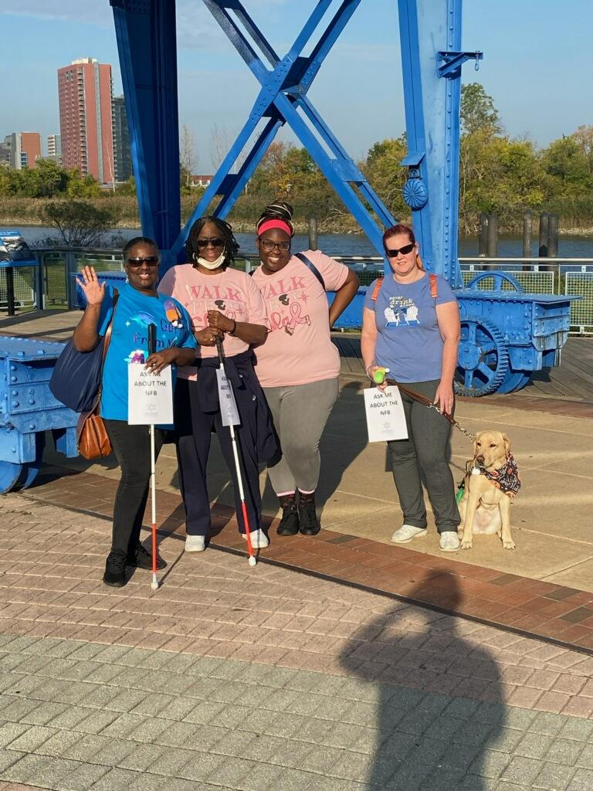
From left to right, image includes Carol King-Ries, June Hunter-Hardy (NoSmoke), Destinee', & Shannon Britt with her guide dog, Udell. The above picture was taken at Delaware's Riverfront on White Cane Safety Day.

THE KT21 CHALLENGE
Faithful readers, we want you to join us and take a moment to ponder a particular thought. In the month of November, there is an observance for World Kindness Day, which takes place on Saturday, November the 13th. Then, there is a whole week dedicated to caring for others, called World Kindness week. Plus, in the United States, we traditionally celebrate Thanksgiving Day on the last Thursday of the month. It could be a long shot, but do our readers believe that maybe, just maybe, the world is trying to tell us something?
There is power in being friendly, generous, and considerate towards others. We have an entire division that motto that kind of compassion for others. Some may even say that it is what binds us all together.
So, CSD & Readers! We know, we’ve seen, and we’ve heard of your abilities to bring and give joy. It’s time for a November Challenge, a K&T Challenge!
We want you to flood our list serve and social media page with your demonstrations of November 2021 acts of kindness or your words of thankfulness.
Use the hash tag, #KT21 whenever and wherever you post. We’re not only part of the blind movement, we’ve got the mightiness to be, the kind movement!
www.facebook.com/communityservicedivision/

THE ONE MINUTE VIDEO CHALLENGE
Yes! Another challenge for our readers this month! We absolutely love being able to move it, move it, within all of our communities. And we are dying to know, who do you appreciate? So, take on our One Minute Video Challenge! Dust off your smart devices and get ready to roll the camera, for our November Attitude of Gratitude video blast!
Send your best videos to:
Jeanetta Price by email or SMS message.
Three things you must say:
- Your full name
- National Federation of the Blind Community Service Division
- “The Attitude of Gratitude”
Now, it’s time to express your sweetest gratitude in your own unique way. In one minute, tell us about that special person that has influenced your service. All of your November 2021 video blasts will have the hash tag, #OneMinute21 and will be shared on our social media platforms! Okay CSD, roll the camera.

A STUDENT AT HEART
MSG Vernon F. Humphrey, US Army (R)
Contributed by Emily Gindlesperger
“It was an honor to be a soldier. And it continues to be an honor, to be a Veteran.”
Veteran’s Day is an important day that has been set aside each year to honor the champions who have sacrificed and served and continue to serve our nation. More specifically, it’s an enlightening opportunity to recognize the courageous men and women that are the living veterans among us.
It is our honor and a privilege to be able to introduce to our readers, Master Sergeant, Vernon F. Humphrey and President of our National Association of Blind Veterans.
“I have many feelings about Veterans Day. Proud, honored, reflection, respect, longing for times gone by, and my father (who was also a veteran). And unfortunately, there are some that are not so positive ones. For instance, when I see people who do not understand the importance of thanking those who gave (or offered to) give everything. I am honored to have served my country and, in many ways, will always be serving. My sisters and brothers in arms and I, will always share a bond that most will never understand.
Because of my vision loss and medical retirement, I had an advantage most do not. I was able to spend a few years watching my children grow, and then Veterans Affairs offered to send me back to college.
At Columbus State University (CSU), I helped create and was an officer Omicron Psi chapter an honors program for nontraditional students. I eventually graduated in 2005 with a BA degree. I soon realized how much I loved learning and started a Master’s degree in Counseling at CSU. It was not long after that I realized the many years of being a Non-commissioned Officer (NCO) and a father, that counseling wasn’t for me. I went to the University of Louisiana at Lafayette (ULL)and earned a Masters in Communication with a focus on Interpersonal and Organizational Communication and a minor in counseling (2009). There, I helped create Delta Alpha Pi chapter an honor society for people with disabilities. Additionally, I was a member and officer of the Beacon Club at ULL. Our focus was to bring disability awareness to the campus and community. Not wanting to stop, I went to the University of Southern Mississippi and earned my PhD in Communication with a focus on Interpersonal and Intercultural Communication (2015). The topic for my dissertation was unique in that I researched how couples changed their communication patterns when one of them became blind.
After I returned to Columbus, Georgia, I became the Chair of the Board of directors for a Non-profit organization, the Disability Service Center, where we created a one stop shop for people with disabilities. I joined Rotary and found the camaraderie I knew in the Army. I have joined and become the President of the National Association of Blind Veterans, as well as, the First VP of the Fountain City Chapter of the NFB Georgia Affiliate.
In addition, I am active in the Blinded Veterans of America (BVA), the Disabled American Veterans (DVA), and supporting local law and enforcement, fire prevention, and EMS fields that my children are also active in.
I feel it is very important to remind people of how honored we are as a country, to have had Veterans serve us. Although I think it should happen every day, and I am often told thank you for your service, celebrating Veteran’s Day in unity, on one day makes us feel even more honored. Our country thought enough of our service, to set aside one special day, every year.”

SAYING THANK YOU
National Veteran’s Day
Every November the 11th, we are given a life-altering opportunity to truly learn and understand the sacrifices that service members and their families make day after day, year after year.
Have you ever wondered how you could celebrate Veteran’s day? We went on the hunt for eager volunteers in search of their plans to pay tribute to our Veterans this year!
"We invited all of our church members and families, to our ‘Care Package Party’! We didn't know someone currently overseas, but we’ve all have had loved ones in service at some point. We wanted to let our soldiers know that they are not forgotten and contacted Blue Star Moms in our local area, to see if there were any troops that were in need. We were able to send four heavy boxes this year!” -A senior citizens group at North Chapel Church.
“We pass out flyers throughout our neighborhoods, hang them on the doors of our local post office, library, grocery stores, coffee shops, and post on the VA bulletin board, about our annual, ‘Chicken Soup For Eleven Eleven’ event. We say thank you by offering free unlimited, homecooked bowls of hot chicken soup.” -The Frederick & Bloomberg Families.
Join the Community Service board members, our Willing Worker’s Committee members, and all of our invaluable Community Achievers, as we say, thank you! We are eternally grateful for your service!
“Our debt to the heroic men and valiant women in the service of our country can never be repaid. They have earned our undying gratitude.”

IT’S YOUR YEAR OF VISION
National Scholarship Awareness Month
Written by Mirranda Williams
I am not here to boast or brag, nope, never that! However, I am here to let you all know that I am a scholar with a vision!
Excuse me while I give a holler of praise to my god for blessing me! Ok, praise break over for now, and now back to our scheduled narrative!
I am Mirranda Williams an original Georgia Peach that has been racking up multiple wins in this season since 2020 the year of vision. Collectively, I have received a total of 10 scholarships to further my life’s endeavors. This number includes the opportunity to be a part of the National Federation of the Blind illustrious 30. I was awarded a scholarship that afforded me the opportunity to continue my education as well as starting my own consulting agency Inspeyere LLC), assisting the older adult population concerning mental and behavioral health.
I am truly thankful for all my scholarship opportunities because they motivated me to reach for my greatest potential and let it shine for all to see. It is not about the amount of money I received but how I use it to achieve my life goals. Most people say that the process is rigorous, and truthfully it is. However, nothing is worth having if it can be easily obtained. Pause and let that soak in! Challenges make us better and allows us to recognize our inherent strengths we all have them! I challenge you to take a little time and apply for scholarships and see how they could change your life, I did, and I could not be any more grateful than I am now! Thank you, Federation Family, for believing in me and recognizing my hard work!
Now future fellow scholars go apply, apply, apply and let your own light shine!

A FIERY PASSION TO SERVE
November is National Diabetes Month, a time when communities across the country team up to bring attention to a far too common condition, diabetes. Wanda Sloan also known as Firecracker, is a member of the National Federation of the Blind of Ohio and was born with a form of insulin rejection, but was not properly diagnosed as a diabetic until she was 32 years of age.
Wanda Marie Sloan was born in Dayton, Ohio in 1948. She is a graduate from Sinclair Community College with an associate degree in Nursing & Liberal Arts. She is also a graduate from NYACK College, with a bachelor’s degree in Organizational Business Management. Wanda has been blessed with a beautiful singing voice and has been a dedicated member of local traveling community gospel choirs for the past twenty-one years. While she was in college, she wrote a script, and performed a Historical Tribute To Gospel Music. It was originally written for a Black History program, and it was and has been performed throughout the Nation. Her script was so powerful and popular, it was sold to Dr. Bobbie Jones and his Tennessee Super Choir. And the best part, when they came to Dayton, she had an amazing opportunity to sing with them.
Miss Sloan has served and continues to serve on many committees and boards such as the City of Dayton Civil Service Board, Home Finding Apartments committee, HRC (Human Relations Council) board, ACIL (Access Center for Independent Living) board, DAN (Diabetes Action Network) board, for a number of years. When she is not working tirelessly to advocate, fundraise, and educate her local communities, she is expanding her skill sets like taking Sign Language courses to be able to communicate with deaf community members.
Diabetes is the leading cause of adult blindness, kidney failure, cardiovascular disease, amputations, nerve damage and other complications. This is why individuals like Wanda work hard to create awareness, resources, and opportunities. She is extremely passionate and committed in being a resource for those newly diagnosed with diabetes, individuals new to blindness with diabetes, and continuing to educate herself on all the latest technology advances regarding this condition.
“I know what it’s like to be blind and I know how it feels to be diabetic. People need to know they are capable of managing their condition without sight. I’m living the life I want and so can they.
It’s important to encourage people to establish a healthy eating habit, be faithful in taking their blood sugars, and monitor their A 1 C test, which is a very important reading.”
Wanda believes that it is crucial for every diabetic to know all their options and to not be afraid to ask questions. Members like Miss Sloan and the NFB Diabetes Action Network have made tremendous strides, and know there is still a lot of work to be done.
“Remember to take small steps. Making changes to your lifestyle and daily habits can be hard, but you don’t have to change everything at once. It’s okay to start small. Also, remember that setbacks are normal and do not mean you have failed. The key is to get back on track as soon as you can.”

THE GIGGLE SPOT
Friends & Families! CSD is celebrating the fall harvest and every blissful blessings from this past year! Which brings us to your November giggle for the month.
Question: What did the turkey say to the computer?
Answer: Googgle, google, google!
Don’t think about it, laugh about it!

AT THE INTERSECTION OF BLINDNESS
Native American Heritage Month
Written by Justin Mark Hideaki Salisbury
“I was first elected to the board of the national Association of blind students in 2012, and I am currently the second vice president. There were a few years that I was not in school and not on the board, so that is not a continuous nine years of leader ship, but it is true that I was first elected to the national Association of blind students board in 2012 and currently serve as second vice president.”
Community Service Division, this young man has done so much for so many people, it’s very difficult to keep track of all the ways he has empowered, advocated, inspired, and educated his local communities. We could not truly celebrate National Native American Heritage month without including Justin in the conversation. It’s important to our federation family that we recognize Native American and Indigenous peoples heritage, the original inhabitants of what is now the United States.
“When I showed up on the University of Wisconsin campus in Madison, I was ready for all the intensity of a university program that would prepare me for my career. It was a beautiful university on a lakefront property, and there were a lot of talented people there. I was still wondering why they chose me to be a part of their club.
Another part of arriving on that campus meant that Native American students kept approaching me to recruit me to cultural programming. At first, I started wondering if I was wearing something that showed off Native identity, but I wasn’t. Then, I started paying attention to what these Native students would do after they left our conversations. Did they just keep inviting everyone? Were they catching me as part of a canvassing effort to recruit? No, it wasn’t that, either. In Wisconsin, my fellow Native students could see me as one of them. Now, I am a mixed-race person, and I had been going to school in the Confederate states, where I don’t look like the Native people from there. In a way, these recruitment efforts were super validating to me. Many mixed-race people go through a process of figuring out where we fit in with each group. I’m not sure any of us get to a point where we don’t have to figure that out in new circles of people. I can be sure of one thing, though: service helped me belong.
At the University of Wisconsin, service often meant helping to put on events. I remember walking throughout campus in small teams with other Native students, putting up flyers to advertise. When it comes to putting on a powwow, there is a lot of planning involved. We spent a lot of time working with the venue, the lodging, the vendors, and putting together a solid program. It involved a lot of the same skills we use to put on a student seminar or state convention in the National Federation of the Blind. People didn’t seem to think about the fact that I was blind. They seemed to think about the work that needed to be done and the ability that I had to contribute. I remember coming back from a state convention only to help clean up at the end of the University’s powwow, which I had missed.
That wasn’t my first-time doing service activities in our community. During my undergraduate years at East Carolina University, I was able to help rebuild a traditional Native American village and cultural center after a hurricane had damaged them badly. On that occasion, I did not go out of my way to prove what I could do as a blind person. Perhaps there were activities that people silently thought would be off-limits to a blind person. I really don’t know. I just focused on doing the tasks that were given to me. Was I asked to drag the brush out of the woods after others had used the chainsaws because I was blind, or was I asked to do the other job because the people operating the chainsaws were the owners of the chainsaws? I don’t know. Could I have used a chainsaw? Sure thing—I had done this many times at my parents’ house—but the goal was to address the hurricane damage as quickly as possible. I focused on being a part of the team, and I allowed the elders to divvy up the tasks. It also occurred to me that certain tasks could have certain meaning to the people doing them. I did not have to know that meaning for each person, but I knew that we collectively took meaning from our work. I was a part of the team, and we served our Native community.”

RESOURCES
NFB Diabetes Action Network for the Blind (DAN)
President: Debbie Wunder
Email: debbiewunder@charter.net
Website: nfb.org/about-us/divisions-committees-and-groups/divisions/diabetes-action-network
Mailing List: nfbnet.org/mailman/listinfo/diabetes-talk_nfbnet.org

NFB National Association of Blind Veterans
President: Vernon Humphrey
Email: mr_president@nabv.org
Website: nabv.org
Mailing list: nfbnet.org/mailman/listinfo/blindvet-talk_nfbnet.org

REPRESENT YOUR STATE
Kansas
November 12-14, 2021
Location: Olathe (Holiday Inn)
For more information, please visit: nfbks.org

Kentucky
November 5-7, 2021
Location: Virtual
For more information, please visit:nfbofky.org

Louisiana
November 5-7, 2021
Location: Baton Rouge (Crowne Plaza)
For more information, please visit: nfbla.org

Maryland
November 12-15, 2021
Location: Baltimore (Holiday Inn Inner Harbor)
For more information, please visit: nfbmd.org

Michigan
November 11-13, 2021
Location: Virtual
For more information, please visit: nfbmi.org

Minnesota
November 5-7, 2021
Location: Minneapolis (Minn/St. Paul Airport Hilton)
For more information, please visit: nfbmn.org/

Nevada
November 13-14, 2021
Location: Virtual
For more information, please visit: nfbnevada.org

New Jersey
November 10-13, 2021
Location: Virtual
For more information, please visit: nfbnj.org

Ohio
November 5-6 2021
Location: Virtual
For more information, please visit: nfbohio.org

Oregon
November 12-14, 2021
Location: Cottage Grove
For more information, please visit: nfb-oregon.org

Pennsylvania
November 12-14, 2021
Location: Harrisburg (Crowne Plaza)
For more information, please visit: nfbp.org

Texas
November 5-7, 2021
Location: Virtual
For more information, please visit: nfbtx.org

Washington
November 5-7, 2021
Location: Virtual
For more information, please visit: nfbw.org

Wyoming
November 13, 2021
Location: Virtual
For more information, please visit: http://nfbwyoming.org/

EDITOR’S NOTES
We want to feature you in our next issue! Write about your personal experience with your community service project and submit the article by the first of the month.
We also want to help promote your community projects and state affiliate events. Share your calendar with Beyond The Six Dots and we will feature your events in the ‘Represent Your State’ section of our next issue. Contact our editor to submit your calendar events and featured articles. (The editor may edit the Length and/or wording of your article.)

NFB Community Service Division
www.facebook.com/communityservicedivision/
President Jeanetta Price
Email: price.jeanetta@gmail.com
Mobile: (409) 344-1005
Newsletter Editor: Maggie Stringer
Email: Ravensfan784@gmail.com
Mobile: (443) 750-0070

ONE MINUTE MESSAGE
The National Federation of the Blind knows that blindness is not the characteristic that defines you or your future. Every day we raise the expectations of blind people because low expectations create obstacles between blind people and our dreams. We are survivors!

