NAVIGATE SAFELY IN AND AROUND YOUR HOME

Eliminate tripping and slipping hazards
- Remove loose rugs and small non-essential items such as magazine racks, floor plants, and side tables.
- Attach extension cords to the wall and secure electrical cords with ties or tape.
- Have non slip stair treads installed or use colored non slip tape to highlight the fronts of the stair treads. Keep stair treads in good repair. Consider installing stair rails on both sides.

Improve lighting in and around your home.
- Good lighting can illuminate shadowy corners and help you make the most of your vision.
- Good lighting in entranceways, hallways, stairs, and outdoor walkways.
- Compare different types of lighting to determine which lighting best suits your vision needs (full spectrum, incandescent, cool to warm light options)
- Eliminate lighting that causes glare that might interfere with your vision.

- Enhance color contrast. Use light against dark background or vice versa to make it easier to see items.

- Declutter
- Get rid of anything lying around that you don’t need.
- Make sure everything has its own place
- Clean up as you go
- Pick up shoes, clothes, books, toys, anything lying around to prevent tripping.

- The kitchen
- Close drawers, cupboards, and dishwasher when you are finished using them to avoid bumps and tripping.
- Clean up spills immediately when they occur to avoid slipping.

- Outside your house
- Have low hanging branches and wandering plants trimmed and cleared from walkways.
- Be sure that garden tools, hoses, and toys are put away after being used.
- Use contrasting strips or paint to mark steps, uneven surfaces, or edges of walkways.
GREATER CLEVELAND REGIONAL TRANSIT AUTHORITY (GCRTA)
http://www.paratransit.gcrta.org/
ADA Complementary Paratransit Service
To supplement accessible fixed-route service, RTA offers persons with disabilities who qualify under ADA, special Paratransit service. RTA's Paratransit service is provided by specially trained operators using smaller, lift-equipped buses.
Individuals who qualify for Category I & III are eligible for special Door-to-Door Service. Customers are provided service from point of origination to destination anywhere in the RTA service area, provided the trip origin and destination are within 3/4 of a mile of RTA fixed route service and at a time when fixed route service is available. Service will be provided to ADA eligible riders who reside more than 3/4 mile from a fixed route, but only within a five-mile radius (within Cuyahoga County) and on a space available basis.
Paratransit Eligibility
Guidelines provided in the 1990 Americans with Disabilities Act establish the eligibility criteria for RTA's Paratransit service. There are three categories of eligibility for this service. You may qualify for special RTA service under ADA if:
- You are unable, without special assistance, as the result of physical or mental impairment, to get on, ride, or get off an accessible vehicle on the public transit system.
- You need the assistance of a wheelchair lift or other boarding device and can get on, ride, and get off an accessible vehicle, but such a vehicle is not available on the route when you are planning to travel.
- You have a specific impairment-related condition which prevents you from traveling to or from a station or stop on the transit system.
Applying for Paratransit Service
To use RTA's Paratransit service, you must first apply for ADA certification. To request an ADA application, or if you need help completing the application, call 216.566.5124 or for the hearing-impaired only call 216.781.4757 (TDD). Also, based on your individual needs, the application is available in large print or other accessible forms. http://www.paratransit.gcrta.org/
GO GO GRANDPARENT
https://gogograndparent.com/

How It Works

Go Go Grandparent allows older adults to utilize on demand transportation companies like Lyft while keeping family and loved ones notified.

Step 1: CALL 1 (855) 464-6872 and wait to hear "thanks for calling GoGoGrandparent"

Step 2:

PRESS 1 for a car to your home

PRESS 2 for a car to where we dropped you off last

PRESS 3, 4 or 5 for a car to a custom pick up location (once you're registered please give us a call to set these up)

PRESS 6 to order a ride with an operator

PRESS 0 to speak with an operator about anything else
Call or text our operators for any other questions.

Extra Features

Custom Pick Ups: Add more locations to your touch tone menu.

Family Notifications: Get by-the-minute updates texted to your loved ones.

Scheduled Services: Set up automatic rides for fixed medical appointments.

Voice Commands: Say 'home', 'operator' or 'last location'.

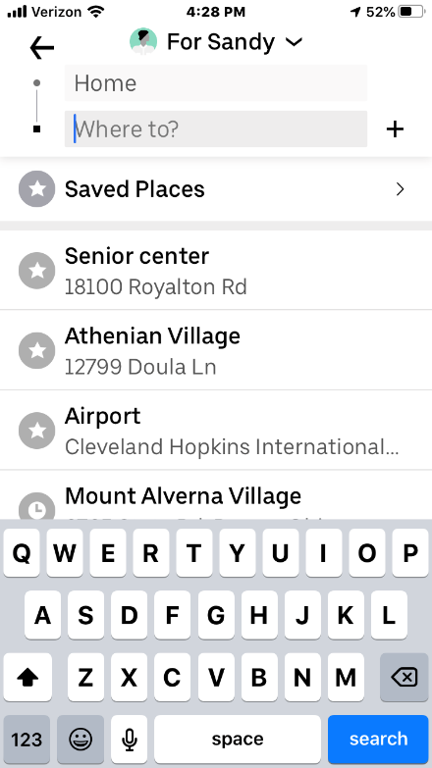
RIDE SHARES: UBER AND LYFT
Order your ride, pay, and tip through smart phone app. No cash is exchanged.
Arrange a list of frequently used addresses and your home address so that you can order a ride with one selection rather than entering text.
Contact the driver by phone or text message after ordering a ride if you need to convey specific information.
Security features. Pre-select family members who will be informed of your driver and route in real time. Pre-select a PIN (optional) so that your driver can be identified by stating your preselected PIN.

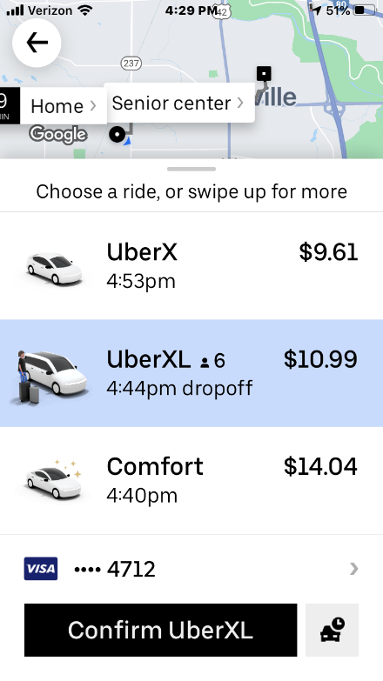

Helpful Resources
- Cleveland Sight Center, (216) 791-8118

- National Federation of the Blind, www.nfb.org

- Hadley “Travel Talk” Discussion Group. www.hadley.edu
Or Hadley Travel Talk on Facebook

