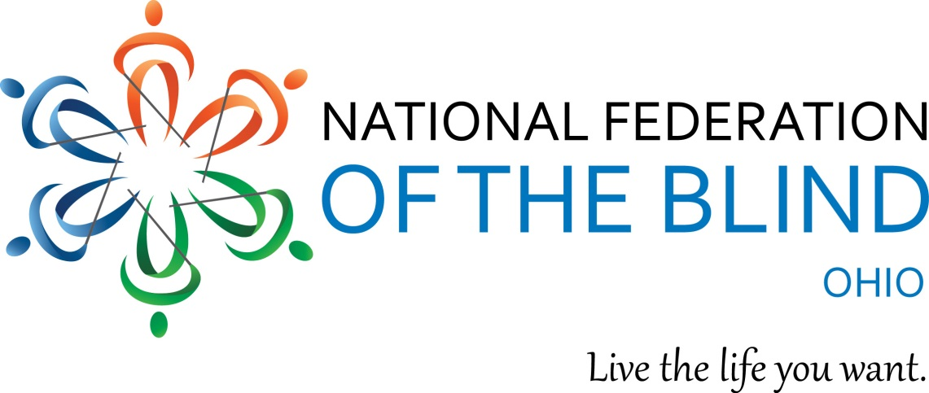
2022 Scholarship Program

National Federation of the Blind of Ohio

The National Federation of the Blind of Ohio joyfully announces the opening of our 2022 scholarship program intended to benefit blind college students. In the fall of 2022 NFBO will offer scholarships to outstanding blind students who currently live in, or are attending college in, the state of Ohio during the 2022-2023 academic school year.

Scholarship winners must attend the entire National Federation of the Blind of Ohio (NFBO) state convention during the month of November and participate in all activities sponsored by the Ohio Association of Blind Students (OABS). In addition, scholarship winners will be required to meet with the Scholarship Committee during the state convention. All convention expenses will be provided for each scholarship winner. These expenses include, transportation, hotel accommodations, registration, and banquet fees. For more information on the NFBO state convention, please visit http://www.nfbohio.org.

Applicants do not need to be members of NFBO to apply for these scholarships.

To be eligible for these scholarships, all applicants shall:
•Be certified as being legally blind.
•Be a resident of the state of Ohio or be a full-time student at an Ohio college or university.
•Be pursuing a full-time postsecondary course of study during the 2022-2023 academic school year.
•Participate in the entire NFBO 2022 state convention and all scheduled OABS activities.
•Complete all application requirements by Monday May 30, 2022 no later than 11:59 p.m.

To complete this year's application students should visit:
https://forms.gle/ohcWFzXAh1r5jbin7
If students have any questions they should contact Jordy Stringer jssocil@gmail.com
In addition students will be able to find the application link by visiting nfbohio.org.
Please make sure all applications are complete. The National Federation of the Blind of Ohio's scholarship committee does not accept responsibility for incomplete applications. Each application will be reviewed by the committee, and candidates will be notified of their awards by e-mail. All decisions made by the scholarship committee are final.
Questions can be directed to:
Jordy D. Stringer, Chairman, Scholarship Committee, National Federation of the Blind of Ohio jssocil@gmail.com
(614) 531-3945
Richard Payne: President, National Federation of the Blind of Ohio
Rchpay7@gmail.com

National Federation of the Blind of Ohio Scholarship Application

Application must be submitted by May 30, 2022.
Name: | Email:
Date of Birth: | Address:
Phone Number: | Cumulative GPA:
Major / Proposed Major: | Institution to be attended in Fall 2022:
Name of the state officer or chapter president who has interviewed you:
*Attachments required:
- Transcripts from all past post-secondary institutions attended through December 31, 2021 or high school transcripts if not yet attending college AND
- Three (3) letters of recommendation:
  - At least one of the first two letters needs to be from someone that can address your academic performance and achievements. The third letter should be from a leader of the National Federation of the Blind of Ohio. Please visit NFBohio.org or contact President Richard Payne at rchpay7@gmail.com or Jordy Stringer Jssocil@gmail.com to find an appropriate interviewer.

List all post-secondary institutions attended and cumulative grade point averages:
Institution | GPA

List all academic accomplishments and honors:
Honor / Accomplishment | Reason for Honor

List all community service activities you have participated in:
Organization | Community Service Activity

Please discuss how you learned about this scholarship program:

Personal Essay: Limit to 700 words maximum. Please address the following or similar questions:

In the following essay, please answer the following questions:
- tell us about yourself.
- How have you dealt with your blindness?
- What are your educational and vocational goals?
- What makes you stand out from the crowd?
- What are your dreams and aspirations?
- What else would you like for us to know about you that is not covered in your application?

