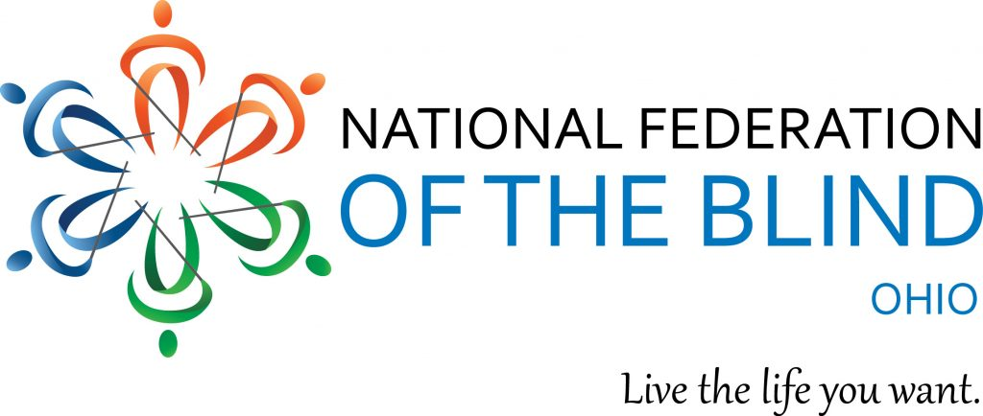

Volunteers Needed!

National Federation of the Blind of Ohio

76th Annual Convention
Millennium: Honoring The Past, Treasuring The Present, Shaping The Future

When:
November 4th-6th (Friday to Sunday), 2022
(with priority for Saturday November 5)

Opportunities to volunteer from:
November 4: 5 pm - 10 pm
November 5: 7:30 am - 10 pm
November 6: 7:30 am - 10 pm

Where:
DoubleTree by Hilton Hotel, 6200 Quarry Ln., Independence, Ohio 44131

Why:
The 2022 Annual Convention of the National Federation of the Blind of Ohio (NFBO) will be the largest gathering of blind people in the state. We provide encouragement and motivation to families with blind children and to people who are losing vision or have become blind later in life. At our convention, we provide resources about accessible technology, accessing jobs, learning braille, independent living skills, receiving mobility training, and more!

We are looking for volunteers 18 years or age or older to
- Help people find locations they need
- Provide verbal descriptions of the area
- Assist with reading print labels and documents
- Be a door prize runner
- Be a bus attendant
- Assist hotel staff with food buffet lines
- Be a human sign (call out your location like “room 300, exhibit hall!”)

We will provide training for your group via Zoom or in-person to provide information and demonstrations on how to best interact with blind people.

Volunteers must be at least 18 years old. You will also be able to learn about braille, how blind people navigate, screen readers/assistive technology, and more!

For more information and to sign up as a volunteer, please contact:
Suzanne Turner (smturner.234@gmail.com).

About the NFBO
The National Federation of the Blind of Ohio (NFBO) is a 501c3 non-profit organization and a founding affiliate of the National Federation of the Blind (NFB). We are proud to be an integral part of the oldest and largest blindness organization in the United States. We are a diverse group of people dedicated to changing what it means to be blind. Our members work tirelessly to break down the legal, social, and personal barriers to living the lives we want.
www.nfbohio.org

