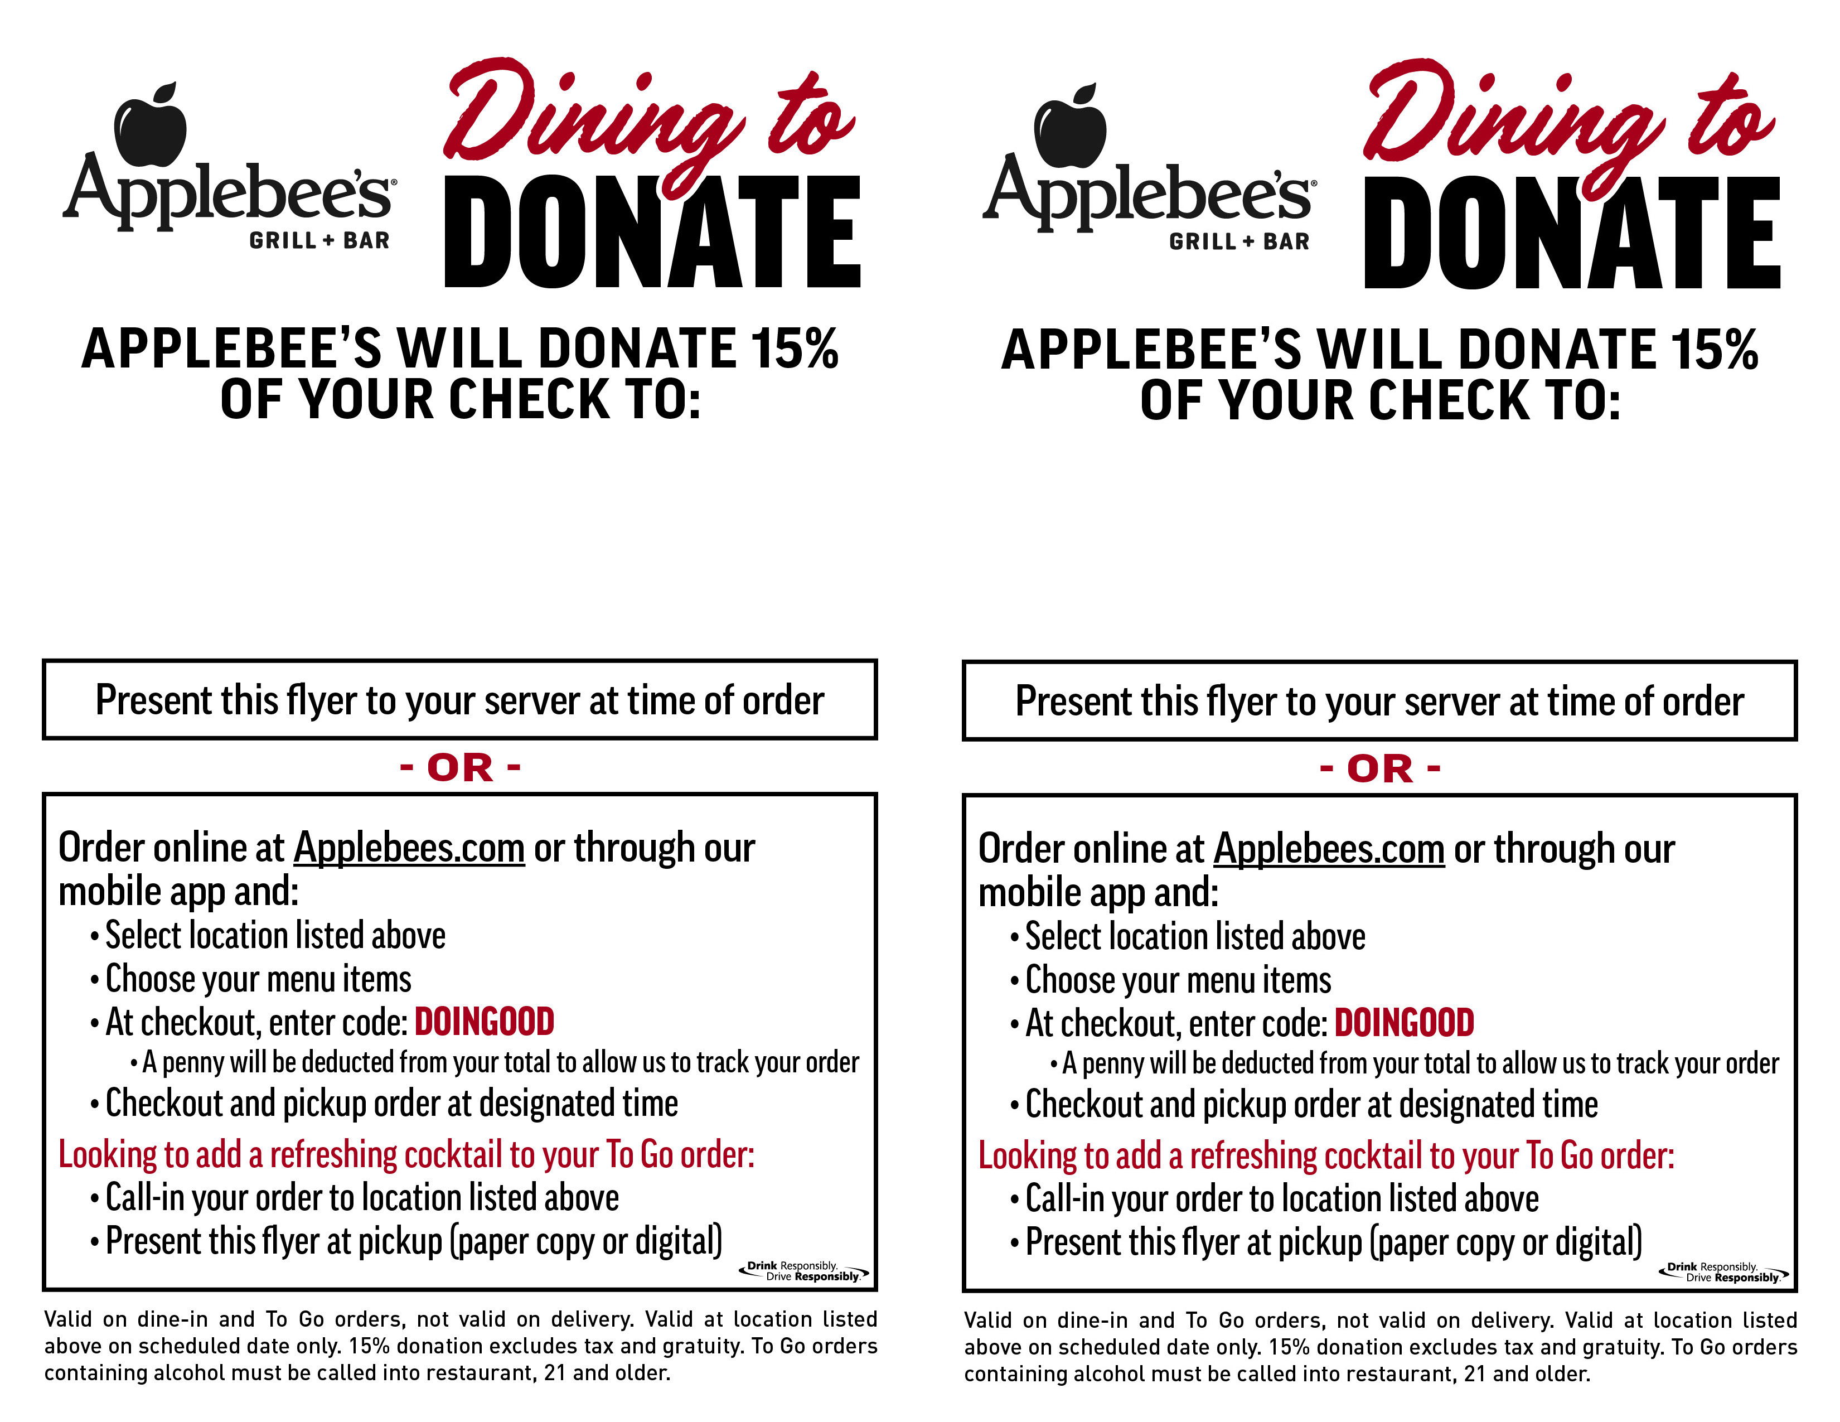

**Date:10/12/22**

**Time: 11am−Close 11am\\drobo\public\Applebees\AAG OH (Terry)\2021\_!DESIGN ONLY\03 MARCH\1,5_D2D_Donate 15%_Two Ways to Order_Flyer_5.5X8.5\**

**Date: 10/12/2022**

**Time: 11am−Close**

NFB Cuyahoga

County

NFB Cuyahoga

APPLEBEE’S

**5685 Mayfield Road**

**Lyndhurst, OH 44124**

APPLEBEE’S

**5685 Mayfield Road**

**Lyndhurst, OH 44124 4412412345**