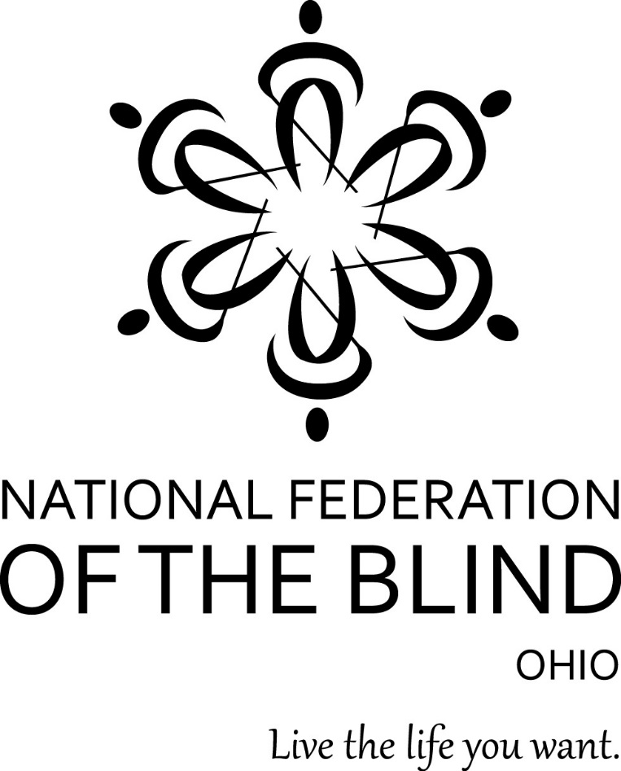
76th Annual Convention
Millennium: Honoring the Past, Treasuring the Present, Shaping the Future
Independence, Ohio
November 4-6, 2022

Richard Payne, President

Suzanne Turner, Vice President and Convention Coordinator

Host Chapters
Cleveland Chapter: Suzanne Turner, President
Cuyahoga County Chapter: Annette Anderson, President

DoubleTree by Hilton Hotel
6200 Quarry Lane, Independence, Ohio 44131
216-447-1300

Welcome by Richard Payne, President

Thank you for traveling to the rockinest weekend of the year to take part in our 76th annual state convention. We are truly happy that you are here. This year’s agenda is filled with information designed to help you live the life you want. As you take the time to become familiar with the hotel, listen to guest speakers, participate in breakout sessions, join division and chapter meetings, and enjoy a meal with your Federation family during our annual banquet, please take a moment to reflect on the historic significance that 76 years of blind people building the lives we want by marching together toward independence has had on our lives.

Join us as we celebrate the National Federation of the Blind of Ohio’s annual convention and expand our circle of participation, connecting blind Ohioans from across the state for what we expect to be the largest gathering of blind people in Ohio in many years. We encourage you to begin preparing to attend this outstanding event during the first weekend of November 2022. This convention will offer blind people an opportunity to learn about accessible technology at our Tech Fair and living with blindness by attending many educational seminars.

Although you will undoubtedly enjoy time with your friends, please reach out to those who have never joined us before and help them to become comfortable and learn more about the Federation. Of course all attendees are asked to attend and participate in all sessions.

Dozens of people across our affiliate have worked tirelessly to make this convention possible. I am sincerely grateful to all those who have given hours and hours of their time and energy to make this convention special. As an all-volunteer organization, we are blessed to have a wide range of dedicated members ready to lend a hand. I hope that you enjoy the fruits of our collective efforts. Let’s go build the Federation.

Code of Conduct

Through advocacy, public awareness, and mentoring, the National Federation of the Blind provides support to members and advocates for our rights to live the lives we want. As a member or guest at our convention, you represent not only yourself but also our organization. We want you to enjoy your time with us, make new friends, and renew old acquaintances. Although we encourage members to socialize and have fun, the convention also provides an important opportunity to come together to continue the work of our organization, to learn about the important initiatives that we are involved with on a local and national level, and to plan our work for the future.

We welcome all attendees to our convention and embrace diversity, inclusion, and mutual respect. As with all NFB events attendees of the 76th Annual Convention of the National Federation of the Blind of Ohio are subject to the NFB’s Code of Conduct, which can be found at: https://nfb.org/about-us/history-and-governance/code-conduct/code.

To that end please keep the following expectations in mind when you join us:

- We welcome people from all walks of life and with diverse needs and experiences. Please treat everyone as equals and with respect.
- Discrimination or harassment will not be tolerated under any circumstances. If your behavior could possibly make anyone uncomfortable, even if you would not be upset by it yourself, do not do or say anything that could be considered inappropriate by others.
- The Code of Conduct prohibits sexual harassment and sexual misconduct of any kind.
- The Code of Conduct prohibits the use of illegal drugs at NFB events, and states that “Although alcoholic beverages are served at some Federation social functions, members, employees, contractors, event attendees, volunteers, and program participants may not take part in any such functions in a condition that prevents them from participating safely and from conducting Federation business effectively or that might cause embarrassment to or damage the reputation of the Federation.”

We hope that everyone enjoys their time at the convention. Please take the time to review the NFB Code of Conduct at https://nfb.org/about-us/history-and-governance/code-conduct/code to make sure that you understand your responsibilities. If you witness an incident that you believe violates the Code of Conduct, you should immediately report it to a member of the NFB of Ohio Board of Directors.

About the National Federation of the Blind of Ohio

The National Federation of the Blind of Ohio (NFB-O) is a 501(c)3 non-profit organization and a founding affiliate of the National Federation of the Blind (NFB). We are proud to be an integral part of the oldest and largest blindness consumer organization in the United States. We are a diverse group of people dedicated to changing what it means to be blind. Our members work tirelessly to break down the legal, social, and personal barriers to living the lives we want.

One Minute Message

The National Federation of the Blind knows that blindness is not the characteristic that defines you or your future. Every day we raise the expectations of blind people, because low expectations create obstacles between blind people and our dreams. You can live the life you want; blindness is not what holds you back.

NFB Pledge

I pledge to participate actively in the effort of the National Federation of the Blind to achieve equality, opportunity, and security for the blind; to support the policies and programs of the Federation; and to abide by its constitution.

If you would like to join the National Federation of the Blind of Ohio, you may contact William Turner, Membership Coordinator, at TurnerW794@gmail.com or (330) 328-9860, and he will refer you to a local chapter in your area.

Navigating the DoubleTree by Barbara Pierce

This is a lovely facility with delicious food. The entrance is on the north side of the hotel, which means that you are facing south as you enter. If you step forward a few feet, the registration desk will be on the right (west) side of the lobby. Seating groups of furniture are in the center of the lobby, and Shula's Restaurant and Bar is located on the east wall. You pass through the bar before reaching restaurant seating. Wait in the bar to be seated.

After checking in, continue walking south. You will notice a corridor turning west (right). This leads to the sleeping rooms and the elevators to the upper floors. As you walk down this hall, west, you will first pass the Directors Room on your right and then the Boardroom. These are small meeting rooms, and they are close to the lobby end of the hall. After a forty-five degree bend to the left, this corridor dead ends into an exit with grass outside it. This is one of two dog relief areas, and a trash receptacle will be located outside the door for your convenience. Back in the hallway turn south about ten feet before that door to reach sleeping rooms and the elevator. At the south end of the hall you can bear right and immediately find Room 121, our hospitality room, or turn left (east) to walk along a hall that connects with the south end of the foyer area outside the ballrooms, which are also our principal breakout rooms.

Before you reach the ballrooms, you come to a cross hallway running south to the back parking lot and north to the lobby. In the northwest corner of this intersection is the Amphitheatre. If you walk south toward the parking lot, you will pass Petit Ballrooms C, D, and E on your left before you reach the door to the parking lot. This door is also a dog relief exit with a trash receptacle outside it.

If you return to the lobby and face south, just before the right turn to pass the Directors Room and Boardroom, you can angle yourself forty-five degrees to the left and find a corridor with access to the indoor and outdoor swimming pools and the business center on the right. This hall goes into the ballroom area. There are two ballrooms, both on the left side. The first is the Grand Ballroom with division rooms 1, 2, and 3 going south. Next is a carpeted hall to the left (east) which gives access on the right side to Petit Ballrooms A and B. Rooms C, D, and E lie to the south of these two smaller rooms, opening onto the hallway leading to the parking lot and dog relief area. Note that the only access to rooms A and B is from the cross hall. There are restrooms in the foyer on the east side before the ballrooms and also around the hallways near the elevators.

That's it. Read through this article several times, pausing after reading each new element to build a map in your head. If you take time to do this, you will sail through the convention with no problems. All rooms are marked in Braille and raised print in the standard locations. Happy travels.

Convention Arrangements

If you have any questions about convention arrangements, contact Suzanne Turner, Convention Coordinator, at (216) 990-6199, Email: SMTurner.234@gmail.com

Registration and Literature

NFB literature will be available throughout the convention in the registration area. Pre-registration packet pick-up and convention registration will take place in the foyer outside of the Grand Ballrooms. Those who have completed their registration before convention will form a line at the Pre-Registration Table for a speedy process. Visit the Registration Table to register for convention or to purchase additional tickets to events. Both tables will be open for three shifts on Friday, Nov. 4th, from 9:00 AM to 10:30 AM and 12:45 PM to 1:45 PM and 5:45 PM to 6:45 PM. The Cuyahoga County Chapter has volunteered to staff both tables at convention. Please contact Annette Anderson with any questions or concerns at 216-702-1246.

Door Prizes

Door prizes should be labeled clearly in print and Braille with the donor's name and the amount of cash or type of gift. Annette Lutz is in charge of door prizes. They may be brought to her directly or left at the Convention Information Desk with Carolyn Peters. You can call or text Annette at 614-288-4323 if you have questions or concerns.

Registration Is Now Open

You must pre-register for the Ohio convention by October 28, 2022. Convention registration makes attendees eligible for door prizes. Door prizes will be drawn during Convention festivities, general sessions, and the banquet. Registration is required, and you must be in the room to win.

Hospitality

A grab-and-go hospitality with snacks and beverages will be available Friday from 5:30 PM to 8:30 PM. The hospitality room will be in room 121. The Ohio Association of Blind Students and the Cleveland Chapter will be on hand to greet attendees.

Resolutions

All resolutions must be submitted to the Resolutions Committee Chair, Todd Elzey, no later than October 23. Resolutions will be considered at the general session on Sunday. For questions, email Todd Elzey at toddelzey@gmail.com.

Guide Dogs

There are two relief areas for your convenience. The first is located outside the west doors, off the hall that runs past the Directors Room. The second is on the south side, at the end of the hall, past the meeting rooms. A trash receptacle will be provided outside each door. Please note, you will need your room key after 10:00 PM to get back into the hotel from those exits. If you have questions or need assistance, contact LuAnn Bowers, President of the Ohio Guide Dog Users Division at 419-822-6828.

How To Give

You can help build a future of opportunity for the blind by becoming a member of our Dream Makers Circle. Your legacy gift to the National Federation of the Blind or the National Federation of the Blind of Ohio can be made in the form of a will or living trust, an income-generating gift, or by naming us as the beneficiary of a life insurance policy. For additional information, please contact Patti Chang at (773) 307-6440 or at pchang@nfb.org.

Also the PAC Plan allows members, affiliates, chapters, and others to give a regular and automatic donation to the Federation every month. All you need to provide is your checking or savings account identification information. Because of the costs associated with operating the program, the minimum donation is $5 a month, and there is no restriction on how much you donate. If you wish to sign up as a new member on the PAC plan or increase your contribution, you can go to www.nfb.org/pac.

Exhibit Hall

Whether you are an information seeker or a new gadget shopper, you will find everything that you need to help you live the life you want at this year’s Exhibit Hall. Visit the Exhibit Hall in Grand Ballroom 3 on Saturday afternoon from noon to 4:00 PM to explore the latest technology and to get answers to the questions that race through your mind about employment, healthcare, services for the blind, and much more.

National Representative

The Ohio affiliate is pleased to have Carla McQuillan as our National Representative. Carla is president of the NFB of Oregon and a member of the NFB Board of Directors.

Convention Agenda

Friday, November 4, 2022

9:00 AM to 10:30 AM: Pre-Registration Packet Pick-up and Convention Registration – Grand Ballroom Foyer

9:00 AM to 10:30 AM: The Art of Structured Discovery: Cane Travel the Federation Way led by Shawn Martin, Cuyahoga County Chapter. Participants should meet in the main lobby near the front desk to take a walking tour of the hotel.

10:30 AM to Noon: Board of Directors Meeting - Grand Ball Room I & II–Open to all convention attendees.

12:45 PM to 1:45 PM: Pre-Registration Packet Pick-up and Convention Registration–Grand Ballroom Foyer

1:00 PM to 1:45 PM: Rookie Roundup–Petit AB–All first-time convention attendees are cordially invited to attend a reception. Vice President Turner and other Federation leaders will be on hand to welcome you to the convention and preview the weekend’s activities. Veteran conventioneers should urge all first-timer convention participants s to attend this special event. We cannot wait to welcome you.

General Session–Grand Ballroom I & II

2:00 PM: Call to Order: Richard Payne, President, National Federation of the Blind of Ohio

2:02 PM: Invocation: Rev. Carolyn Peters, President, Communities of Faith Division

2:05 PM: Welcome to Independence, Ohio: Annette Anderson, President, Cuyahoga County Chapter, and William H. Turner, Vice President, Cleveland Chapter

2:10 PM: Color Guard Presentation: United States Air Force

2:25 PM: Convention Announcements: Suzanne Turner, Vice President

2:30 PM: National Report: Carla McQuillan, National Representative

3:00 PM: Fighting Low Expectations: Todd Elzey, Treasurer

3:15 PM: Opportunities for Ohioans with Disabilities (OOD): Bernadetta King, Program Manager, Bureau of services for the Visually Impaired (BSVI)

3:40 PM: Cleveland City, Department of Transit & Mobility: Calley Mersmann, Senior Strategist, Cleveland City Hall

4:05 PM: A year of Progress Hiring People with Disabilities in State Government, Office of Diversity, Equity, & Inclusion Enterprise: James Clinkscale, State ADA Coordinator, State Human Resources Division

4:35 PM: An Update from Disability Rights Ohio (DRO): Kerstin Sjoberg, Executive Director, Disability Rights Ohio

5:00 PM: Recess–General Session resumes at 9:00 AM Saturday, November 5, 2022.

5:45 PM to 6:45 PM: Pre-Registration Packet Pick-up and Convention Registration Grand Ballroom Foyer

5:30 PM to 6:50 PM: Changing What it Means to be Blind Through the Legislative Process – Grand Ballroom: Eric Duffy, Legislative Coordinator, National Federation of the Blind of Ohio, Come learn how the NFV-O Gets it done in the State House and in Congress.

5:30 PM to 7:00 PM: Ohio Community Service Division Meeting: Petit AB, Patricia McPherson, Chair

5:30 PM to 7:00 PM: Ohio Association of Blind Students Division Meeting–Petit C: Emily Kiehl, President -Swing by the Ohio Association of Blind Students to network with old and new friends. Participate with a team-building ice breaker, business meeting, and elections. speaker, LaToya V Smith, will discuss job opportunities and internships with her company.

7:00 PM to 8:30 PM: Communities of Faith Division Meeting–Amphitheatre, Dr. Carolyn Peters, President – The doors are always open. We are a diverse group of blind members representing various religions. Join our business meeting and elections and learn about resources.

7:00 PM to 8:30 PM: At Large Chapter Meeting – Petit C - Colleen Roth, President

7:30 PM to 8:30 PM: Resolutions Committee Meeting–Petit AB - Todd Elzey, Chair - We encourage the participation of all members. Come help shape and set the policies of the National Federation of the Blind of Ohio to advocate for positive change.

8:30 PM: Nominating Committee Meeting–This is a closed meeting.

9:00 PM: Talent Show – Grand Ball Room - Perhaps you have a talent you would like to share. We will feature YOU in an NFB of Ohio “You Got Talent” show. Contact, Wilbert Turner Facilitator at (216) 212-4959 to learn more.

Saturday, November 5, 2022

7:00 AM to 8:45 AM: Ohio Diabetes Action Network Meeting–Susan Day, President - Come network with us in the Shula's Restaurant Private Dining Room for breakfast, elections, and our business meeting

General Session–Grand Ballroom I and II

9:00 AM: Call to Order–Suzanne Turner, Vice President

9:05 AM: Invocation–Ali Benmerzouga, member, Communities of Faith Division

9:10 AM: Blindness and Low Vision Etiquette–Tom Sawyer, Outreach Specialist, Cleveland Sight Center

9:25 AM: Ohio Library for the Blind & Print Disabled–Kenneth Redd, Library Assistant, Outreach

9:50 AM: Presidential Address, Millennium: Honoring the Past, Treasuring the Present, Shaping the Future–Richard Payne, President

10:15 AM Deafblind Awareness with an Emphasis on the Aging Population, Retirees, and Baby Boomers–John Filek, Regional Service Coordinator, Helen Keller National Center

10:40 AM: General Voting ADA Requirements–Brett Harbage, ADA Coordinator, Office of the Ohio Secretary of State

11:10 AM: Introducing A Cubed Design (Accessible, Affordable, Accelerated Design), a Columbus start-up that aims to tackle the Braille literacy crisis by making a more affordable Braille display that can be customized and serviced by users–Caroline Karbowski, Chief Community Officer, Garrett Carder, Chief Executive Officer and Chief Engineer, Enan Srivastava, Chief Operations Officer

11:35 AM: Empowering and Assisting Medicare Beneficiaries to Prevent Healthcare Fraud, Errors, and Abuse and to Avoid Scams–Lisa Dalga, MBA, Project Manager, Senior Medicare Patrol (SMP) and Pro Seniors Inc

Noon: Recess – (General Session resumes at 9:00 AM Sunday.)

12:05 PM: Boxed Lunch Pick-up (tickets required) – Grand Ballroom Foyer

Noon to 4:00 PM: Exhibit Hall – Grand Ballroom III

12:30 PM to 1:50 PM: NFB of Ohio, Blind Seniors Division Meeting–Amphitheatre–Barbara Pierce, President

12:30 PM to 1:50 PM: Ohio Association of Guide Dog Users Meeting–Petit AB–LuAnn Bower, President

1:30 PM to 2:50 PM: Leadership Seminar, Establishing the Tone and Setting the Pace–Ball Room 1 and II–All are invited to participate in a dialog on developing a leadership plan and establishing vision as a trailblazer in the NFB, President Richard Payne and National Rep. Carla McQuillan and other leaders will offer insight on how to be vigilant and confident in getting the job done.

2:00 to 5:00 PM: Hands-On and Interactive Boutiques

2:00 PM to 3:30 PM: Boutique 1–Amphitheatre (Braille Technology Workshop) –Come and learn through demonstrations and discussions about Braille displays, Braille notetakers and other Braille devices. Please bring your Braille devices into the room and learn how to navigate, compile information, and connect to various devices such as iPhones, iPads, and more.

2:00 PM to 3:30 PM: Boutique 2 (OABS STEM Showcase)–Petit AB–Come learn about geology, physiology, technology, and more from members of the Ohio Association of Blind Students. This exhibit and showcase of tools used for nonvisual navigation will provide an understanding of how the blind interpret STEM through accessible modifications. On display will be the Talking Lab Quest, how blood cells are differentiated by touch, and more.

3:30 PM to 4:45 PM: Boutique 3 (Technology Workshop)–Amphitheatre–Come participate in Demonstrations and discussions about Windows 10 operating system, Google Apps, Apple products, popular iPhone Apps, KNFB Reader, Tap Tap See, and more.

3:30 PM to 4:45 PM: Boutique 4 (OABS Tactile Art Show)–Petit AB - Come and enjoy the students' non-visual art and learn about the tools we use to create it! We will also have a space for everyone to get creative and show off their own art skills.

3:30 PM to 4:50 PM: You Have the Write to Heal–Petit CD–The season is now to write, recite & heal with me–Jeanetta Price, CEO and Founder, Blind Girl Magic

5:30 PM to 6:30 PM: Pre-Banquet Social Hour–Grand Ballroom Foyer–Walk the Red Carpet and enjoy a cash bar; as beautiful soloist Denise Hudson and the Music Settlement fills the atmosphere with memorable and harmonious classics.

6:30 PM: NFBO Banquet (tickets required) – Grand Ballroom
Event Highlights:
- Master of Ceremonies–Richard Payne, President
- Invocation – Wilbert Turner, Treasurer, Communities of Faith Division
- Keynote Speaker–Carla McQuillan, National Representative
- Gavel Awards – Annette Lutz, Awards Chair, Member, Ohio Board of Directors
- Scholarship Awards–Kinshuk Tella, Scholarship Co-chair, Member, Ohio Board of Directors
- Not So Silent Auction–Annette Lutz, Member, Ohio Board of Directors
- Money for the Movement–Todd Elzey, Treasurer

9:00 PM to 11:00 PM: After Party – Grand Ballroom – Stick around after the banquet to karaoke the night away with your federation family. Enjoy live music, cash bar, and fellowship.

Sunday, November 6, 2022

8:00 AM to 8:50 AM: Musical Showcase–Grand Ballroom

General Session–Grand Ballroom

9:00 AM: Call to Order–Richard Payne, President

9:05 AM: Moment of silence

9:10 AM: Financial report–Todd Elzey, Treasurer

9:25 AM: Walking In Purpose–Emily Kiehl, President, National Association of Blind Students

9:45 AM: Nominating Committee Report

10:00 AM: Affiliate Elections–Note: Only those who are current dues-paying members can vote in this election.
National Federation of the Blind of Ohio Officers and board members’ terms ending In 2022:

President: Richard Payne
Vice President: Suzanne Turner
Secretary: Eric Duffy
Treasurer: Todd Elzey
At-large Board Member: Marianne Denning
A vacancy for a one-year board term is also to be filled.

10:30 AM: The History of our Movement, Archiving the Past and Recording our Future–Annette Lutz, Ohio Affiliate Historian

10:50 AM: NFB Philosophy, Louisiana Center for the Blind–Andra Stover, Secretary, Greater Akron Chapter

11:10 AM: Report of the Resolutions Committee–Todd Elzey, Chair

11:45 AM: Convention Wrap-up and Other Announcements – Richard Payne, President

Noon: Adjournment

National Federation of the Blind of Ohio Board of Directors

Terms ending 2022

President:
Richard Payne
937-396-5573
rchpay7@gmail.com
PO Box 20544, Dayton, OH 45420

Vice President:
Suzanne Turner
216-990-6199
SMTurner.234@gmail.com
1127 Euclid Ave. Apt 210, Cleveland, Ohio 44115

Secretary:
Eric Duffy
614-377-9877
peduffy63@gmail.com
185 Crestview Rd., Columbus, Ohio 43202

Treasurer:
Todd Elzey
315-879-1746
toddelzey@gmail.com
611 Blenheim Rd., Columbus, OH 43214

At-Large Board Member:
Marianne Denning,
513-607-6053
Marianne@Denningweb.com
835 Carini Lane, Cincinnati, Ohio 45218

Terms ending 2023

Annette Lutz
614-288-4323
annettelutz@att.net
77 West Jeffrey Place Columbus, OH 43214

Dr. Carolyn Peters,
937-293-2131
dr.carolyn.peters@gmail.com
411 Elmhurst Road, Dayton, OH 45417

Barbara Pierce,
440-774-8077
barbara.pierce9366@gmail.com
198 Kendal Dr., Oberlin, OH 44074

Kinshuk Tella,
Kinshuk.Tella@gmail.com
2614 Rockcastle Ct., Miamisburg, Ohio 45432

William Turner,
330-328-9860
TurnerW794@gmail.com
1064 East 167th Street, Cleveland, OH 44110

Sponsors
Vanda Pharmaceuticals
Vanda Pharmaceuticals is dedicated to raising awareness of Non-24-Hour Sleep-Wake Disorder (Non-24) and supporting the blindness community. Non-24 is a rare circadian rhythm disorder affecting up to 70% of people who are totally blind. People living with Non-24 experience excessive daytime sleepiness and nighttime sleeplessness, which leads to impaired social and occupational functioning. This is due to the misalignment between the internal master body clock and the 24-hour day. To learn more about Non-24 and Vanda Pharmaceuticals, visit us on the web at www.non-24.com or call us at 1-855-856-2424.
Disability Rights Ohio
Disability Rights Ohio is a non-profit corporation with a mission to advocate for the human, civil, and legal rights of people with disabilities in Ohio.
Southeastern Ohio Center for Independent Living - serving Fairfield and Hocking counties.
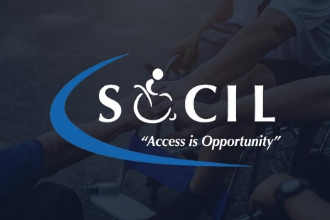
Founded in 2002, SOCIL is managed by a Board of Directors and staff comprised of mostly persons with various disabilities. The foundation of CIL services is the peer relationship - people with disabilities assisting other people with disabilities as role models and mentors. Each center is unique.
Magnifiers & More

