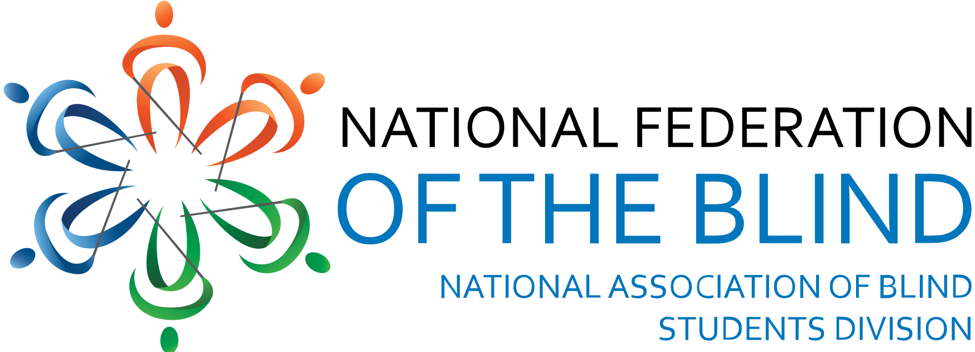

The National Association of Blind Students

“Helping blind students realize our dreams.”
Trisha Kulkarni, President
nabs.president@gmail.com
www.nabslink.org

General Background | NABS
The National Association of Blind Students (NABS) is a proud division of the National Federation of the Blind, an accredited 501(c)(3) organization promoting equality for blind people. Through leadership development, resource sharing, personal/professional networking, and advocacy for equal access in the classroom, NABS aims to level the playing field for all students regardless of visual acuity. To fulfill our mission, we need your help to ensure blind students continue benefitting from the systemic change, support, and resources necessary to unlock our full potential and achieve our goals.

Our Mission
The mission of NABS is to promote equal access to educational and career opportunities for blind students. We accomplish this mission through an internal and external approach. Internally, we provide blind students with timely and relevant information on issues and developments that directly impact their experiences in the classroom and beyond. Additionally, we serve as a forum for networking, mentoring, and problem solving among our members. Externally, NABS engages in advocacy efforts to raise awareness of the capabilities of blind students and push for social change.

Our Goal
To accomplish our mission, we raise the necessary funds that enable blind or visually impaired students the opportunity to attend NABS programs, nationwide, where they:
1. Gain extensive leadership skills through hands-on workshops
2. Become aware of academic, social, and professional issues affecting the nation’s blind
3. Receive mentorship from successful blind individuals in their chosen fields
4. Build confidence through self-advocacy and community
5. Develop nonvisual tools and techniques that foster active participation in society

Help us accomplish our goals and improve the lives of blind students. Consider donating with the attached form.

Donation Form

Individual/Organization/Business Name: ___________________________________
Contact Name: ____________________________________________________
Mailing Address: __________________________________________________________
City: _______________________ State: _______ Zip Code: __________
Phone Number: ___________________________
Email Address: ____________________________
Please indicate below how you wish to contribute to our initiative:
Sponsor a Student for Leadership Training: $500 ___ $300 ___ $200 ___ Other______________
Donate Goods or Services (please specify): ____________________________________

Signature: ______________________________________ Date: ____________________

Return this form via e-mail and/or send items via postal mail to:
Elizabeth Rouse
Treasurer, National Association of Blind Students
PO Box 942
Durant, IA 52747
Elizabethrouse.nfb@gmail.com

