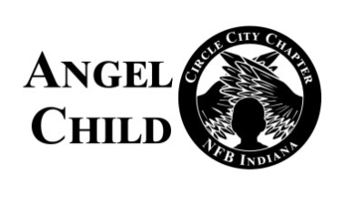

The National Federation of the Blind-Circle City Chapter of Indiana cordially invites you to attend our virtual Angel Child gifting and service awards Christmas program on:

Date: December 3, 2022
Time: 4:00p.m. to 6:00p.m. (EST)

Theme: “ANGEL CHILD SPREADING IT’S WINGS of Unity FROM VILLAGE TO VILLAGE”

This year’s Angel Child is truly spreading its wings of unity throughout the state of Indiana and beyond, please join us with the enclosed Zoom invite on December 3, 2022, the Zoom room will open at 3:30p.m.

See Zoom connection information below.

https://zoom.us/j/9908141333
One Tap Mobile:
+16468769923,,9908141333,,#

Call with your home phone:
646 876 9923
Enter the 10-digit pin:
990 814 1333#

The objective of the NFB Circle City Chapter of Indiana’s Angel Child Gifting & Service Awards is to collectively celebrate the lives of families and children during the Holiday Season, lift up families in need with a small financial gift, and to recognize those who have served in the advancement of our community.

The Circle City Elves and affiliate family have been busy preparing this heart-warming event to start your Christmas season.

Come join us in the great spirit of lifting and gifting.

Lee Martin, Sr. - President
Florence Myers McSwine, Vice President
Enrique Alleyne, 2nd Vice President
Ray Montgomery, Secretary
Jessica Dalton, Treasure
Angela Timberlake, Board Member

“Alone we can do so little; Together we can do so much” Helen Keller

