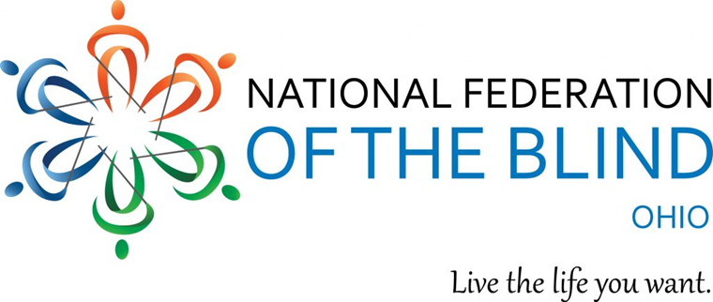

**STEM2U**

**Held at COSI in Columbus with the National Federation of the Blind of Ohio**

The National Federation of the Blind works to improve opportunities for blind students in the areas of science, technology, engineering, and mathematics. NFB STEM2U, brings nonvisually accessible STEM lessons and activities to blind youth. The theme this year is space! Students of varying ages across the country will receive instruction from NFB personnel, blind mentors and expert instructors.

# **Attendee information**

## **Who:**

Blind and low-vision youth grades 3-12* who

* Are interested in STEM
* Are unsure about STEM but interested in a fun program specific to blind students
* Are in need of hands-on, nonvisual skills training opportunities from blind role models

Students do NOT need to be from Ohio.

*If your student wants to participate but is not in grades 3-12, contact Caroline at [CarolineKarbo@gmail.com](mailto:CarolineKarbo@gmail.com).

## 

## **When:**

May 21st2023 (Sunday) from 10:00 am to 3:30 pm

## **Where:**

Center of Science and Industry (COSI)  
 333 W Broad St.  
 Columbus, OH 43215

## **How to Register:**

Sign up **by May 7th**, 2023 using the [NFB STEM2U sign up form](https://nfb.org/form/nfb-stem2u-application)

<https://nfb.org/form/nfb-stem2u-application>

In the sign up you can include dietary and access needs for your student.

## **More details:**

* Lunch will be provided for students and volunteers.
* The event is free for students participating! Admission to the COSI exhibits is not included. If enough families are interested in viewing the COSI museum while their child is at STEM2U, we may be able to get discounted group tickets. Parking for families will be free.
* Students will receive instructional materials in large print and braille, the Sensational Blackboard (tactile drawing board), and tactile graphics to keep.

# **Volunteer information**

We are looking for volunteers to

* Assist with setup (8-10 am) and teardown (3:30-4:30 pm).
* Assist students with activities (10-3:30 pm)
* Assisting with drop off/pick up
* Talk with families

Volunteers will have an interview with Ohio STEM2U coordinators. If over 18, the volunteer will need to take the NFB background check (unless they have taken one since May 21, 2022). Background check fees will be covered by NFB. If under 18, a parent/guardian needs to sign a form allowing the minor to volunteer.

We will provide training beforehand via Zoom and during the setup time from 8-10 am.

We are seeking volunteers who have high expectations of blind students and a positive philosophy on blindness. Experience in STEM is not required.

If you are interested in volunteering, please contact Laura Pitner at [laurapitner22@gmail.com](mailto:laurapitner22@gmail.com), or if you prefer phone, call or text Caroline Karbowski at 513-374-3587.

We will be in contact with you on the interview and background check.

# **Contact**

## **Coordinators for the Ohio event**

### Caroline Karbowski: [CarolineKarbo@gmail.com](mailto:CarolineKabo@gmail.com) or call or text 513-374-3587

### Laura Pitner: [laurapitner22@gmail.com](mailto:laurapitner22@gmail.com)

## **National STEM2U Coordinator**

### Karen Anderson: [STEM@nfb.org](mailto:STEM@nfb.org) and 410-659-9314, extension 2418. Note, sometimes NFB emails do not go through with their filter. If you do not hear a response contact Karen directly via phone or her email [KAnderson@nfb.org](mailto:KAnderson@nfb.org).

# **About the NFBO**

The National Federation of the Blind of Ohio (NFBO) is a 501c3 non-profit organization and a founding affiliate of the National Federation of the Blind (NFB). We are proud to be an integral part of the oldest and largest blindness organization in the United States. We are a diverse group of people dedicated to changing what it means to be blind. Our members work tirelessly to break down the legal, social, and personal barriers to living the lives we want.

[www.nfbohio.org](http://www.nfbohio.org/)

# **Support**

Due to the generous donation from General Motors, blind students across the country will learn fundamental nonvisual tools and techniques they can use to pursue further education and careers in STEM. The members of the NFB are extremely grateful for this gift from GM, which will truly help blind students live the lives they want.