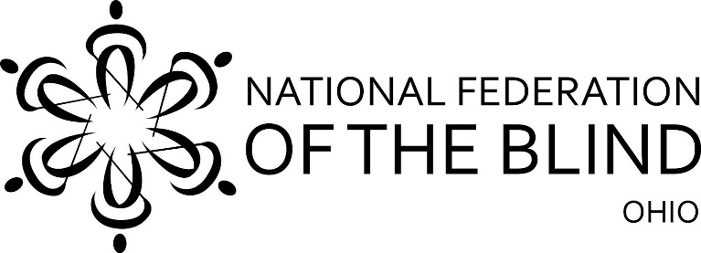

Assisting Clients and Patients Losing Vision

Advice from Blind Seniors
The National Federation of the Blind of Ohio, Senior Division will present a two-hour seminar on ways to think about and help seniors losing vision.
When: May 16, 2023, from 10:00 a.m. to Noon on Zoom
https://zoom.us/j/4081850851

Meeting ID: 408 185 0851

One tap mobile +1-646-876-9923, 4081850851# US

Who are we?
The National Federation of the Blind of Ohio (NFB-O) is the oldest and largest statewide consumer organization in the blindness field. We are its division for those over fifty. Many of us have been dealing with vision loss for decades, but many more are still adjusting to vision loss and have discovered that the attitudes and outlook of the NFB are immensely helpful in learning to cope with the world using our remaining senses.

We recognize that inevitably many blind seniors are dealing with additional disabilities: hearing loss, impaired memory, balance problems or orthopedic impairment, as well as various diseases.

We don’t claim to have all the answers, but we can advise you on how to help blind people think about blindness constructively and show you techniques to assist with orientation, ways to mark household equipment and identify items tactilely. We will show you how to guide a blind person and help blind people enter a car or van. We can provide advice for assisting blind people who use wheelchairs, and we can answer specific questions.

We hope you will join us on May 16. Useful documents and resources will be available to registrants.
\
To register: Send your name, job title, agency or business name, email address, and preferred phone number to nfbo.seniors@gmail.com.

