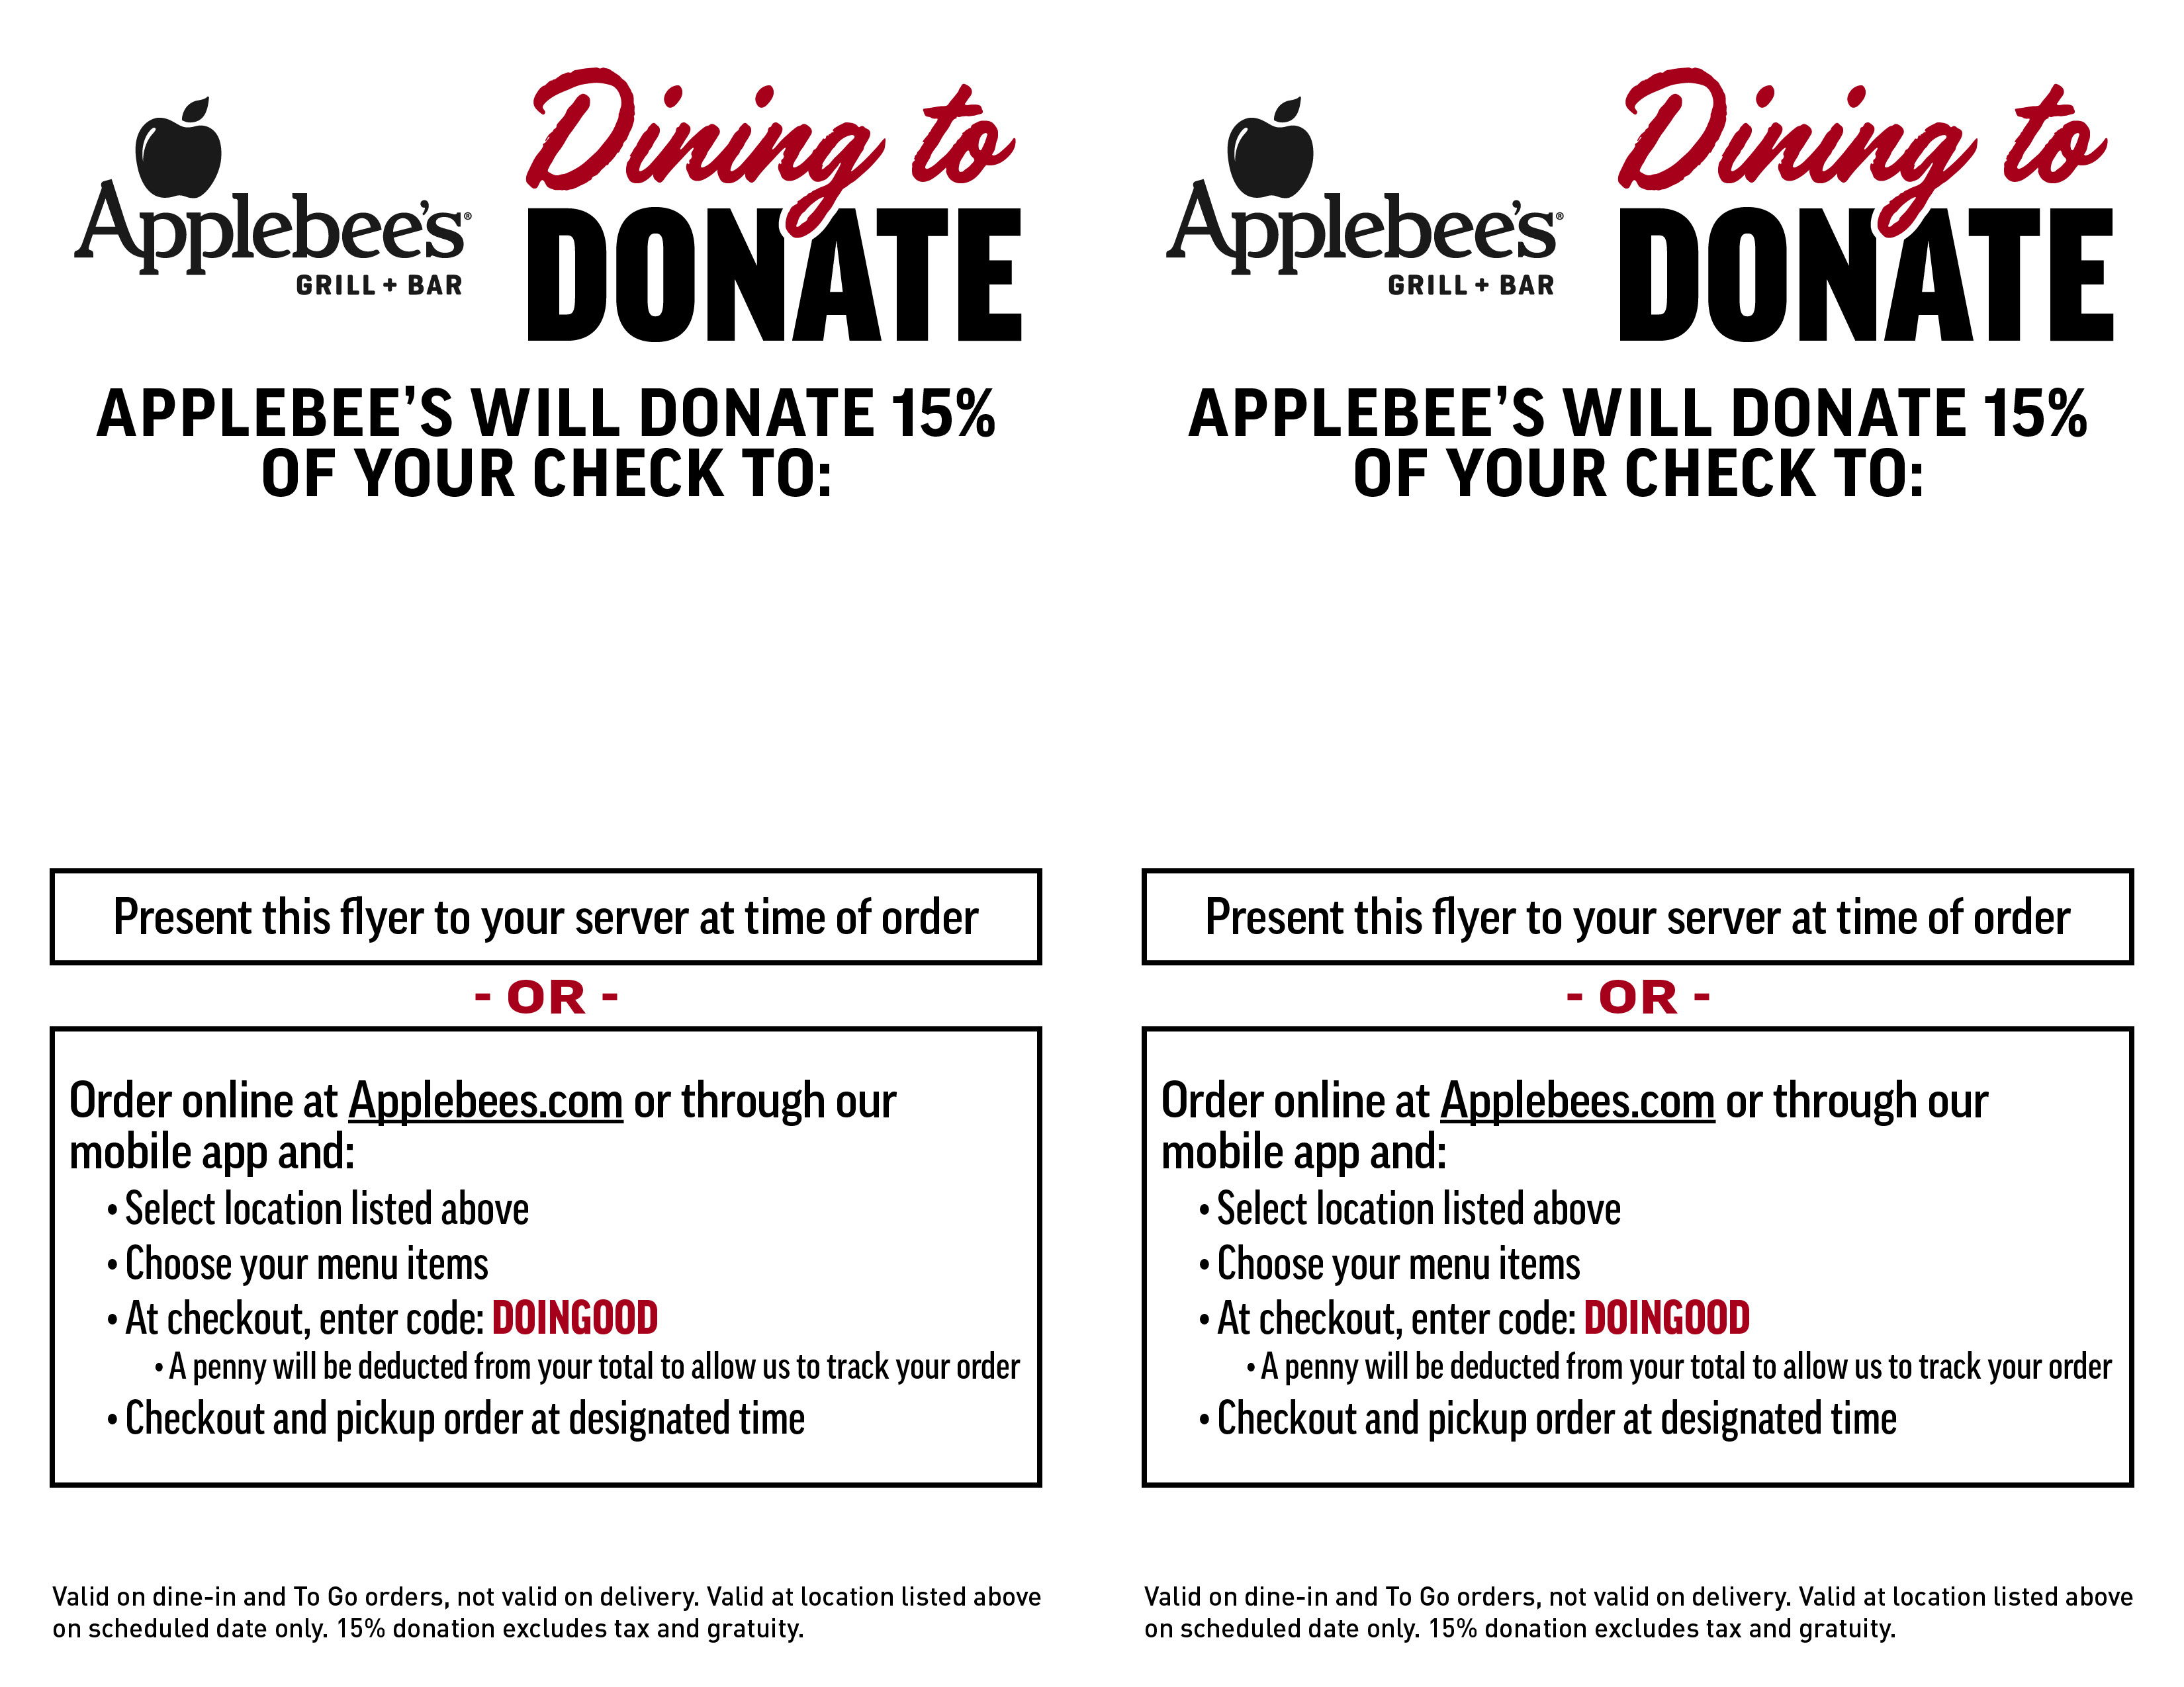

Cuyahoga county chapter of the national federation of the blind

APPLEBEE’S Lyndhurst

5658 Mayfield Road

Lyndhurst, OH 44124

**Date: 6/20/2024**

**Time: 11am−Close 11am\\drobo\public\Applebees\AAG OH (Terry)\2021\_!DESIGN ONLY\03 MARCH\1,5_D2D_Donate 15%_Two Ways to Order_Flyer_5.5X8.5\**

Cuyahoga county chapter of the national federation of the blind

APPLEBEE’S Lyndhurst

5658 Mayfield Road

Lyndhurst, OH 44124

**Date: 6/20/2024**

**Time: 11am−Close 11am\\drobo\public\Applebees\AAG OH (Terry)\2021\_!DESIGN ONLY\03 MARCH\1,5_D2D_Donate 15%_Two Ways to Order_Flyer_5.5X8.5\**