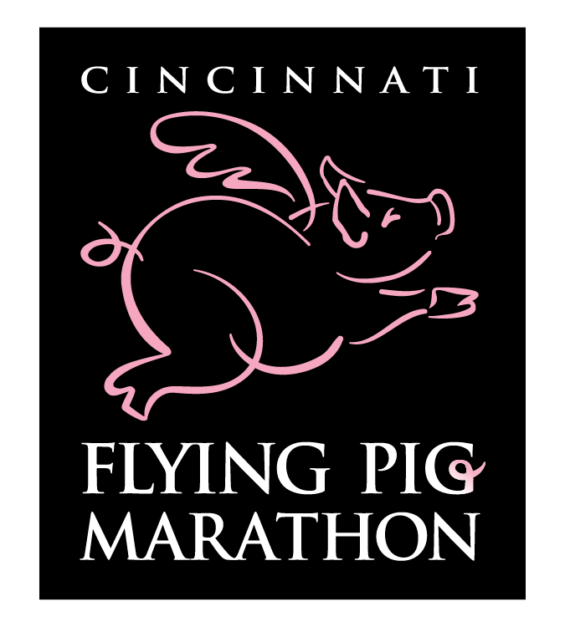
Raffle Level Charity
Piggest Raffle Ever

National Federation of the Blind of Ohio offers
An opportunity to raise funds for Ohio and win a cash prize.
Just click on:
https://piggestraffleever.com/.
And choose National Federation of the Blind of Ohio as your charity.
How’s it Work? Easy! Purchase a Raffle Entry for $5 each on behalf of one of the participating charities from the drop-down menu below. For each Pig purchased, you have a chance to win on Flying Pig Marathon Weekend and the charity you select receives 100% of your donation!
GRAND PRIZE: $10,000 Cash*
($5,000 to the charity and $5,000 to the winning ticket holder)
SECOND PRIZE: $5,000 Cash*
($2,500 to the charity and $2,500 to the winning ticket holder)
THIRD PRIZE: Cincinnati Get-Away Experience
($1,500 in Downtown Cincinnati, Inc. vouchers)

