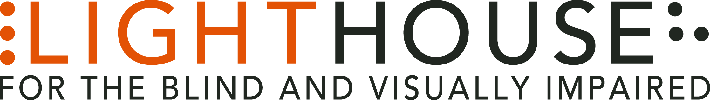

LIGHTHOUSE JOB ANNOUNCEMENT

POSITION: Content Marketing Manager

REPORTS TO: Director of Communications

LightHouse for the Blind and Visually Impaired, headquartered in downtown San Francisco, is looking for a full-time Content Marketing Manager to fill a valued role in our growing organization.
Role Overview: The LightHouse is seeking a media professional to guide production of the LightHouse’s websites, printed collateral and overall brand presence. This Content Marketing Manager will engage and mobilize our local and global audiences by promoting our life-changing programs for the blind, public events and elevating our name recognition.
The LightHouse is seeking a media professional to guide production of the LightHouse’s websites, printed collateral and overall brand presence. This Content Marketing Manager will engage and mobilize our local and global audiences by promoting our life-changing programs for the blind, public events and elevating our name recognition.
Design is a major focus of this position: designing everything from brochures and flyers to multifaceted and large scale ads. The position requires creating audio and video content documenting our programs in photography and stories. There are opportunities to pursue an ambitious slate of video, audio, and photo projects. This role will also perform the foundational tasks of copyediting, managing and developing our web sites. LightHouse Communications is a small, agile team where each individual is expected to think creatively, produce steadily, and be prepared to juggle deadlines.
The role is responsible for sourcing, writing, producing and distributing content for online and/or offline marketing needs. Uses written, multimedia and video storytelling to create innovative and engaging content in support of the organization’s marketing goals. Contribute to content marketing initiatives, coordinating with development and program staff to create compelling materials and presentations.
Qualifications:
• Bachelor’s degree or higher
• Minimum 2 years in marketing, communications and/or graphic design

Job Responsibilities:
• Work as a member of the Communications team in the publication of all agency announcements, student and other public-facing media.
- Daily copyediting
- Take, crop and edit photographs
- Organize media assets
• Produce and edit audio, video with strong LightHouse branding.
• Design full gamut of printed brochures with accessible versions
• Work in tandem with Development Department to support fundraising efforts through design of printed and online campaigns, printed and online newsletter design, annual report and invitation design.
- Design billboards and ads as needed
- Create branded schwag such as t-shirts, sleep shades and other items
• Promote LightHouse programs to increase enrollment, grow communities, educate and engage students and the greater population.
• Assist with the Holman Prize for Blind Ambition and related communications.
• Oversee and complete special projects as assigned.

Who We Are:
LightHouse has an audacious mission – to transform the lives of the 40,000 blind people in the greater Bay Area and beyond. We do this through tech design, disability advocacy, consultation, classes and community formation in San Francisco, our four satellite offices and Enchanted Hills Camp in Napa. We are a fun, fascinating, widely diverse, warm and friendly community. We work in downtown San Francisco in a 40,000 square foot state-of-the-art workspace renowned for its universal design, steps from Civic Center BART. LightHouse is working for nothing less than to change the future for blind people and the wider community.
Within a five-minute walk are the world headquarters for Twitter, Uber, Dolby, Zendesk and many other tech giants. Within three blocks are all of the principal building for Northern California’s federal, state and local government. Also in our neighborhood are many theaters, San Francisco Symphony and Opera, the Asian Art Museum and dozens of other key cultural anchors of the entire Bay Area.
The successful candidate will join a unique organization in which blind and sighted professionals work together at every level. Our governing Board of Directors, management and staff are all composed of roughly equal numbers of blind and sighted people, a parity unprecedented in our field.
Founded in 1902, LightHouse for the Blind and Visually Impaired provides skills, resources and community for the advancement of all individuals who are blind or have low vision. Our innovative programs have been featured in 60 Minutes, the New York Times, the Wall Street Journal and beyond. The blind community comes to LightHouse to learn how to travel independently with a white cane, to rejoin the workforce, use accessible technology, and meet a community of mentors and peers. From unique tactile maps, to an unparalleled camp for blind campers, to a world prize for blind ambition, LightHouse offers programs unavailable elsewhere.
Learn About Us:

LightHouse for the Blind and Visually Impaired
155 Market Street, 10th Floor
San Francisco, CA 94103
www.lighthouse-sf.org

Employee Benefits:
The LightHouse offers a rich package of benefits, including medical, vision and dental insurance. Employees are eligible for an employer-matched 401(k) plan and subsidized health club membership, among many other perks.
Compensation:
Depending On Experience; industry competitive.

How to Apply:
Please submit a LightHouse Job Application, cover letter and résumé in word processing document attachments (no PDFs please), to hr@lighthouse-sf.org, including the job title in the subject line.

