Getting In Touch With Literacy Conference
November 12 – 15, 2009
www.gettingintouchwithliteracy.com

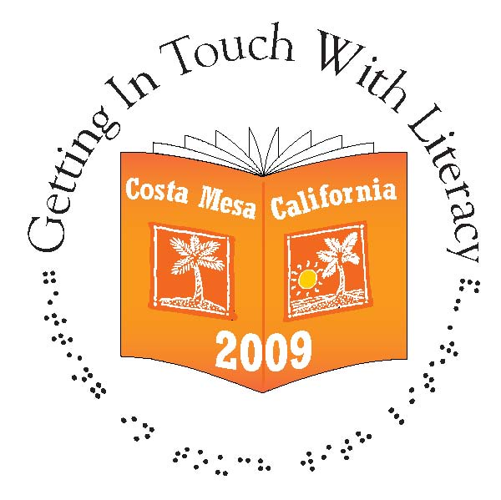
The Hilton Orange County/Costa Mesa

REGISTRATION

July 29, 2026

Registration for Getting In Touch With Literacy is now available! Log on to
http://www.gettingintouchwithliteracy.com/registrationform.php

In order to complete your registration, the online form will need to be printed out and sent along with a check payable to “CSULA-UAS Getting In Touch With Literacy”. Sorry, we are unable to accept credit cards.

Early Bird Registration must be received by September 30, 2009. The conference will be Thursday-Sunday and includes the Thursday Exhibitor Reception, Friday Louis Braille Birthday Celebration Luncheon, and Saturday Evening Gala.

Early Bird Registration (By September 30th) $175/Person
Late Registration or at the Door (After September 30th) $195/Person
One Day Registration (Saturday Workshops) $95/Each
Includes All Concurrent Sessions, Keynote and Evening Gala.

Conference Program Ads, Dedications, and/or Tributes
If you are interested in placing an ad, dedication, or tribute in the conference program, and are not an exhibitor/vendor, you may submit ads, dedications, and tributes by contacting Penny Rosenblum at rosenblu@u.arizona.edu. All ads, dedications, and/or tributes must be received no later than September 18, 2009.

Ads are available in various sizes: full page, half page, quarter page, and business card/tribute starting at $100.

Hello!

My apologies if this is a duplicate post, however, I did not see it come across the airwaves on Monday. Here it is again for your convenience. ☺

Registration is now open for Getting in Touch With Literacy Conference! Tribute Ads are also available!

Getting In Touch With Literacy Conference
November 12 – 15, 2009
www.gettingintouchwithliteracy.com

The Hilton Orange County/Costa Mesa

REGISTRATION

August 24, 2009

Registration for Getting In Touch With Literacy is now available! Log on to
http://www.gettingintouchwithliteracy.com/registrationform.php

In order to complete your registration, the online form will need to be printed out and sent along with a check payable to “CSULA-UAS Getting In Touch With Literacy”. Sorry, we are unable to accept credit cards.

Early Bird Registration must be received by September 30, 2009. The conference will be Thursday-Sunday and includes the Thursday Exhibitor Reception, Friday Louis Braille Birthday Celebration Luncheon, and Saturday Evening Gala.

Early Bird Registration (By September 30th) $175/Person
Late Registration or at the Door (After September 30th) $195/Person
One Day Registration (Saturday Workshops) $95/Each
Includes All Concurrent Sessions, Keynote and Evening Gala.

Conference Program Ads, Dedications, and/or Tributes
If you are interested in placing an ad, dedication, or tribute in the conference program, and are not an exhibitor/vendor, you may submit ads, dedications, and tributes by contacting Penny Rosenblum at rosenblu@u.arizona.edu. All ads, dedications, and/or tributes must be received no later than September 18, 2009.

Ads are available in various sizes: full page, half page, quarter page, and business card/tribute starting at $100. The attached “advertisement” form must be completed and submitted to L. Penny Rosenblum no later than September 18, 2009.

We look forward to a wonderful conference and hope to see you there!

Jana Hertz
GITWL Publicity

