Stand out among teachers of the blind and visually impaired!
Don't miss this opportunity to hold this important,
nationally recognized certification of literary braille proficiency.

The National Certification in Literary Braille (NCLB)
test will be administered by the National Blindness Professional Certification Board (NBPCB)
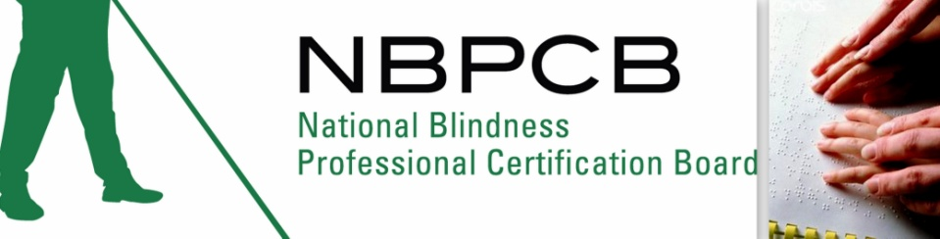
in
Minneapolis, Minnesota

Saturday, February 23, 2013
at BLIND, Inc. / NFB of MN Headquarters building
100 East 22nd Street
Minneapolis, MN 55404

Please go to our website, www.nbpcb.org/nclb
to find out more information and to register for this important test.

Deadline for registration is Febuary 10th!
Contact the NBPCB office at (318) 257-4554
or by email at braille@nbpcb.org.

