SAVE the DATES!!
05.16-17.2014

What: Unified English Braille Workshop
When: Friday, May 16, 2014, at 1:00 p.m.—5:00 p.m.
Saturday, May 17, 2014 at 9:00 a.m. - 12:00 p.m.
Where: The Louisiana Center for the Blind, 101 South Trenton Street, Ruston
Teachers, instructors, consumers, and all those whose work involves the teaching, production, and/or use of braille are aware that the United States has adopted the Unified English Braille code by January 4, 2016 as the standard code for literacy.
The purpose of this workshop will be to familiarize participants with the changes to the braille code introduced by UEB, and to provide hands-on training in order to provide a solid working knowledge of Unified English Braille. Information will also be presented on the new National Certification in Unified English Braille (NCUEB) which will be available later this year.
Cost: Participation in the workshop is $50 for professionals and free to consumers and students. Continuing Learning Units (CLU) will be provided to workshop participants.
For more information, contact Edward Bell at ebell@latech.edu or 318-257-4554.

Housing may be available on a limited basis. Contact Eric Guillory for details: eguillory@louisianacenter.org Or 318-251-2891.

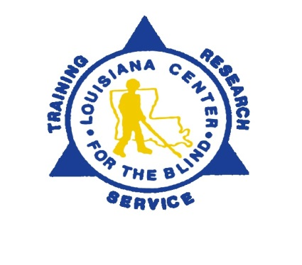
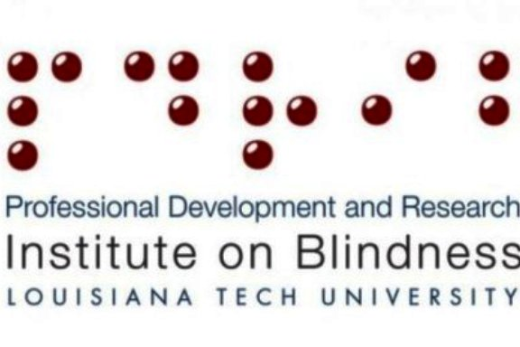
A registration form will be circulated by late April.

