National Braille Association 2016
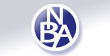
Professional Development Conference
70 years of providing continuing education to those who prepare braille and braille materials to persons who are visually impaired.
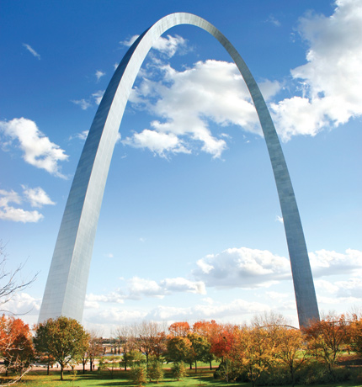
Meet Me in St. Louis …
Gateway to the West
October 27, 28, and 29, 2016

Registration is now open!

The National Braille Association is pleased to announce that we will be heading to St. Louis, Missouri for our 2016 professional development conference. Known as the Gateway to the West, the Gateway Arch greets visitors to this cultural and historic city! St. Louis boasts of historic and cultural attractions, many of which are free. Get a glimpse of where Lewis and Clark set out on their historic expedition by visiting the Lewis & Clark Boat House and Nature Center, or the Lewis & Clark monument on the Missouri River. Interact with butterflies at the Sophia M Sachs Butterfly House. Roam the Missouri Botanical Garden, a National Historic Landmark with 79 acres of scenic landscaping and elegant structures. Journey to the top of the Gateway Arch, our nation’s tallest man-made monument at 630 feet. Relax on a Riverboat cruise; or immerse yourself in a little arts and culture. If you are feeling adventuresome, there is a wealth of attractions to see and experience.

Our host hotel is the St. Louis Union Station, once the largest and busiest passenger rail terminal in the world. Today, this 120 year old National Historic Landmark of unmatched beauty and elegance is home to the St. Louis Union Station Hotel – a DoubleTree by Hilton Hotel.

Once again, we are looking forward to 30 exciting workshops. With the Unified English Braille Code as our focus, there is a lot to learn! Topics will include but are not limited to UEB, textbook and Nemeth format, music, computer-assisted transcription and tactile graphics. Just to pique your interest here are a few of the sessions being developed just for you:
- Mathematics: Nemeth in UEB
- Tactile Graphics: Tactile Graphics for Young Readers
- Music Braille: Music Theory Textbooks in UEB
- Formats: Formats and UEB
- Computer Assisted: Workshops available for Braille 2000 and Duxbury

This is the ONLY NBA conference this year! Don’t miss out!

Register now at: www.nationalbraille.org

We look forward to seeing you there!!!

