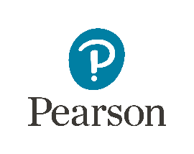
Jan McSorley
400 Center Ridge Drive
Austin, TX 78753
512-673-9569

Pearson User Study -- Potential Participant Letter
Dear Potential User Study Participant:
Pearson is working to improve the accessibility of our digital tools and content. For this reason, we are pleased to invite teachers of the visually impaired to participate in an interview about the development of a curriculum to teach Nemeth Code for math and science notation. We will be conducting the interviews during the 2016 National Federation of the Blind (NFB) Convention.

Time and Incentive to Participate:
- Estimated Time: 20 – 30 minutes
- Incentive for Participants: $50 Visa card
- Total slots available: 6
How to Participate:
If you are already attending the 2016 NFB National Convention and are interested in participating, please activate the link at the bottom of this letter to complete a survey and provide us with additional information. This information will be used to make sure that this study is a good fit for you. The participant slots will be allotted on a first-come-first-serve basis, so please complete the survey as soon as possible.
Surveys must be completed no later than June 17, 2016. The responses will be reviewed by Pearson staff and Consent Letters will be sent on or before June 21, 2016 to those selected for participation. Signed consent must be received by email no later than June 27, 2016.
Please activate this link to take the survey

