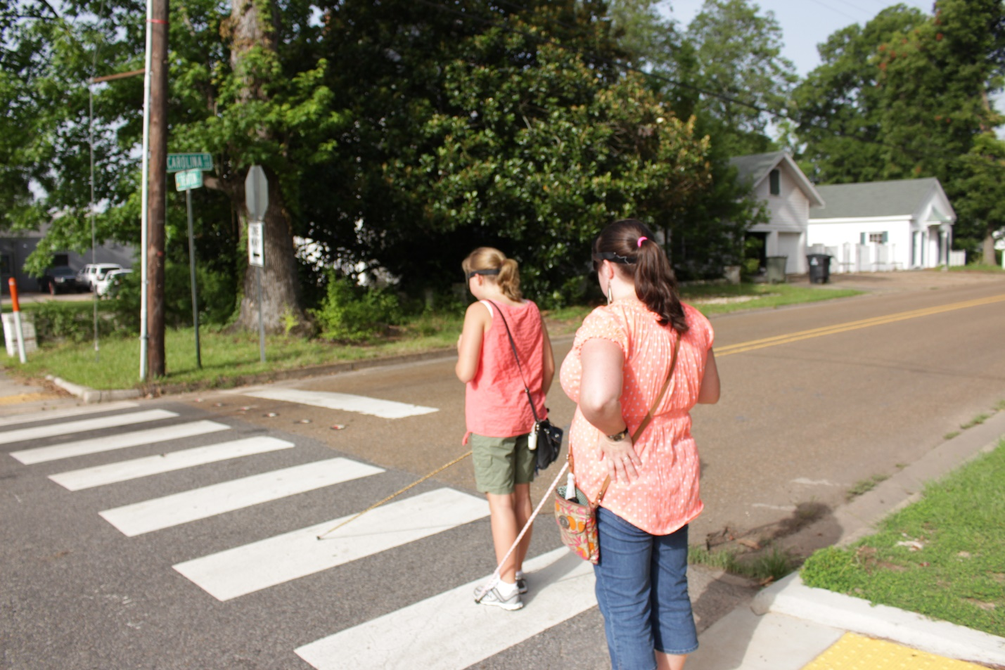

BUDDY PROGRAM 2018
Putting the Pieces Together

Come and join us for a summer of fun and learning!

Since 1989, the Louisiana Center for the Blind has offered an innovative summer program for blind children in grades four through eight. This summer, the Buddy Program promises to be full of learning opportunities, new friendships, and fun-filled activities.

Many blind children have misconceptions about their blindness due to the lack of positive role models and to the negative stereotypes about blindness in society. Unlike other summer programs for blind children, the Buddy Program is directed and staffed by competent blind adults. Classes in cane travel are taught to instill independence and self-confidence. The knowledge of Braille enables the blind child to compete on terms of equality with sighted peers in the classroom and provides a solid background in spelling and other grammatical skills. Classes in access technology expose students to available mainstream and adaptive solutions. Daily living skills instruction promotes equal participation in household duties such as cooking, shopping, and cleaning. In addition to learning valuable alternative techniques of blindness, children will enjoy participating in a wide variety of exciting activities such as swimming, camping, bowling, roller skating, and field trips.

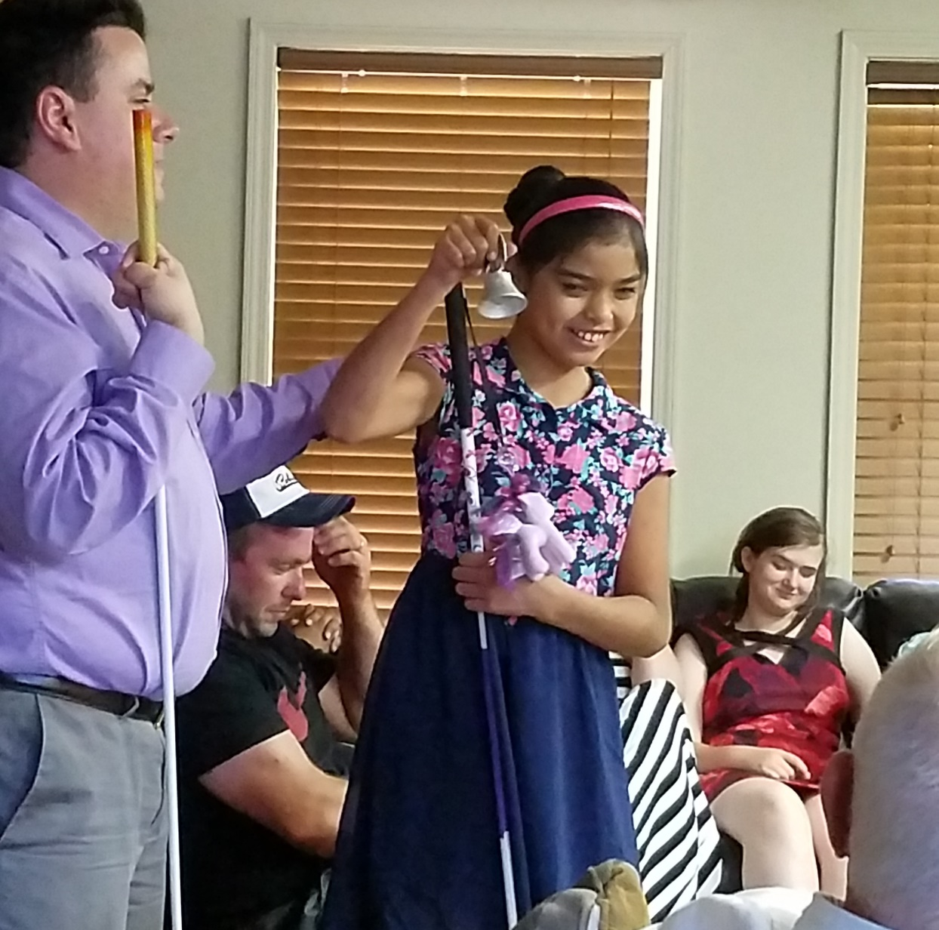

The combination of hard work and fun activities will provide a rewarding experience that children will cherish. Involvement in the Buddy Program helps them realize that it is not blindness that holds them back. Rather, it is the negative attitudes and misconceptions about blindness that may prevent them from reaching their potential. At the close of the program, parents are REQUIRED to attend a Parents’ Weekend. This weekend will allow them to interact with other parents of blind children and to learn what their children have discovered about their blindness and themselves. Friendship, training, fun, growth and interaction between blind children and positive blind role models is how the Louisiana Center for the Blind is “changing what it means to be blind.”

The Louisiana Center for the Blind will sponsor one session of the Buddy Program in 2018. Program dates are July 15-August 4. We recognize that there may be some overlap between the conclusion of our program and school district dates. If accepted, we are happy to coordinate with a student’s school district in this regard.

Perhaps we will have the opportunity to work with your child this summer. We know it will be a memorable experience for both you and them. All interested families should visit www.louisianacenter.org for more details and to apply. Please also feel free to contact our Director of Youth Services, Eric Guillory before April 20. Please email Eric at eguillory@louisianacenter.org or call 800-234-4166.

Due to limited space, we cannot guarantee that every applicant will be granted enrollment. Please note that the fee for students not from Louisiana is $1,000—which is all-inclusive save for transportation to and from the program. The fee for Louisiana students is $500.

