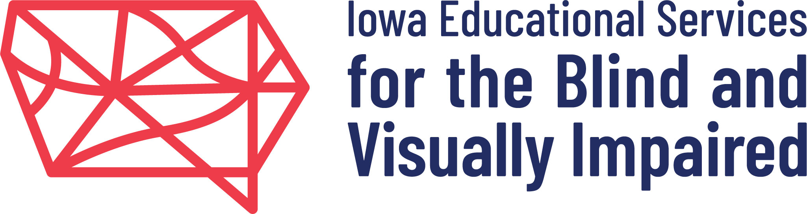

Iowa Educational Services for the Blind and Visually Impaired
Iowa Braille and Sight Saving School

Announces Employment Opportunity:

Teacher of the Visually Impaired – 4PLUS Program
Send resume, cover letter and copies of transcripts by email to: deb.leheup@iaedb.org or mail to:
Human Resources; IESBVI; 3501 Harry Langdon Blvd; Council Bluffs, IA 51503
Additional information and job posting available at http://www.iowa-braille.k12.ia.us/
Contact Human Resources at Phone: 712-366-3283; Email: deb.leheup@iaedb.org

Primary Function:

- Provides appropriate transition support and/or instruction to students aged 17-21 with visual impairments participating in the 4PLUS Program located on the Council Bluffs campus.
- Formulates appropriate educational objective, activities, evaluation, goals, and instruction.
- Reports student growth and programs to parents periodically.
- Participates as a member of multidisciplinary teams; involved with evaluations; educational planning; development of Individualized Educational Plans (IEP); program implementation. Provides written reports and documentation. May lead IEP meetings.

Required Qualifications:

Bachelor’s degree in education plus experience using a computer and other office equipment required. Candidates must meet State of Iowa teacher licensure requirements with an endorsement in visual impairment by the time of appointment. Candidates possessing a special education endorsement may also qualify, but must complete the visual impairment endorsement within three years of appointment (financial assistance available for necessary coursework). Information on Iowa licensing requirements may be found at the Board of Educational Examiners webpage: www.state.ia.us/boee/.

Preferred Qualifications:

Master’s degree in education and experience working with students who are blind and visually impaired preferred.

Salary and Benefits:

Salary will be determined by the successful applicant’s educational and teaching experience.
(BA degree - $44,897-$69,658; MA degree – $52,701-$81,255). Comprehensive benefit package.

Position Details:

School-year appointment. Position starts August 2021. Position is located in Council Bluffs, IA on the Iowa School for the Deaf campus. Criminal and other relevant background checks also required. Applications will be accepted beginning immediately. Applications accepted until the position is filled.

Iowa Educational Services for the Blind and Visually Impaired / Iowa Braille and Sight Saving School is an Equal Employment Opportunity and Affirmative Action Employer. A Board of Regents, State of Iowa Program.

