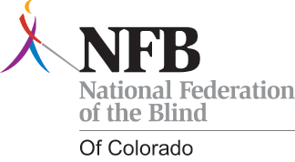

What: The Poudre Valley Chapter of the National Federation of the Blind of Colorado (NFBCO) Benefit Concert
When: Friday June 6, 2014 at 7:00 PM – 1:00 AM

Donation Coordinator: Dillon Allen (970) 581-3489

You could mail a donation to: 2233 W. Shepperd Ave.
Littleton, CO 80120

WE NEED YOUR HELP!
Donate items or services for the
Poudre Valley Chapter of the
NFBCO Benefit Concert

The Poudre Valley Chapter of the National Federation of the Blind of Colorado will greatly appreciate your support. Proceeds from your donation and the concert will support our 2014 Braille Enrichment for Literacy and Learning (BELL), which is a training program for elementary school age children to learn Braille and independence skills, as well as other programs to benefit the blind in Fort Collins. All proceeds will go directly to our annual BELL program,

The National Federation of the Blind of Colorado is a 501(c) 3 not-for-profit organization. Our tax identification number is: 84-610 7081. Your donation will be completely tax deductible.

For information or donation pick-up, please contact Dillon Allen (970) 581-3489

About the National Federation of the Blind
With more than 50,000 members, the National Federation of the Blind is the largest and most influential membership organization of blind people in the United States. The NFB improves blind people’s lives through advocacy, education, research, technology, and programs encouraging independence and self-confidence. It is the leading force in the blindness field today and the voice of the Nation's blind. In January 2004 the NFB opened the National Federation of the Blind Jernigan Institute, the first research and training center in the United States for the blind led by the blind. The NFB has affiliates in all fifty states, including the state of Colorado, plus Washington D.C. and Puerto Rico.

