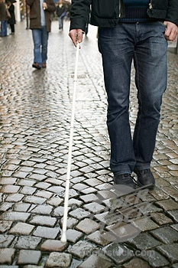
Project HIRE: New Opportunity for Youth who are Blind or Visually Impaired: An Online Employment Preparation Program

Are you interested in finding a job? Are you a senior or recent graduate from high school OR a senior or recent graduate from college? If you answer yes to both of these questions, we have a program for you that is being offered online, and it’s free! We know that youth who are blind or visually impaired often have difficulty finding employment, and we want to help by providing a program that specifically focuses on identifying the right job for you and the steps to take to find that job. The program will last 8 weeks, beginning in September 2009 or January of 2010, and it will cover the following topics:
- Self-assessment & discovery
- Interest & career exploration
- Job search skills training
- Employment issues specific to blindness
- How to locate specific job openings & apply for jobs

This program will take place online, so you can be located anywhere in the U.S. and participate. You can participate from home, school, or anywhere you have internet access. We can also help you obtain internet access in order to participate if this is a problem for you. Although this is an online program, it will involve interaction with others and will require completion of assignments. Two programs will be offered: one for seniors or recent graduates from high school and one for seniors or recent graduates from college.

Specific requirements for participation include:
- Legal blindness or more severe visual impairment
- Blindness as the primary disability, without additional significant disabilities
- Senior in high school (or recent graduate) who does not plan to attend college, OR Senior in college (or recent graduate), under the age of 25, who expects to seek (or is seeking) employment after graduation
- Basic computer literacy and knowledge of accessibility software/hardware that would allow participation in an intervention provided on the Internet

If you meet these requirements and are interested in participating in one of these free programs, you can get information and sign up on line by September 14 at http://www2.blind.msstate.edu or contact Lynda Goleman at 1-800-675-7782 or lgoleman@colled.msstate.edu



