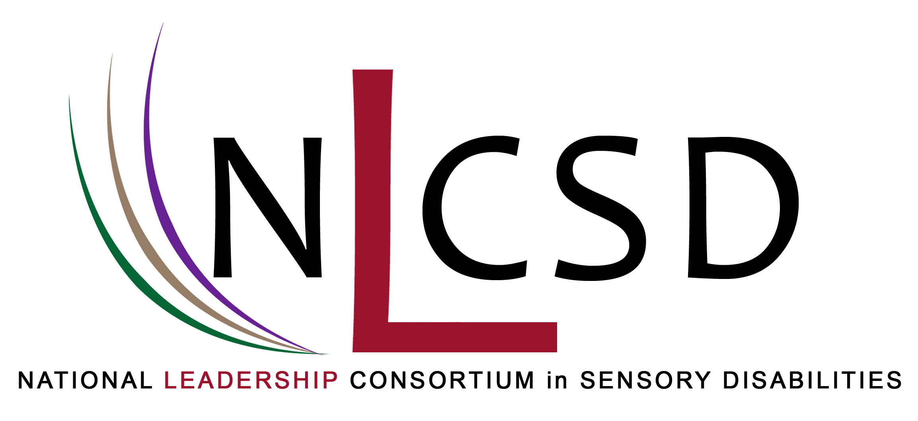
We are pleased to announce that applications for the second and final cohort of the National Leadership Consortium in Sensory Disabilities (NLCSD) are now being accepted. Sponsored by the U.S. Department of Education, Office of Special Education Programs, the consortium consists of 25 universities with doctoral programs that have an emphasis in one or more of the three sensory impairment areas: blind/visually impaired, deaf/hard of hearing, and deafblindness.
Information about the application process and the application are available at http://www.salus.edu/nlcsd/index.html. Applications will be accepted until December 31, 2010. The cohort will begin their studies in the Fall of 2011.
More information about this exciting opportunity can be obtained on the web or by contacting the following:
Kathleen M. Huebner Brooke C. Smith
NLCSD Project Director NLCSD Project Coordinator
Salus University Salus University
kathyh@salus.edu bsmith@salus.edu
John Killoran Brenda Schick
NLCSD Liaison to NLCSD Liaison to the
the Deafblind Community Deaf & Hard of Hearing Community
Western Oregon University/NCDB University of Colorado - Boulder
killorj@wou.edu brenda.schick@colorado.edu
Glinda Hill Tina Fitzpatrick
OSEP Project Officer NLCSD Administrative Assistant
glinda.hill@ed.gov Salus University
tfitzpatrick@salus.edu

