T-Shirts that Promote Independence for the Blind

We are glad to offer you two new T-Shirts that are designed to promote independence for the blind in a fun and moving way. We have two different shirts to offer.
The descriptions, picture, and order information for both are listed below.

For more information, you can call Edward Bell or Dianne Seilhan at 318-257-4554, or dseilhan@latech.edu.

Use More Canes

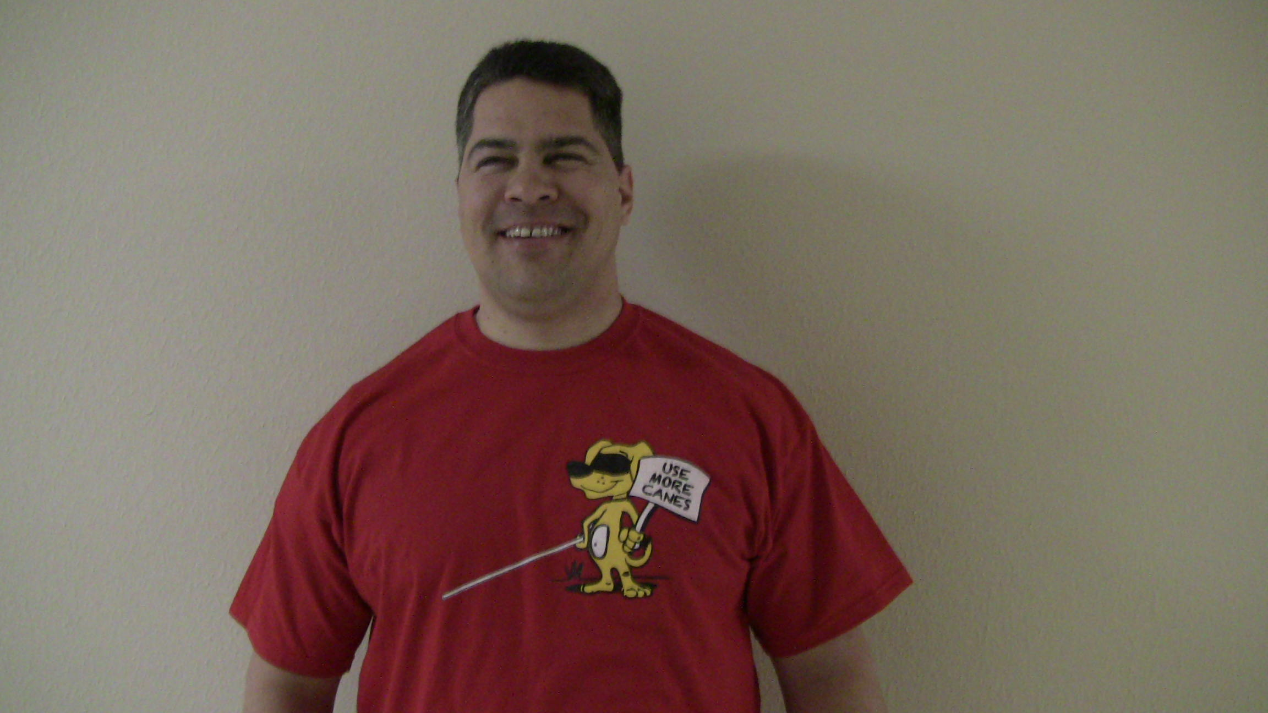
This shirt, reminiscent of the Chick-Fil-A ® Cow, is a Red, short sleeve T-shirt with a graphic cartoon of a cute yellow dog standing up on hind legs. The dog is wearing a blindfold and holding a long white cane in his right paw
He is holding a white sign that says in black letters “Use More Canes" in his left paw.

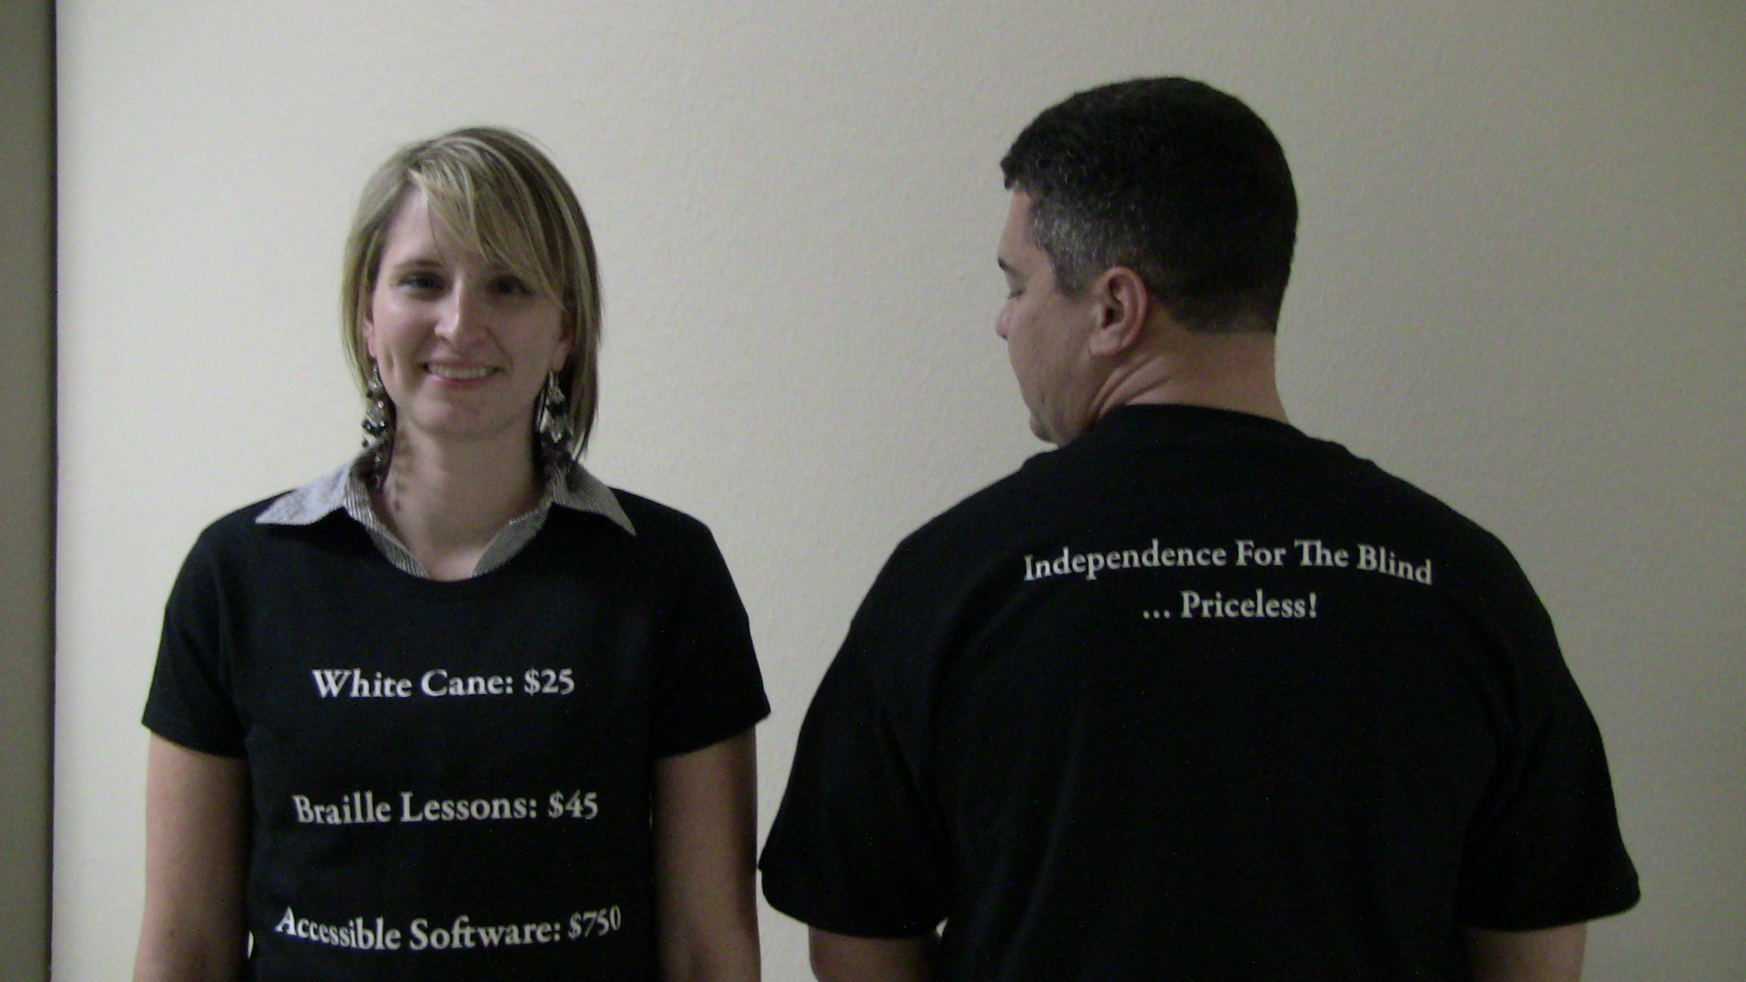
Priceless

This shirt, touting the importance of independence that cannot be captured at any cost, is a black short sleeve T-shirt with white lettering.

The front of the shirt has a printed list which says: “White Cane: $25 Braille Lessons: $45 Accessible Software: $750”

The back of the shirt says: “Independence for the Blind… Priceless!”

Adult shirts are $20 each; Youth shirts are $15 each
Sizes are: Adult: small, medium, large, XL, XXL; Ladies fitted: small, medium, and large; Youth: medium or large

We have two options for you to purchase:
- To place an order by e-mail or phone, send an email to dseilhan@latech.edu, or call 318-257-4554.
Make sure to include the type of shirt, size and quantity, your mailing address, and contact information.
Include $5.00 shipping for 1-5 shirts, $10.00 for 6-10 shirts—speak with a representative for larger orders.

- To purchase online, go to: http://www.gemini-rt.com/?page_id=37.

Include $5.00 shipping for 1-5 shirts, $10.00 for 6-10 shirts—speak with a representative for larger orders

