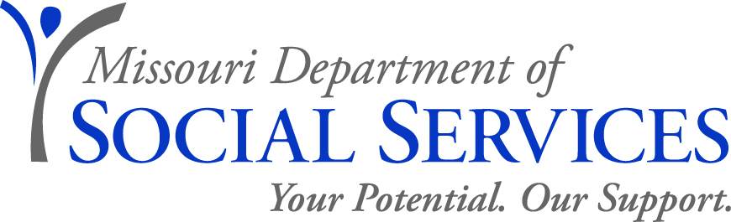

JOB ANNOUNCEMENT

Vocational Rehabilitation Counselor for the Blind
Or Senior Vocational Rehabilitation Counselor for the Blind
Family Support Division, Rehabilitation Services for the Blind
March 21, 2012

The Family Support Division, Rehabilitation Services for the Blind, is seeking applications for the position of Vocational Rehabilitation Counselor (VRC) for the Blind (http://www.oa.mo.gov/pers/ClassSpecs/5172.htm) or a Senior Vocational Rehabilitation Counselor (SVRC) for the Blind (http://www.oa.mo.gov/pers/ClassSpecs/5173.htm). This position is based in the Scott County RSB Office located at Sikeston, Missouri.
JOB DUTIES: The Vocational Rehabilitation Counselor works under the general supervision of the District Supervisor but exercises increasing independence and initiative within established agency guidelines.
The Vocational Rehabilitation Counselor is responsible for assisting blind and visually impaired clients to obtain, or retain employment. VRC’s provide guidance and counseling regarding the client’s personal and vocational adjustment throughout the rehabilitation process, assists clients through informed choice in determining appropriate vocational goals and is a resource for clients seeking information regarding employment and employment goals. VRC’s determine eligibility for services, assesses vocational, social, and medical needs through appropriate testing and medical reports. Essential job duties include conducting initial interviews with vocational rehabilitation applicants; determining eligibility for the vocational rehabilitation program. VRC’s conduct comprehensive vocational evaluations assist the client in determining employment goals consistent with their interests, abilities and capabilities and to determine specific needs to reach the chosen vocational goal. Serves as a resource to service providers; coordinates and authorizes fiscal expenditures based on an agreed to individualized plan of employment.

VRC’s will assist clients to obtain an employment outcome using a variety of job development and job placement strategies including contacting employers, assessing employers’ needs, and providing resources and education to employers and clients. Counsels and guides the clients in the establishment of self-employment goals. VRC’s become familiar with and implement service provision in accordance with statutory and regulatory requirements. VRC’s serve as a liaison providing education, technical assistance, and resource sharing to clients, families, and community stakeholders including service providers, the business community, government agencies, schools, and healthcare professionals.
QUALIFICATIONS FOR VRC: Applicants must meet the following minimum qualifications: Possession of a Master’s Degree from an accredited school of rehabilitation counseling, counseling, guidance and counseling, clinical psychology, counseling psychology, or social work. (Possession of a current Certified Rehabilitation Counselor certification issued by the Commission on Rehabilitation Counselor Certification will substitute for possession of the Master’s Degree.)

QUALIFICATIONS FOR SVRC: Possession of a Master’s Degree from an accredited school of rehabilitation counseling, counseling, guidance and counseling, clinical psychology, counseling psychology, or social work and two years experience as a VRC with Rehabilitation Services for the Blind or comparable experience in other vocational rehabilitation programs.
OR
Possession of a current Certified Rehabilitation Counselor certification issued by the Commission on Rehabilitation Counselor Certification and two years of experience as a VRC with Rehabilitation Services for the Blind or comparable experience in other vocational rehabilitation programs.
SALARY RANGE: Annual salary range for VRC is $33,420 - $47,184. If filled as a SVRC, annual salary range is $35,952 - $51,156.
TO APPLY: Interested applicants must forward a completed Merit application (http://oa.mo.gov/pers/howtoapply.htm) to Sarah Zayumba (fax number is (573) 526-3674. Upon accessing the web site, select "paper application form" because the EASe on-line process is not yet available for these positions. Even if you are already on a register, you must submit a Merit application to Ms. Zayumba on or before April 19, 2012. If you have questions regarding this position, please contact Carl Powers at (573) 472-5240.
Transfers – Individuals who are a currently a VRC or SVRC and are not on probation or a corrective action plan, and are seeking a lateral transfer (same range), please provide a transfer application (http://www.oa.mo.gov/pers/TranRempAppt.htm ) to Ms. Zayumba as instructed above.
RECRUITMENT AREA: Accepting applications from all qualified applicants.
APPLICATION DEADLINE: April 19, 2012
Applications will be subject to review prior to scheduling interviews
DSS IS AN EQUAL OPPORTUNITY EMPLOYER

