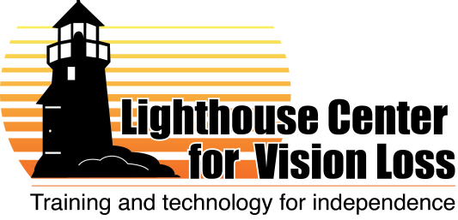

Vision rehabilitation instructor and/or
orientation and mobility specialist
Posted August 31, 2012

Note: Job descriptions and duties are subject to change and will depend on the skills and background of the selected candidate, as well as the needs and opportunities of the organization. What is below reflects our best guess of how this position might be structured within our organization.

Location: Duluth, Minnesota
Description: The Lighthouse Center for Vision Loss is a small, progressive regional nonprofit organization with 12 current staff, offering both center-based and itinerant services to individuals of all ages. Duluth is a beautiful, mid-sized city located on shores of Lake Superior, featuring abundant arts and outdoor recreation opportunities.
We are seeking a qualified instructor for our vision rehabilitation services. The ideal candidate would have joint certification in O&M and vision rehabilitation, but we will consider candidates with certification in either area, as well as other qualified candidates who are willing to seek additional training and certification.
This candidate selected for this position will provide instruction to clients mainly at our center and within nearby communities. This professional will likely also be involved in an innovative new pilot project serving seniors now being funded by the state. Ideally, the person could teach in a number of areas, such as TDL, O&M, braille, and adaptive leisure, and also be able to assist customers in our low vision store. Some travel throughout the region will be required.
Qualifications:
- Bachelors’ degree in relevant field preferred.
- Bachelor’s or masters’ degree in O&M with O&M certification, or willingness to pursue O&M certification (at our expense), strongly preferred.
- Joint certification in O&M and vision rehabilitation would be ideal. Experience working with transition-age youth, adults and seniors is preferred.
- Must have: willingness/ability to travel occasionally around northern Minnesota and Wisconsin, to sit and stand for extended periods, to work in close contact with Lighthouse students, and to work around service dogs.
- Must also have: computer skills, writing skills, ability to work with basic data, flexibility to do a variety of work, and ability to work occasional weekend and evening hours.
Compensation: Salary will be competitive and will depend on experience and qualifications. We also offer generous benefits including health and life insurance, vacation and sick leave and retirement savings.
To apply: Send resume, cover letter and references to mjunnila@lighthousefortheblind-duluth.org, or call Mary with questions 218-624-4828.

