Slide-A-Round Math Manipulatives, LLC


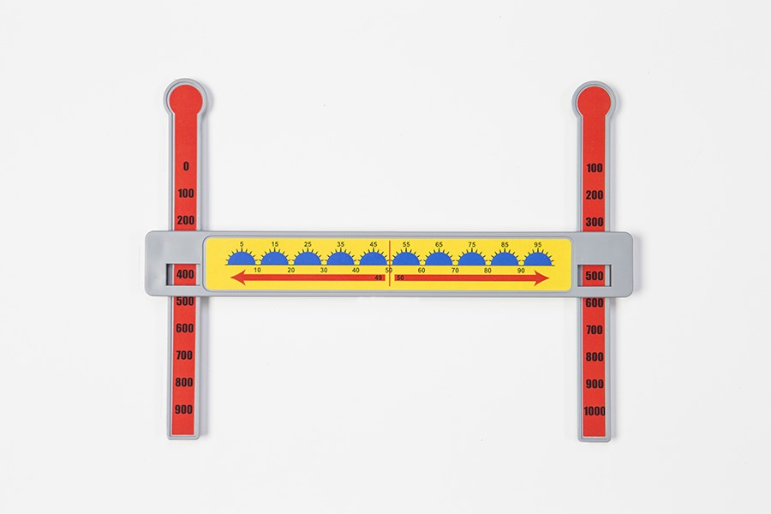

Jim Franklin
Slide-A-Round@comcast.net

www.slidearoundmath.com

706.506.8411

- Number line to 10,000,000
- Add/Subtract fractions with different denominators without paper or pencil
- Available in low vision and braille
- Addresses standards involving money, decimals, weight, and elapsed time
- Practice handouts of math problems available for free download on website
- Created by an elementary special education teacher in collaboration with students, colleagues, administrators, occupational therapists, vision and hearing specialists
- Used in all academic settings (regular education, resource, inclusion, self- contained)

MAJOR CONFERENCE PRESENTATIONS (since November 2012):
2015 Louisiana Assistive Technology Initiative Conference
2015 Institute Designed for Educating ALL Students (IDEAS) Conference
2014 Georgia Assistive Technology in Education (GATE) Conference
2014 Georgia Council for Teachers of Mathematics
2014 Institute Designed for Educating All Students (IDEAS) Conference
2014 Illinois Council for Children with Behavioral Disorders Conference
2013 Alabama Council for Exceptional Children Conference
2013 “Out of Sight” Assistive Technology Conference (in Columbus, OH)
2013 MEGA Conference (in Mobile, AL)
2013 Kentucky Council for Exceptional Children Conference
2012 Alabama Council of Teachers of Mathematics Conference

MAJOR ARTICLES POSTED ON WEBSITE (since October 2012)

National Federation for the Blind Colorado Department of Education
Education World ESVI
Inclusive Schools Network Gallaudet University SW Regional Center
National Center of Deaf- Blindness Autism Speaks!
Teaching Research Institute Fred's Head Blog - American Printinghouse
Canadian Teacher Magazine Center for Instructional Supports and
Canadian Deafblind Association Accessible Materials (CISAM)
CEC Visual Impairment and Deafblind Northeast Regional Center for Vision Education
Education Quarterly

