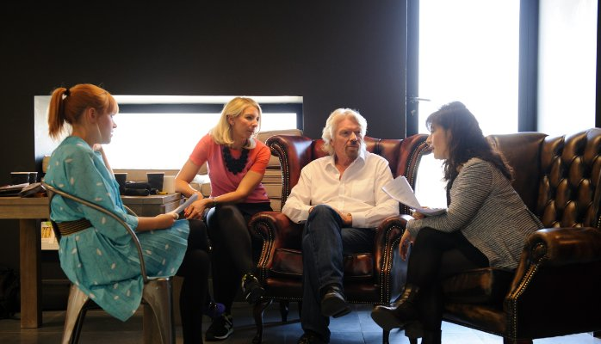
Branson with staff members, courtesy Virgin.com

Richard Branson
Founder at Virgin Group

What Does It Take to Be the Boss? Managers vs. Leaders
Nov 2, 2015
I’m often asked, "What does it take to be the boss?" It’s a hard question to answer, because in my opinion there are two types of bosses: managers and leaders.
When I started out in business, I did so to make a positive difference. I wasn’t determined to organise or direct people, but instead work with them to change the lives of others for the better. I feel that this is the role of a leader.
Management is about maintaining processes, disciplines and systems — something that doesn’t come naturally to yours truly. Where managers keep the rules, leaders have to be willing to break them, or at least find creative ways around them. As I wrote in my book, "The Virgin Way," leaders must have vision, creativity, and the ability to influence others to follow and support them into uncharted and often risky territory.
Both managerial and leadership skills are important in business, but if you want to go into business for yourself as an entrepreneur, it’s crucial that you possess leadership qualities. In entrepreneurship, to be the boss you must be a convincing leader.
One attribute that makes an entrepreneur a convincing leader is passion. When you believe in something, the force of your convictions will spark the interest of others — helping you recruit people that share your vision and are motivated to help you achieve success. And passion is not only just a handy recruitment skill; it will also help you strike up meaningful relationships and partnerships with other entrepreneurs and business people. Many of these, happily, will likely be great managers who can help your business grow.
Another important quality that can turn entrepreneurs into good leaders is collaboration. As I wrote in "The Virgin Way," too many people have a vision of entrepreneurs as people that operate alone — almost like an artist — overcoming challenges and bringing ideas to market through sheer force of their personality. This is the stuff of fiction. Going it alone is a romantic notion; few entrepreneurs ever make it without a lot of help. There’s not much reward that comes from working in solitary. Entrepreneurs must quickly acknowledge what they are good at, and learn to delegate what they are not so good at to great managers. In fact, all leaders should encourage others around them to rise to the challenge and become leaders themselves. That’s the way we like to do things at Virgin
The business world needs both managers and leaders to fill the role of the "boss." While I have never sought to be a manager, I have nothing but respect and appreciation for our managers at Virgin and the wonderful work they do. The brand wouldn’t be successful without them keeping our planes in the skies, running our call centres, organising our offices, and directing our operations.

