**The Missing Middle Class on College Campuses**

* Published on May 8, 2017

[](https://www.linkedin.com/in/jeffselingo)

[**Jeff Selingo**](https://www.linkedin.com/in/jeffselingo)

**New York Times bestselling author, Washington Post columnist, higher education strategist, LinkedIn Top 10 Influencer**

The beginning of May was the deadline for the last of high-school seniors to make their final decision about where they’re going to college next fall. For some it was a sprint to the finish as they weighed the social and academic fit of campuses still on their list, but also the all-important financial aid offers from colleges.

I heard about the agony of the decision-making process from some of them in e-mail messages asking for advice or as I traveled the country in recent weeks to speak at high schools about the admissions process and [how to succeed as an undergraduate](https://www.amazon.com/There-Life-After-College-Navigating/dp/0062388851/ref=sr_1_1?ie=UTF8&qid=1494171889&sr=8-1&keywords=selingo). A few described their financial situation in detail, while others talked about their “middle-class backgrounds,” with jobs as school teachers, firefighters, or supermarket managers. As personal financial columnist [Ron Lieber wrote](https://www.nytimes.com/2017/04/28/your-money/paying-for-college/as-college-deadlines-near-families-wonder-what-they-can-pay.html?ref=business&_r=1) recently about middle-class families—and their angst in paying for college—“nobody sympathizes with them much, and they do not ask for you to do so” given the difficulties that low-income families have in paying for college.

The amount of unmet need for middle-income students is some $10,000 a year, nearly as much as the lowest-income families in the United States.

Indeed, much attention has been given recently to the struggles of [low-income students](https://www.washingtonpost.com/news/answer-sheet/wp/2016/12/23/the-new-american-talent-initiative-on-college-campuses-it-isnt-about-singing-or-dancing/?utm_term=.f1e48c849b78). Research shows that as [family income rises so do the chances of not only going to college](https://www.washingtonpost.com/news/grade-point/wp/2016/09/16/incomes-arent-the-only-thing-not-keeping-pace-with-rising-tuition-neither-are-scholarships/?utm_term=.569d0a40962c) but also completing a degree. But as college prices continue to rise faster than the income levels of many Americans, it begs the question: what happens to those families just on the other side of the low-income cutoff for many financial aid programs?

The proxy often used for the enrollment of low-income students is the percentage of students eligible for the federal Pell Grant. The income ceiling for Pell Grants is not a fixed number, however, as a student’s eligibility depends on household size and other factors. In general, Pell Grants go to families making less than $50,000. The dollar amount of the Pell Grant is also not fixed, as students receive varying amounts up to the annual maximum -- $5,920 for the 2017-18 school year.

The students and families I’ve heard from recently are in the income bands just above the Pell Grant cutoff, between $50,000 and $100,000. According to federal statistics, their amount of unmet need—the difference between what a college costs and what a student can afford to pay—is some $10,000 a year, nearly as much as the lowest-income families in the United States.

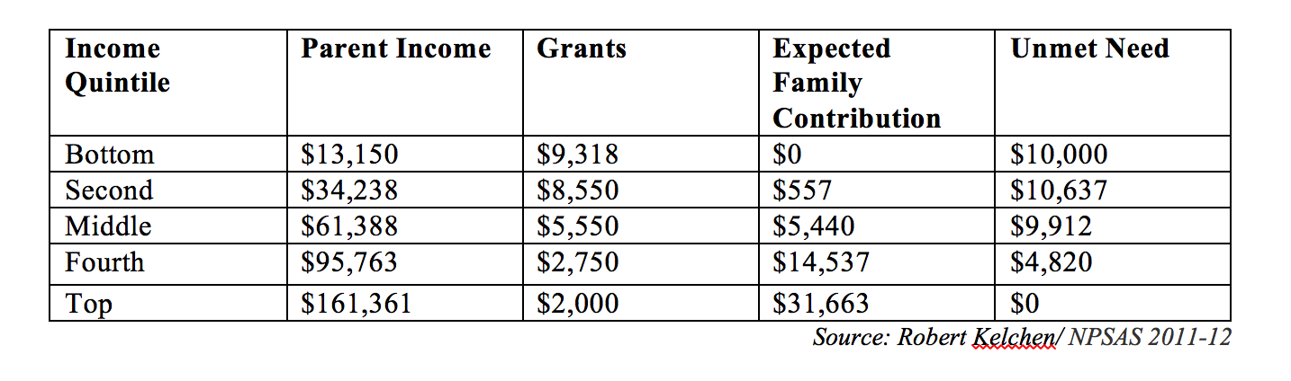

“They are getting squeezed on both ends because they barely miss Pell Grants and they are not the types of students getting grants from colleges themselves,” said Robert Kelchen, an assistant professor of higher education at Seton Hall University and [an expert on student aid](https://kelchenoneducation.wordpress.com/).

This trend has manifested itself on college campuses in the form of a socioeconomic “barbell”—with affluent students who can pay full price or close to it on one end and poor students who receive federal Pell Grants and max out their loan eligibility on the other end. Fewer students are in the middle, especially on the lower end of that middle just above the cutoff for Pell Grants.

For years, merit aid has helped colleges maintain the middle class on their campuses by giving institutions the flexibility to spread aid around to many students in the form of scholarships, while at the same time pulling in some tuition revenue from those students. But as tuition prices have climbed, colleges found they were discounting their tuition too much and their net tuition revenue—the amount of cash actually received from students or their outside aid—was flat or declining. So they moved their merit aid up the income scale in order to capture students, and more revenue, from higher-income families.

“We need to expand opportunity and aid policies for both Pell students and for middle-income students who are not Pell-eligible,” said Daniel R. Porterfield, president of Franklin & Marshall College, and a national leader on improving financial aid for low-income students.

A few years ago, F&M [undertook an ambitious strategy to eliminate merit scholarships](https://www.washingtonpost.com/local/education/colleges-often-give-discounts-to-the-rich-but-heres-one-that-gave-up-on-merit-aid/2014/12/29/a15a0f22-6f3c-11e4-893f-86bd390a3340_story.html?utm_term=.967876b0a93c) to better target its financial aid at needy students. F&M received plenty of national attention for the effort, but press coverage focused mostly on how the college was able to boost the percentage of freshmen on Pell Grants from 17 percent in 2012 to 19 percent in 2016.

For too many colleges, financial aid has become a recruitment and enrollment management tool rather than an affordability mechanism.

What wasn’t mentioned as often was “how we also increased the number of students from middle-income families,” Porterfield told me. The proportion of freshmen at F&M from families earning between $50,000 and $90,000 increased from 9 percent in 2012 to 13 percent in 2016, while the percentage of freshmen from families making more than $150,000 fell 9 percent to about 40 percent of the incoming class.

Many college leaders, however, claim they can’t afford to dedicate the needed dollars to financial aid for *both* low-income and middle-income families. “It’s a false choice to claim they can’t invest in both,” Porterfield said.

The issue is that some colleges don’t want to pay for such investments by taking away aid from higher income students who enroll only because they are enticed with generous packages. For too many colleges, financial aid has become a recruitment and enrollment management tool rather than an affordability mechanism.

The problem with that approach is that pool of students at the lower and middle portions of the income scale are growing, while those at the top are shrinking. Median per capita income in the U.S. has basically flat lined since 2000, when adjusted for inflation. The typical American family makes slightly less than a typical family did 15 years ago. And while many products have become less expensive in that time, the price tag of three of the biggest expenditures made by middle-class families— housing, college tuition, and health care—have risen much faster than the rate of inflation.

If colleges don’t begin to also focus on middle-income families, they will end up with campuses bifurcated by income that don’t reflect the economic diversity of the United States.

*Jeffrey Selingo is author of*[There Is Life After College: What Parents and Students Should Know About Navigating School to Prepare for the Jobs of Tomorrow*.*](http://www.amazon.com/There-Life-After-College-Navigating/dp/006238886X/ref=sr_1_1?s=books&ie=UTF8&qid=1487679003&sr=1-1&keywords=selingo)*You can follow his writing here, on Twitter*[*@jselingo*](http://twitter.com/jselingo)*, on*[*Facebook*](http://www.facebook.com/JeffSelingo)*, and sign up for free newsletters about the future of higher education at*[*jeffselingo.com*](http://jeffselingo.com/)*.*

*He is a regular contributor to the*[*Washington Post’s Grade Point blog*](http://chronicle.com/section/Home/5)*, a professor of practice at*[*Arizona State University*](http://georgetown.asu.edu/)*, and a visiting scholar at*[*Georgia Tech's Center for 21st Century Universities*](http://c21u.gatech.edu/)*.* *Cross-posted from The Washington Post*