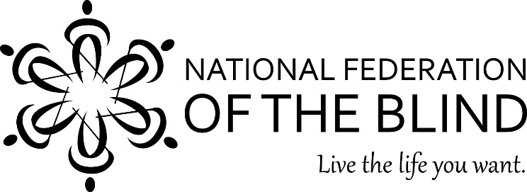

National Federation of the Blind Jernigan Institute
DARE TO BE REMARKABLE:
Ten Years of Progress!

A three-day national training conference for education and rehabilitation professionals who work with blind students and adults.

Location

National Federation of the Blind Jernigan Institute
200 East Wells Street at Jernigan Place
Baltimore, Maryland 21230

Date

Monday, November 6 through Wednesday, November 8, 2017

Online Registration is now open!
Visit this URL:
Register Here

Registration includes all conference materials in alternative formats, lunches, periodic snack breaks, transportation to and from the hotel, and special hospitality/training events.
- Pre-registration prior to October 13, 2017 is $400 per person.
- Registration after October 13, 2017 will be $500 per person.

Lodging
A block of rooms has been reserved for conference participants at the Royal Sonesta Harbor Court Baltimore, located at 550 Light Street, Baltimore, MD, 21202, at a room rate of $169, plus tax, per night. This rate will be available to those that make their reservation before August 29, 2017. Participants should make reservations directly with the hotel by calling 410-347-9702 and referencing conference code 1105NFBDBR. A shuttle to and from the NFB Jernigan Institute will be provided for conference participants staying at the Royal Sonesta Harbor Court.

Call for Presenters now open!

For information on how to submit your idea for one of the conference breakout sessions visit the call for presenters section on the registration page or contact Edward Bell for more information at ebell@latech.edu.

***Continuing Education Credits will be available for conference Participants ***

Questions about the conference can be directed to:

Edward C. Bell, Ph.D., CRC, NOMC
Director, Professional Development and Research
Institute on Blindness Louisiana Tech University
Phone: (318) 257-4554
Email: ebell@latech.edu

The National Federation of the Blind knows that blindness is not the characteristic that defines you or your future. Every day we raise the expectations of blind people, because low expectations create obstacles between blind people and our dreams. You can live the life you want; blindness is not what holds you back.

2017 Dare To Be Remarkable Conference Sponsors:
National Association of Blind Rehabilitation Professionals
National Association of Professionals in Blindness Education
National Blindness Professional Certification Board
Professional Development and Research Institute on Blindness
Louisiana Tech University

