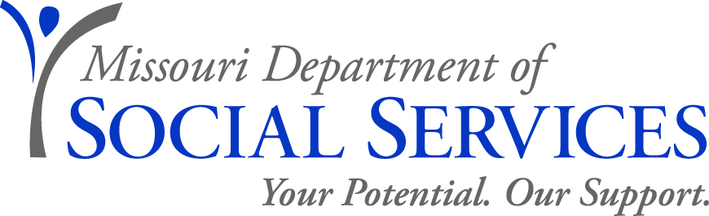

JOB ANNOUNCEMENT

CHILDREN’S SPECIALIST FOR THE BLIND
Family Support Division, Rehabilitation Services for the Blind
St. Louis City
September 12, 2019

The Family Support Division, Rehabilitation Services for the Blind, is seeking candidates for a full-time position as Children’s Specialist for the Blind. This position is based in St. Louis City located at 3867 Magnolia Avenue, St. Louis, MO 63110.

DO you have experience in working with the blind or visually impaired? If so, there’s a great opportunity for you with the State of Missouri! The Department of Social Services (DSS) is committed to building the capacity of individuals, families, and communities to secure and sustain healthy, safe, and productive lives. In support of this mission, DSS is looking for a Children’s Specialist for the Blind to work in Rehabilitation Services for the Blind within the Family Support Division. You’ll primarily be responsible for providing training, counseling, advocacy, and rehabilitation services to children with blindness or low vision, their parents/guardians, and related professionals.
JOB DUTIES:
- Provides casework and/or counseling services as deemed necessary and appropriate to assist the family and/or guardian in coping realistically with the child's visual loss to maximize the child's potential and minimize the effects of blindness.
- Provides parent education concerning infant care and stimulation and self-help skills for children with blindness or visual impairment.
- Provides referral and resource information to schools, families and/or guardian(s) to assist them in obtaining needed services.
- Serves as an advocate, when appropriate, to assist parents in obtaining needed services for the children with blindness or visual impairment.
- Administers and interprets assessment and interest inventories as needed.
- Maintains case records and makes reports as required.
- Provide pre-employment transition services to ensure successful transition and maximize independence.
- Performs other related work as assigned.
QUALIFICATIONS:

One year of professional experience in working with persons with blindness and/or visual impairment or in child development, special education, elementary education, pre-school education, child psychology, child welfare or closely related areas; and graduation from an accredited four-year college or university with specialization in special education for blind and/or visually impaired persons, child development, psychology, social work, sociology, special education, elementary education or closely related areas.

(Graduate work in the specified educational areas may be substituted on a year-for year-basis for the stated experience.)

SALARY RANGE: $1,463.17 - $1,514.17 semi-monthly
*Current FSD employees may receive a salary increase.

TO APPLY: Individuals who meet the required qualifications as specified above and are interested in this position must fill out and send the DSS employment application (https://dss.mo.gov/hrc/pdf/mo886-1315.pdf), resume and any applicable transcripts by fax or email to Lisa Stephen at (573) 526-3674 or Lisa.Stephen@dss.mo.gov. When emailing your application to Ms. Stephen, please specify which position and county you are applying for.

Questions regarding this position may be directed to Dr. Ian Shadrick at (573)751-4959.

**Per provisions of the Americans with Disabilities Act, if you need assistance or special accommodations to participate in an interview, inform our office at the time you are called if selected for an interview.

RECRUITMENT AREA: Accepting applications from all qualified applicants.

APPLICATION DEADLINE: September 26, 2019 by 5:00 p.m.

The Department of Social Services’ mission: We will lead the nation in building the capacity of individuals, families, and communities to secure and sustain healthy, safe, and productive lives.

Applications will be subject to review prior to scheduling interviews.

DSS IS AN EQUAL OPPORTUNITY EMPLOYER

