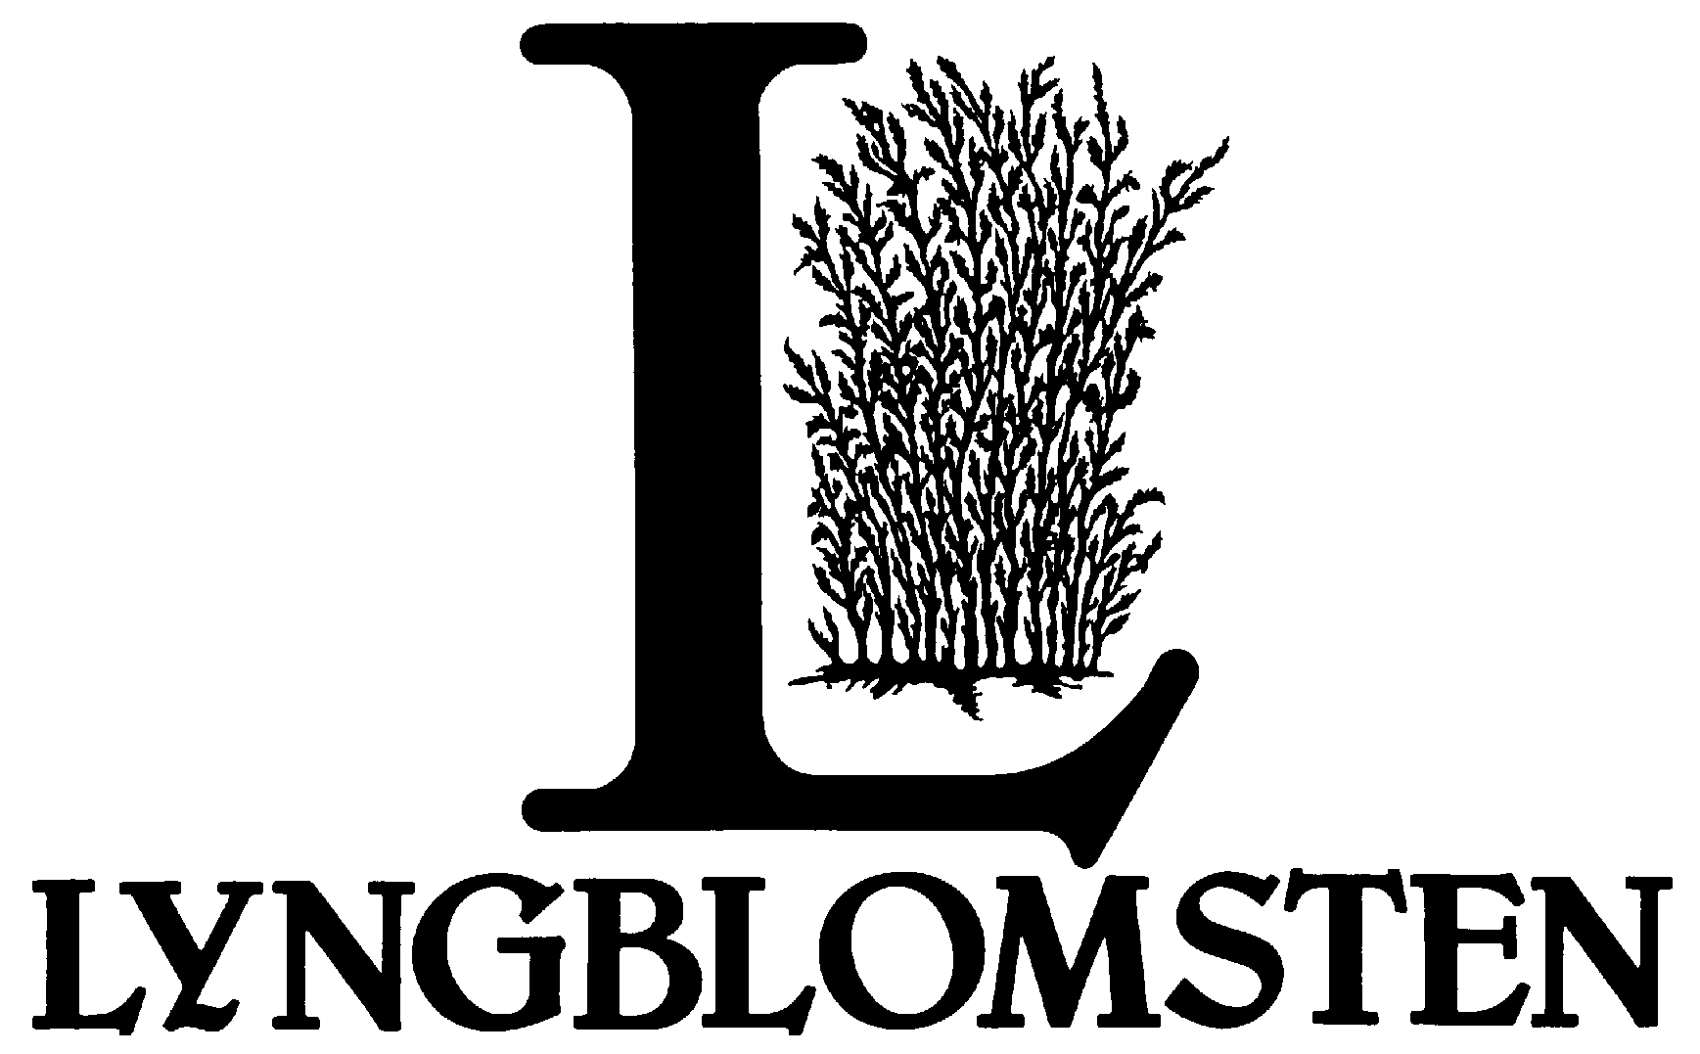
Volunteer Services Department
JOB DESCRIPTION

TITLE: Volunteer Coordinator

TYPE: Part-time (32 hours per week), nonexempt

SUPERVISED BY: Director of Volunteer Services

PRIMARY FUNCTION:
Support Volunteer Services in the recruitment, onboarding and support of individual and group volunteers.

MAJOR RESPONSIBILITIES:

1. Provide stewardship of volunteer pool

- Send appropriate greeting cards to volunteers experiencing a life change
- Review and follow up, on a quarterly basis, with volunteers who have no service hours during previous three months
- Conduct formal check-in with volunteers at 1 month, 3 months, and annually, as needed
- Update Volgistics with changes in volunteer status, making appropriate notes
- Update nametags as volunteers make hourly milestones

2. Serve as the lead recruiter for new volunteers

- Post on recruitment web sites, always looking for new posting opportunities.
- Seek out recruitment fairs to attend.
- Coordinate staff and volunteers to represent at recruitment fairs.
- Participate in recruitment Q &A sessions that happen off and on campus.
- Always be watching the volunteer trends to see what volunteers find appealing and respond to.
- Encourage interested prospects to complete an on-line application.

3. Coordinate volunteer groups

- Includes Corporate, School, Youth, Retirees.
- Ensure contact information in Volgistics is up to date.
- Ensure hours get tracked in Volgistics.
- Conduct ongoing follow-up, thanks and evaluation.

4. Handle administrative tasks contributing to department efficiencies:

- Update running lists of daily resident/volunteer interaction (e.g., visits, reading, etc.)
- Process all DOT physicals for volunteer drivers
- Maintain the Volunteer Lounge
  - Refill snacks and beverages
  - Keep nametag rack organized
  - Update posters and fliers as needed

5. Participate in the planning and implementation of major events utilizing many volunteers or focusing on volunteer involvement:
- Supporters Appreciation Event
- Mid-Summer Festival
- Spring Gala
- Etc.

6. Willingness to uphold the mission, principles, and pillars of the Lyngblomsten brand.

QUALIFICATIONS:
- BA or equivalent experience
- Experience working with volunteers
- Desire to enhance the well-being of older adults
- Able to organize and prioritize multiple tasks
- Effective communication and listening skills
- Demonstrates a professional, welcoming and hospitable demeanor as an ambassador of Lyngblomsten
- Self-motivated, independent worker with ability to function as part of a team
- Knowledge of computer programs such as Microsoft Office Word, Excel, Publisher and database systems (preferably Volgistics)

SAFETY AND PHYSICAL DEMANDS:

Lyngblomsten strives to create and maintain safe conditions for employees, residents/tenants, volunteers, and visitors. All employees are to be aware of total facility and department safety and emergency procedures, as well as be responsible for anticipating and eliminating potentially hazardous conditions and situations.

These physical demands may be modified if a reasonable accommodation can be found that does not create an undue hardship to Lyngblomsten.

- In an 8-hour work day, the Volunteer Coordinator must be able to:
1. sit 6 to 8 hours 2. walk/stand 0 to 2 hours

B. The employee's job requires occasional (1% to 33% of 8-hour day):
1. squatting 2. bending and stooping 3. crouching
4. reaching above shoulder level 5. kneeling 6. pushing and pulling

C. The employee's job requires lifting/carrying:
1. up to 10 lbs. frequently 2. 11 - 25 lbs. occasionally

D. The employee's job requires use of the right and left hands for repetitive actions such as:
1. simple grasping 2. firm grasping 3. fine manipulation 4. keyboarding

ACCEPTANCE:

I have read the preceding Job Description and safety/physical demands. I fully understand the contents and shall perform these duties to the best of my ability.

_______________________________________ _______________________________________
PRINTED NAME of EMPLOYEE PRINTED NAME of SUPERVISOR

_______________________________________ _______________________________________
SIGNATURE of EMPLOYEE SIGNATURE of SUPERVISOR

DATE____________________________ DATE_____________________________

Revised September 2019

