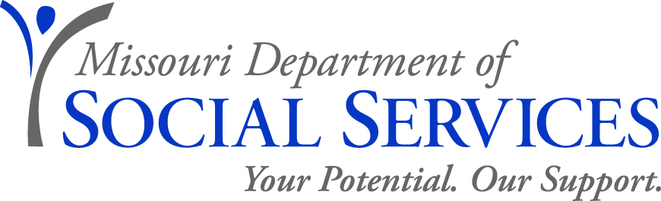

JOB ANNOUNCEMENT

Social Services Manager
Family Support Division, Jackson County
November 20, 2019

The Family Support Division is seeking applications for the position of Social Services Manager, for the District 1 Office of the Rehabilitation Services for the Blind (RSB) program located at 615 E 13th St., Kansas City MO 64106.

JOB DUTIES:
- The District Supervisor (DS) is responsible for the direction of assigned district staff in implementing vocational rehabilitation, independent living, and older blind services programs to fulfill our mission to create opportunities for eligible blind and visually impaired persons in order that they may attain personal independence and vocational success.
- Select, train, direct, and evaluate staff to ensure there is a clear understanding of blindness, blindness issues and the philosophy of independence for clients.
- Supervises and monitors operations of the district office; and directs or assists in the overall planning, development and administration of vocational and independent living services for the blind and visually impaired.
- Ensures clients receive services according to identified needs consistent with their interests, abilities and capabilities, and informed choice.
- Reviews and/or revises programs to ensure compliance and implements service provision in accordance with statutory and regulatory requirements.
- Participates in the development, implementation or interpretation of new or revised programs, departmental or legislative initiatives and will represent Rehabilitation Services for the Blind in conferences and meetings.
- Participates in the development of budget requests, monitors expenditures, and recommends or directs implementation of cost saving measures.
- Conducts investigations, special studies, and prepares or reviews reports and related information to evaluate existing organizations, policies, procedures, and practices.
- Serves as a liaison by maintaining contact with stakeholders including staff, clients, and federal, state, local and community organizations.
- Must exercise considerable initiative and judgment in planning and implementation of assignments or projects.

QUALIFICATIONS: A Bachelor’s degree from an accredited college or university with a minimum of 15 earned credit hours in the following: Criminal Justice, Education, Psychology, Sociology, Social Work, Family and Child Development, Human Services, Counseling, Public or Business or Health Care Administration, Nursing, Physical Rehabilitation, Occupational Therapy, Dietetics, Nutrition or a closely related field; and

Four or more years of professional experience in protective services for children; self-sufficiency/income maintenance; child support; in-home services; programs for blind or visually impaired persons; Medicaid or other health insurance programs; nursing; health care or health delivery system; pharmacy or pharmacology; treatment and education of adjudicated juveniles; juvenile delinquency prevention programs; or resource, financial or legal investigations.

(Additional qualifying experience may substitute on a year-for-year basis for deficiencies in the required education.)

(Earned graduate credit hours from an accredited college or university in the specified areas may substitute on a year-for-year basis for a maximum of two years of the required experience at a rate of 24 earned credit hours for one year.)

SALARY: $2,075.67 semi-monthly.

TO APPLY: Individuals who meet the required qualifications as specified above and are interested in this position must fill out the DSS application (https://dss.mo.gov/hrc/pdf/mo886-1315.pdf), resume and any applicable transcripts by fax or email to Jeremy Wilkerson at (573) 526-3674 or Jeremy.Wilkerson@dss.mo.gov. When emailing your application to Mr. Wilkerson, please specify which position and county you are applying for.

Per provisions of the Americans with Disabilities Act, if you need assistance or special accommodations to participate in an interview, inform our office at the time you are called if selected for an interview.

Questions regarding this position can be directed to Michael St. Julien at (573) 751-4989.

RECRUITMENT AREA: Accepting applications from all qualified applicants.

APPLICATION DEADLINE: December 06, 2019 by 5:00 p.m.

*** Experience Working with Blind or Visually Impaired Persons is preferred but not required***

Applications will be subject to review prior to scheduling interviews.

The Department of Social Services’ mission: We will lead the nation in building the capacity of individuals, families, and communities to secure and sustain healthy, safe, and productive lives.

DSS IS AN EQUAL OPPORTUNITY EMPLOYER

