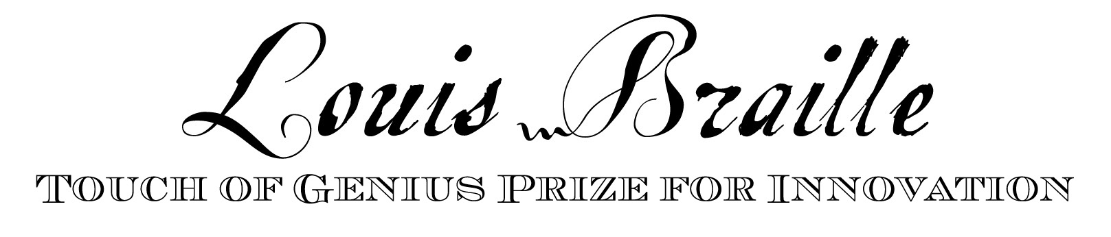

APPLICATION CHECKLIST

Please read the Submission Requirements Document prior to submitting an application.

- APPLICATION - signed and submitted by January 13, 2023

- Electronic application emailed to:
bmacdonald@nbp.org

- Prototype mailed to:
Touch of Genius Prize for Innovation
National Braille Press
88 Saint Stephen Street
Boston, MA 02115

- BRIEF SUMMARY (600 words or less)

- OUTCOME REALIZATION DOCUMENT (10 pages or less)

- RECOMMENDATIONS – mailed by author to NBP
- Letter 1 __________________________
- Letter 2 __________________________

- PROTOTYPE or SUPPORTING MATERIALS (optional)
- Applications that include a prototype will have stronger consideration. We strongly suggest submitting a prototype or video presentation along with your application. If selected as a finalist one will be requested. All materials submitted must be in an accessible format (see Submission Requirements document.) Include usage and return instructions with your prototype if applicable.
The Adjudication Committee will not review any applications that are not accessible and do not contain all of the above materials. All materials must be received at National Braille Press by January 13, 2023.

Applicant’s Name ________________________________________________________

Project Title ____________________________________________________________

Affiliation (if any) ________________________________________________________

Street Address___________________________________________________________

City ______________ State ______________ Country ______________ Zip ________

Telephone _____________________ Email ___________________________________

How did you hear about the Prize? _________________________________________

Please briefly describe the nature of your project (Please limit to 100 words or less):

________________________________________________________________________

________________________________________________________________________

________________________________________________________________________

Please check one of the following:
___ I am applying for this award as an individual. One signature required.
___ I am applying for a group of individuals. One signature required.
___ I am nominating an individual or group. Two signatures required.

If selected as a finalist:
____I am willing to present my project to the Adjudication Committee via video conference in late February 2021 (date TBD).

If selected as a winner/honoree:
___ I am willing to present my material at an event sponsored by National Braille Press in March of 2021.
___ I give National Braille Press permission to reproduce my application for
Promotional purposes and/or use on their website.
___ I am willing to serve on next year’s Adjudication Committee, if asked.
___ I will provide my social security number in order for National Braille Press to issue a Form 1099.
___ I agree to consider a partnership with National Braille Press in promotion of my product/project.

Winners should be aware of the potential ramifications of disclosing new ideas to the general public. National Braille Press assures the confidentiality of submissions reviewed by the Adjudication Committee.

Signature of applicant ____________________________________ Date ___________

Signature of nominee _____________________________________ Date ___________

Recommendation Information

Recommendations should come in the form of a signed letter to the Adjudication Committee. Letters must be in English and should include the following information:

- Applicant’s Name and Project Title
- Recommender’s Name
- Recommender’s Title/Affiliation
- Street Address, City, Country, Zip
- Telephone
- Email

The letter should include specifics about the related accomplishments of the applicant/nominee and comments on the impact that his/her project or innovation may have on tactile literacy for blind people. This letter should NOT solely be an endorsement of the applicant as a person; it MUST reference the specific project.

Letters should be accessible if possible (PDF preferred) and sent BY AUTHOR to bmacdonald@nbp.org.

All materials must be received at National Braille Press by
January 13, 2023.

Questions? Please call 617-266-6160 X412

