**Persons with Disabilities @ State Foreign Service Careers**

**Social Media Posts**

**FACEBOOK**:

The @StateDept is dedicated to creating an inclusive and accessible Department and ensuring our workforce reflects the diversity of the nation. Three employees with disabilities will discuss their experiences joining the Foreign Service and working for the State Department on June 21 @ 4pm ET. The event will include live captioning and American Sign Language interpreting. Register at [https://tinyurl.com/yft6smjv](https://gcc02.safelinks.protection.outlook.com/?url=https%3A%2F%2Ftinyurl.com%2Fyft6smjv&data=05%7C01%7CHowlandH%40state.gov%7C83468095ee2644437edd08db4a8d1fb2%7C66cf50745afe48d1a691a12b2121f44b%7C0%7C0%7C638185742194218240%7CUnknown%7CTWFpbGZsb3d8eyJWIjoiMC4wLjAwMDAiLCJQIjoiV2luMzIiLCJBTiI6Ik1haWwiLCJXVCI6Mn0%3D%7C3000%7C%7C%7C&sdata=jBZd07iRnGBPEqOucp3LjSi2s7YZaTAzxsTJpiYsSrU%3D&reserved=0)

“As Acting Consul General, I led the team that negotiated the release of a family of American citizens from military detention.” - Alex Barrasso, Senior Advisor for DEIA in the Bureau of International Narcotics and Law Enforcement Affairs at the U.S. Department of State. Alex and other Department employees with disabilities will discuss their path into the Foreign Service on June 21 @ 4pm ET. The event will be live captioned and include American Sign Language interpreting. Register at [https://tinyurl.com/yft6smjv](https://gcc02.safelinks.protection.outlook.com/?url=https%3A%2F%2Ftinyurl.com%2Fyft6smjv&data=05%7C01%7CHowlandH%40state.gov%7C83468095ee2644437edd08db4a8d1fb2%7C66cf50745afe48d1a691a12b2121f44b%7C0%7C0%7C638185742194218240%7CUnknown%7CTWFpbGZsb3d8eyJWIjoiMC4wLjAwMDAiLCJQIjoiV2luMzIiLCJBTiI6Ik1haWwiLCJXVCI6Mn0%3D%7C3000%7C%7C%7C&sdata=jBZd07iRnGBPEqOucp3LjSi2s7YZaTAzxsTJpiYsSrU%3D&reserved=0)

“One State Department experience that was incredibly memorable was when I was a control officer for the U.S. men’s soccer team in Honduras for a World Cup qualifying match. I traveled a week before to conduct security meetings with police and FIFA officials and was responsible for more than 50 embassy staff attending the game.” - Pablo Paganini, Office Management Specialist. Pablo and other Department employees with disabilities will discuss their experiences in the Foreign Service on June 21 @ 4pm ET. The event will be live captioned and include American Sign Language interpreting. Register at [https://tinyurl.com/yft6smjv](https://gcc02.safelinks.protection.outlook.com/?url=https%3A%2F%2Ftinyurl.com%2Fyft6smjv&data=05%7C01%7CHowlandH%40state.gov%7C83468095ee2644437edd08db4a8d1fb2%7C66cf50745afe48d1a691a12b2121f44b%7C0%7C0%7C638185742194218240%7CUnknown%7CTWFpbGZsb3d8eyJWIjoiMC4wLjAwMDAiLCJQIjoiV2luMzIiLCJBTiI6Ik1haWwiLCJXVCI6Mn0%3D%7C3000%7C%7C%7C&sdata=jBZd07iRnGBPEqOucp3LjSi2s7YZaTAzxsTJpiYsSrU%3D&reserved=0)

The @StateDept recognizes the countless contributions of employees with disabilities. Are you interested in joining the Foreign Service as a person with a disability? Join us on June 21 @ 4pm ET. Three employees with disabilities will discuss their experiences joining the Foreign Service and working for the State Department. The event will include live captioning and American Sign Language interpreting. Register at [https://tinyurl.com/yft6smjv](https://gcc02.safelinks.protection.outlook.com/?url=https%3A%2F%2Ftinyurl.com%2Fyft6smjv&data=05%7C01%7CHowlandH%40state.gov%7C83468095ee2644437edd08db4a8d1fb2%7C66cf50745afe48d1a691a12b2121f44b%7C0%7C0%7C638185742194218240%7CUnknown%7CTWFpbGZsb3d8eyJWIjoiMC4wLjAwMDAiLCJQIjoiV2luMzIiLCJBTiI6Ik1haWwiLCJXVCI6Mn0%3D%7C3000%7C%7C%7C&sdata=jBZd07iRnGBPEqOucp3LjSi2s7YZaTAzxsTJpiYsSrU%3D&reserved=0)

**TWITTER**:

The @StateDept is powered by inclusion. Learn more about joining the Foreign Service as a person with a disability, June 21 @ 4pm ET. Register at [https://tinyurl.com/yft6smjv](https://gcc02.safelinks.protection.outlook.com/?url=https%3A%2F%2Ftinyurl.com%2Fyft6smjv&data=05%7C01%7CHowlandH%40state.gov%7C83468095ee2644437edd08db4a8d1fb2%7C66cf50745afe48d1a691a12b2121f44b%7C0%7C0%7C638185742194218240%7CUnknown%7CTWFpbGZsb3d8eyJWIjoiMC4wLjAwMDAiLCJQIjoiV2luMzIiLCJBTiI6Ik1haWwiLCJXVCI6Mn0%3D%7C3000%7C%7C%7C&sdata=jBZd07iRnGBPEqOucp3LjSi2s7YZaTAzxsTJpiYsSrU%3D&reserved=0)

The @StateDept recognizes the countless contributions of our Foreign Service colleagues with disabilities. Interested in joining our team? Tune in June 21 @ 4pm ET. Register at [https://tinyurl.com/yft6smjv](https://gcc02.safelinks.protection.outlook.com/?url=https%3A%2F%2Ftinyurl.com%2Fyft6smjv&data=05%7C01%7CHowlandH%40state.gov%7C83468095ee2644437edd08db4a8d1fb2%7C66cf50745afe48d1a691a12b2121f44b%7C0%7C0%7C638185742194218240%7CUnknown%7CTWFpbGZsb3d8eyJWIjoiMC4wLjAwMDAiLCJQIjoiV2luMzIiLCJBTiI6Ik1haWwiLCJXVCI6Mn0%3D%7C3000%7C%7C%7C&sdata=jBZd07iRnGBPEqOucp3LjSi2s7YZaTAzxsTJpiYsSrU%3D&reserved=0)

Join a team that prioritizes accessibility and inclusion. Join the @StateDept. Learn more about working in the Foreign Service as a person with a disability June 21 @ 4pm ET. Register at [https://tinyurl.com/yft6smjv](https://gcc02.safelinks.protection.outlook.com/?url=https%3A%2F%2Ftinyurl.com%2Fyft6smjv&data=05%7C01%7CHowlandH%40state.gov%7C83468095ee2644437edd08db4a8d1fb2%7C66cf50745afe48d1a691a12b2121f44b%7C0%7C0%7C638185742194218240%7CUnknown%7CTWFpbGZsb3d8eyJWIjoiMC4wLjAwMDAiLCJQIjoiV2luMzIiLCJBTiI6Ik1haWwiLCJXVCI6Mn0%3D%7C3000%7C%7C%7C&sdata=jBZd07iRnGBPEqOucp3LjSi2s7YZaTAzxsTJpiYsSrU%3D&reserved=0)

Interested in joining the Foreign Service as a person with a disability? Join us June 21 @ 4pm ET. Three employees with disabilities will discuss their experiences in the Foreign Service. Register at [https://tinyurl.com/yft6smjv](https://gcc02.safelinks.protection.outlook.com/?url=https%3A%2F%2Ftinyurl.com%2Fyft6smjv&data=05%7C01%7CHowlandH%40state.gov%7C83468095ee2644437edd08db4a8d1fb2%7C66cf50745afe48d1a691a12b2121f44b%7C0%7C0%7C638185742194218240%7CUnknown%7CTWFpbGZsb3d8eyJWIjoiMC4wLjAwMDAiLCJQIjoiV2luMzIiLCJBTiI6Ik1haWwiLCJXVCI6Mn0%3D%7C3000%7C%7C%7C&sdata=jBZd07iRnGBPEqOucp3LjSi2s7YZaTAzxsTJpiYsSrU%3D&reserved=0)

GRAPHICS:

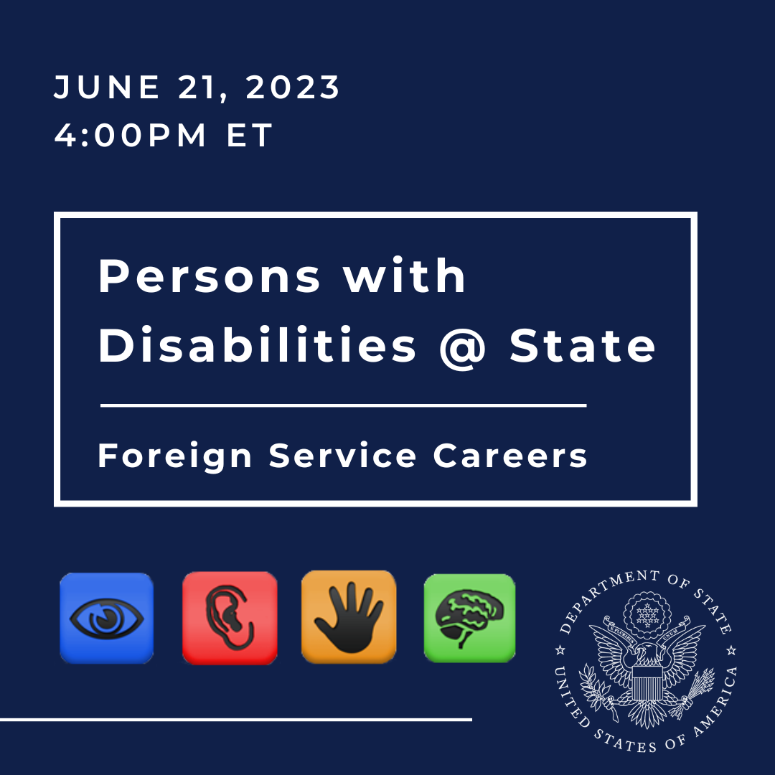

Alt text: June 21 @ 4pm ET, Persons with Disabilities@State – Foreign Service Careers, accessibility logos, State Department seal

JMT cleared [05/31/2023]