
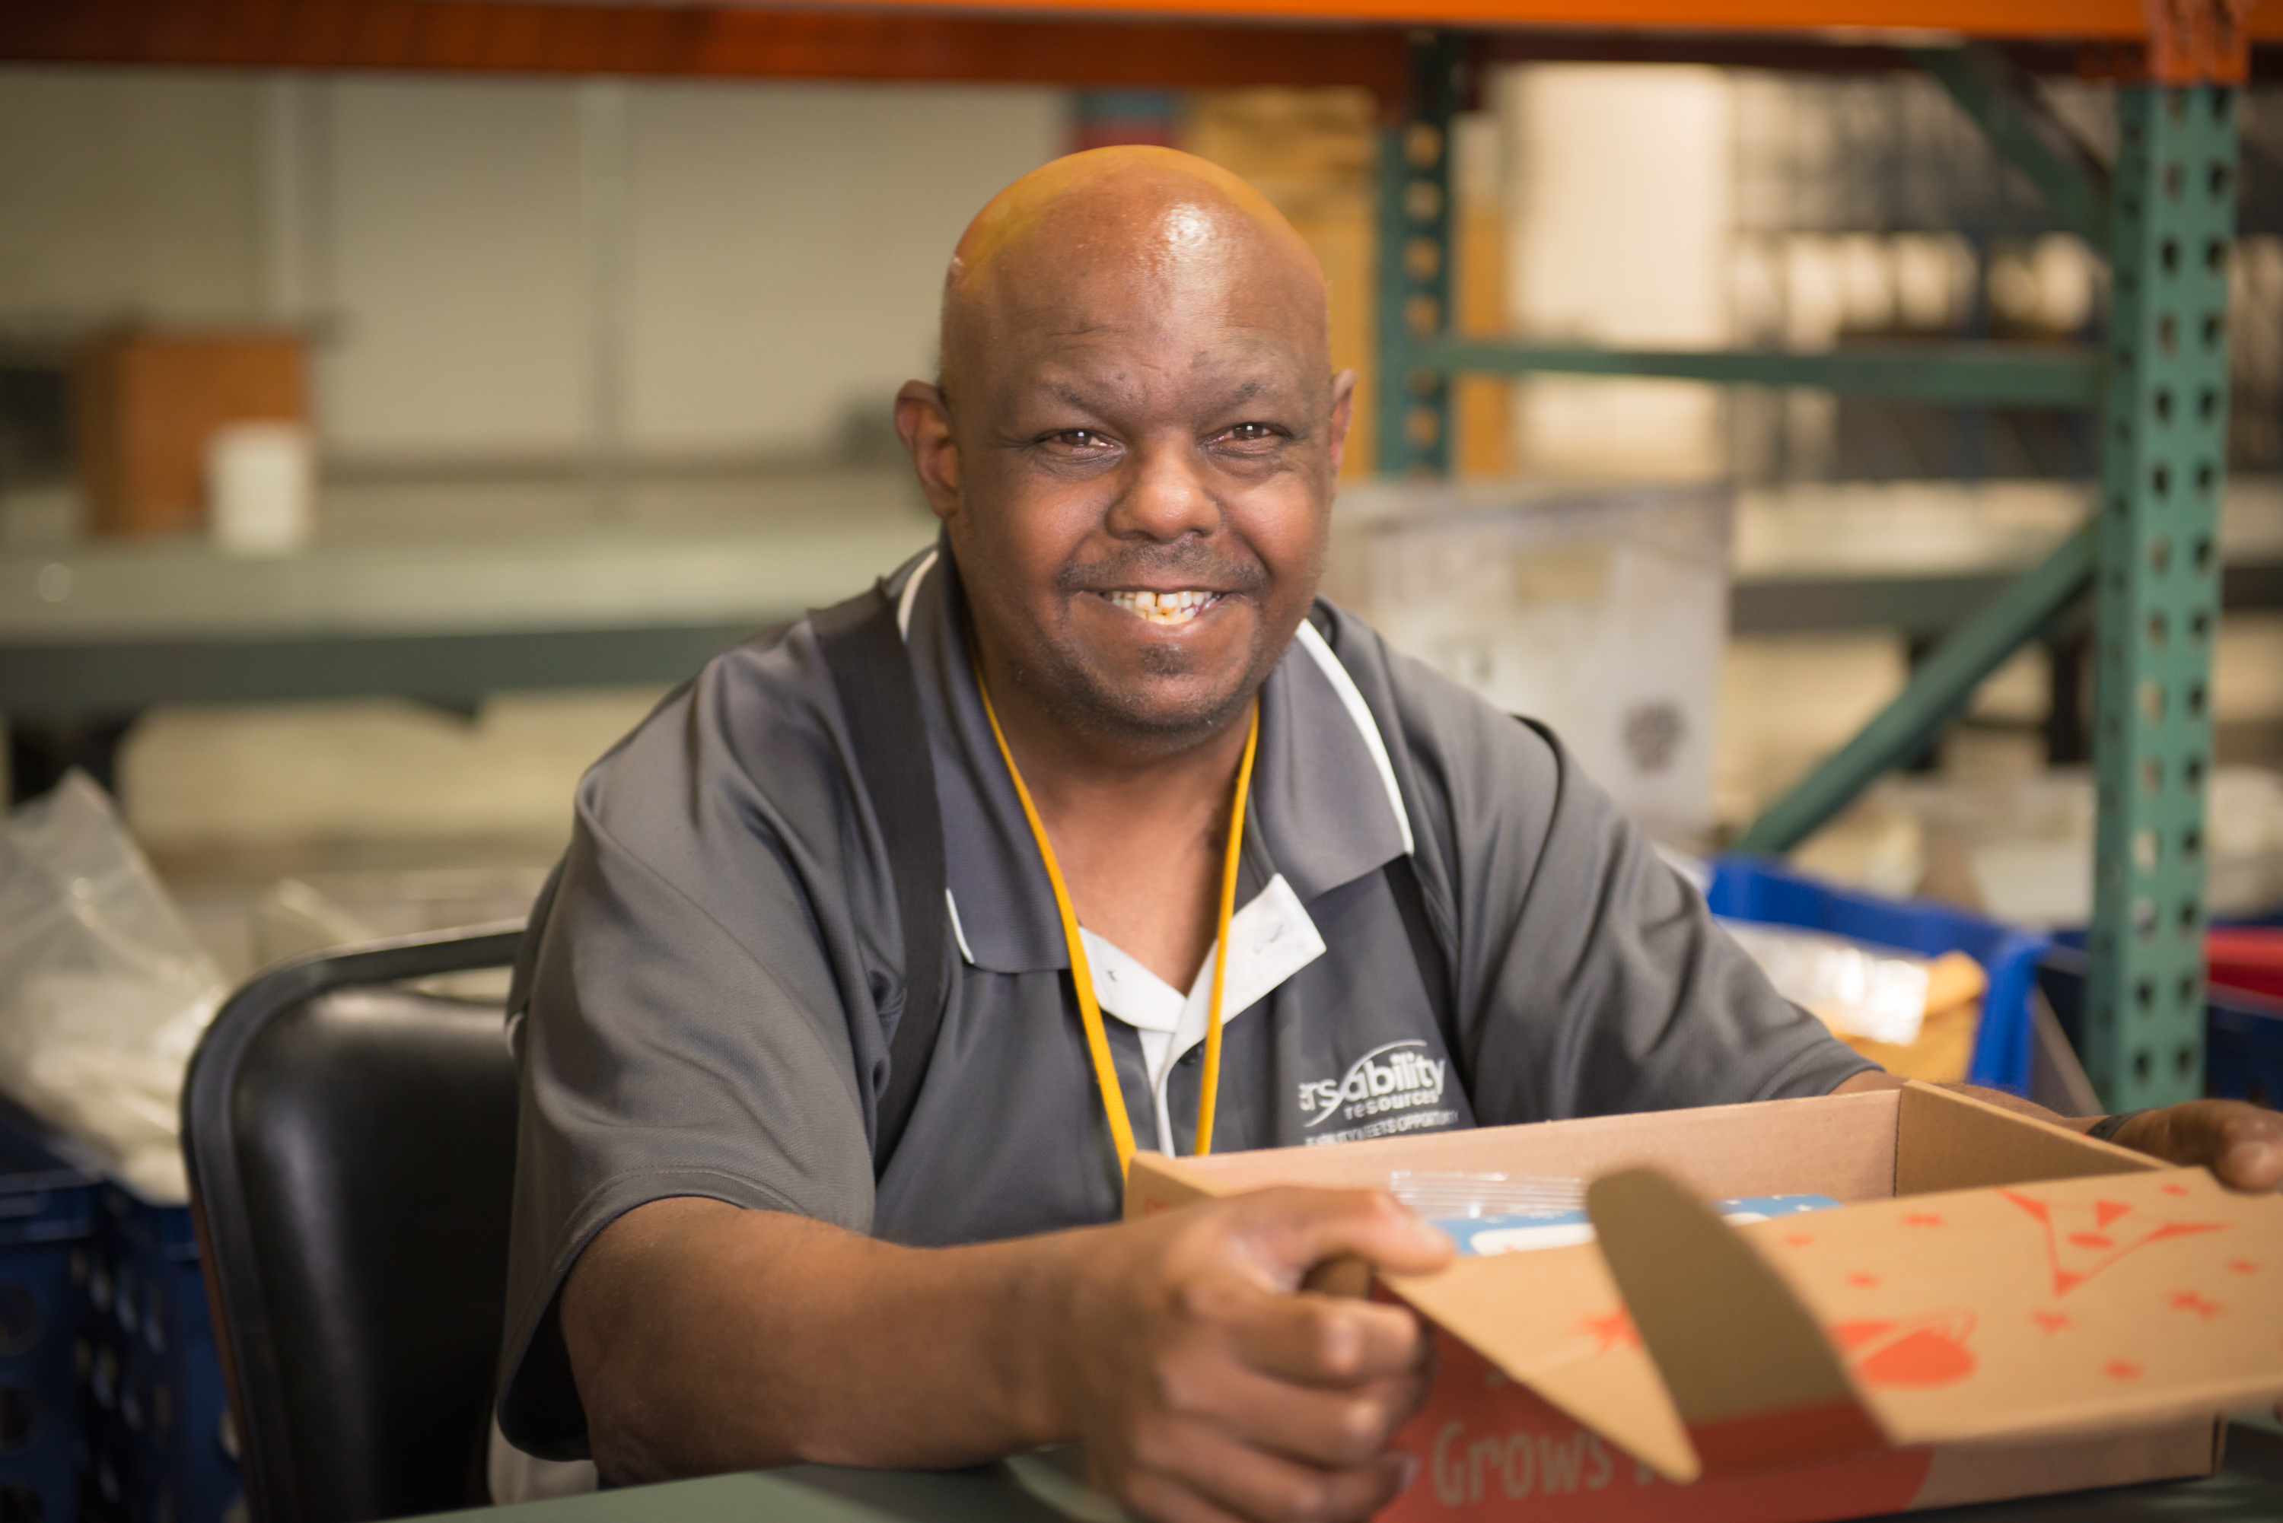
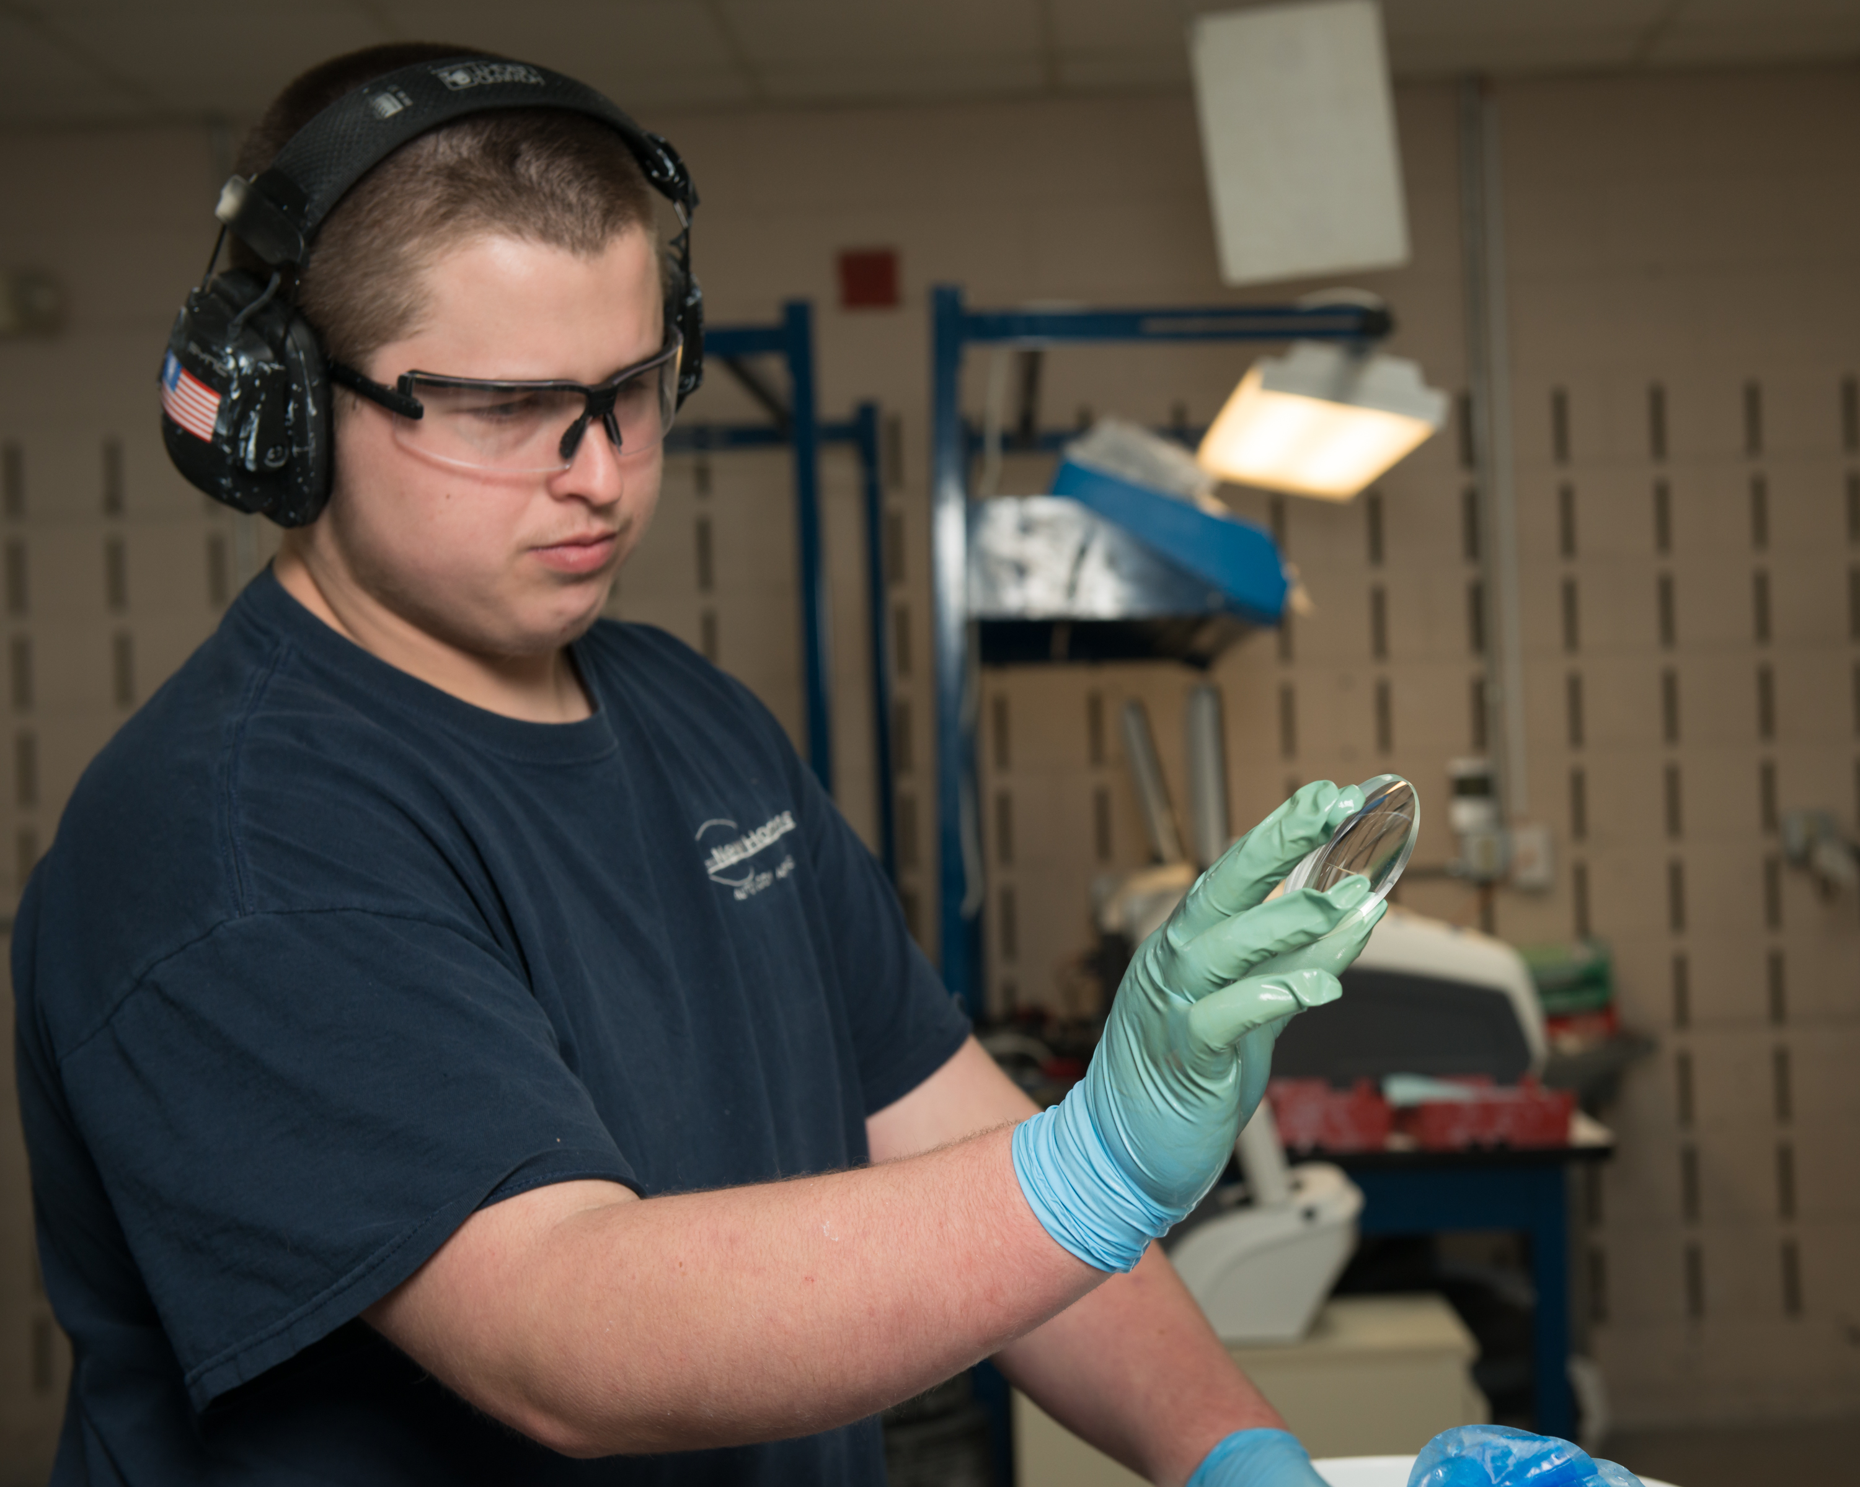
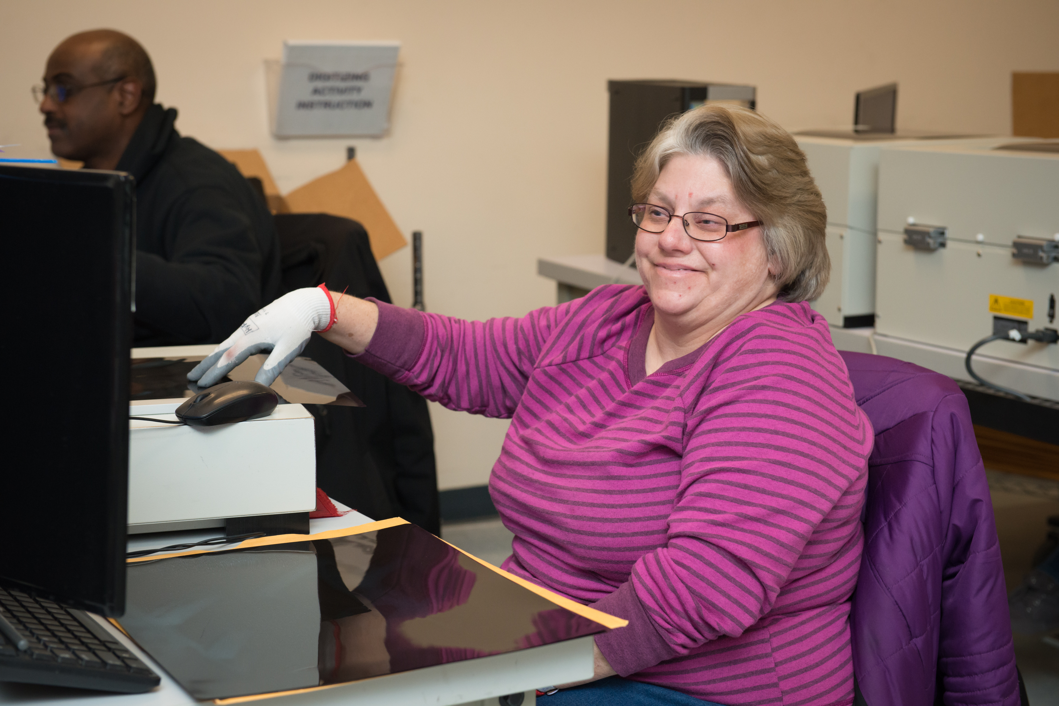

Interested in applying?

- All jobs are posted on www.versability.org.
- Click the orange “Join our Team” button at the top of the homepage to apply.
- Or Click this link: VersAbility Resources Inc. Career Opportunities (prismhr-hire.com)
- Questions : phardy@versability.org or wehire@versability.org
- Laborer Norfolk Ship Provisioning Logistics Food Provisions
- Laborer
- NORFOLK, VA
- $24.08 Hourly
- General Clerk II Norfolk Administrative Norfolk VA
- Administrative
- NORFOLK, VA
- $17.20 Hourly
- FULL TIME EVENING Direct Support Professional- Community Living
- Direct Support
- NEWPORT NEWS, VA
- $17.06 Hourly
- Food Service Worker Yorktown Naval Weapons Station
- Food Service
- YORKTOWN, VA
- $17.20 Hour
- Janitor Custodial Part Time Evenings Yorktown Naval Weapons Station
- Custodial
- YORKTOWN, VA
- $17.20 Hourly
- HR Leave of Absence and Compliance Specialist
- Staff
- HAMPTON, VA
- $58,000 ‒ $72,500 Annually
- Employment Specialist
- Supported Employment
- HAMPTON, VA
- $23.40 ‒ $25.10 Hourly
- Lead Food Service Worker - Yorktown Naval Weapons Station
- Food Service
- YORKTOWN, VA
- $18.45 Hourly
- Custodian Medical Clinic -Yorktown
- Custodial
- YORKTOWN, VA
- $17.20 Hourly
- Working Supervisor - Yorktown Custodial- Yorktown, Va
- Custodial
- YORKTOWN, VA
- $19.70 Hourly
- Lens Lab Production Worker General Clerk I Yorktown VA
- Ability One
- YORKTOWN, VA
- $17.20 Hourly

