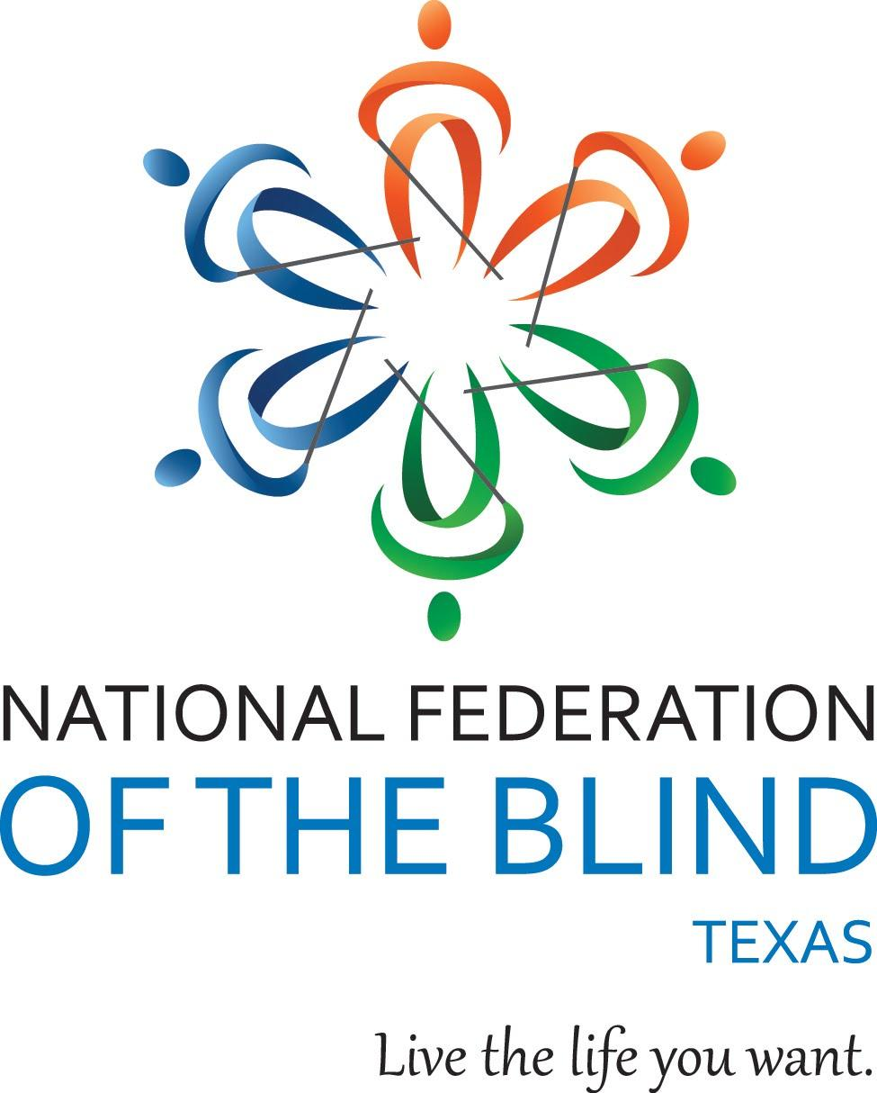

Meta Glasses: Exploring News & Information Through a Different Lens

Sponsored by NFB-NEWSLINE® Texas

Date: Saturday, June 27, 2026
Time: 2 p.m.-3:30 p.m. Central
Location: Zoom

Meta Glasses have opened up a new, hands-free way for blind people to explore and gather information with a few simple voice commands. From asking Meta AI questions about current events, having Meta Glasses read the print document in your hand, and using live translation features, Meta Glasses can help everyone stay more connected to what is happening in their homes and around the world.

Join members of the NFB of Texas to learn how blind people are using Meta Glasses in their everyday lives to get the information they need when they want and where they want.

Presentation highlights include:
- a panel of blind Meta Glasses users who will discuss useful new features and techniques
- a demonstration of the NFB-NEWSLINE® service
- plenty of time for Q&A

Students, technology enthusiasts, blind professionals, and everyone welcome!

Please register online or call 281-968-7733 for assistance.

Qualifying Texas residents will be registered for the free NFB-NEWSLINE® electronic information service.

