The Bay Area Outreach and Recreation Program (BORP) invites you to attend:
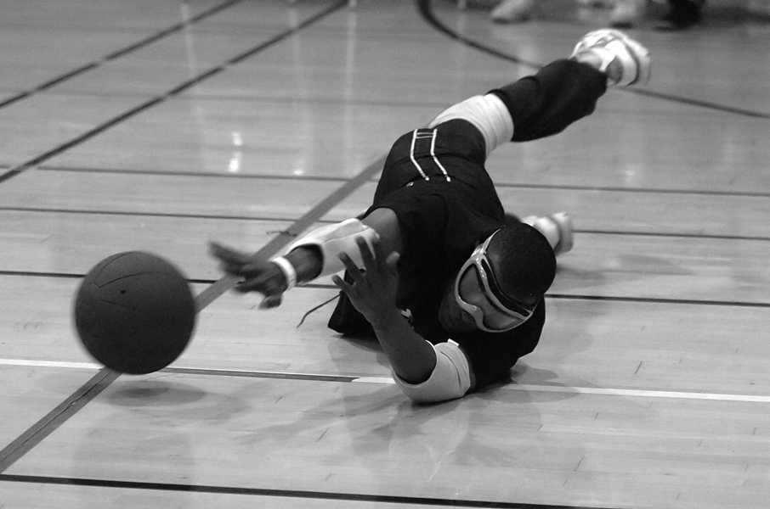
Photo courtesy of Scot Goodman

BORP Goalball Invitational #15
November 7, 2009 10:00 AM – 5:30 PM

James Kenney Recreation Center
1720 8th Street
Berkeley, CA 94710

Come see the top teams in Northern California square off for the coveted BORP Goalball Championship title. Admission is free.

BORP has been offering sports, recreation and fitness programs for people with physical disabilities since 1975.

Contact Jonathan Newman at: jonathan@borp.org or (510) 849-4663 X 304.

Thanks to our sponsors:
Autopsychic.com, CamelBak, Innovative Interfaces, Nakashima Fine Arts, Sue Johnson Custom Lamps & Shades, Sun Light & Power, Vision Faire Optometry,
Zander Associates Environmental Consultants

