Now available for Amazon's Kindle
and Barnes & Noble's Nook!
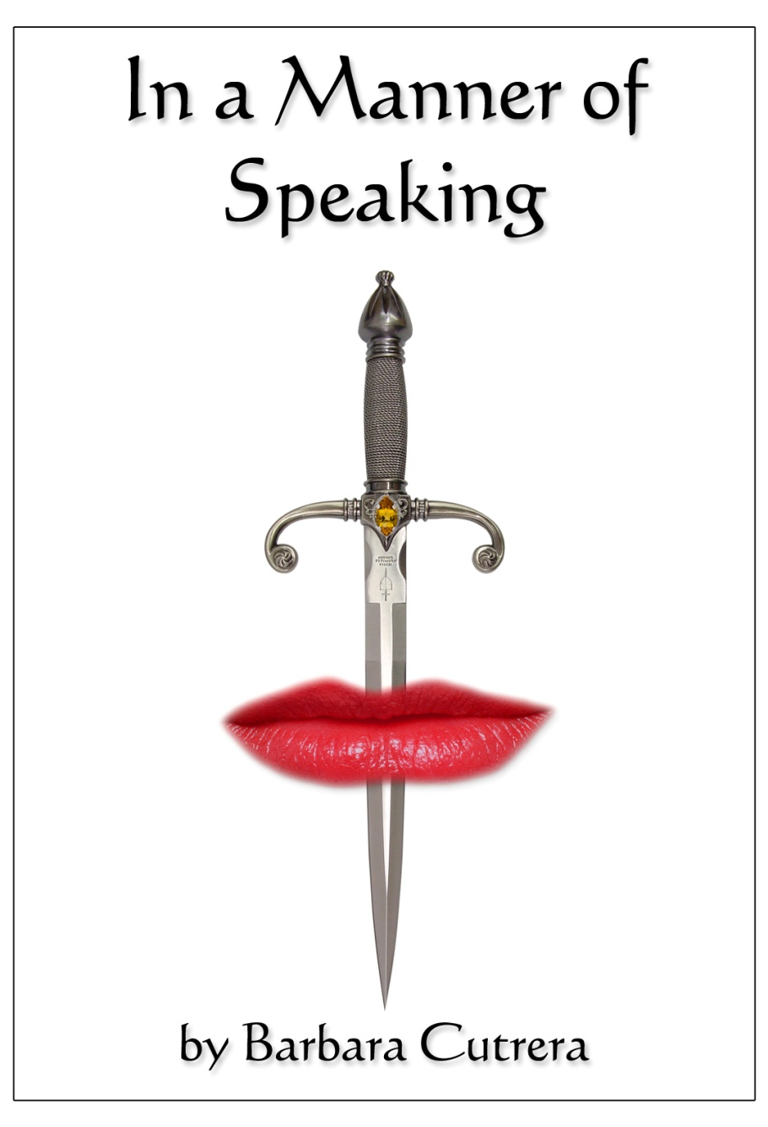

Neile Landry, a talented corporate interpreter, is forced to face her past fears and rethink her future plans as she is confronted with deception, threats to her life, and murder. Shocking revelations about the release of a global healthcare network lead to mysterious accidents, vicious killings, and insidious threats by an unknown assailant. As she journeys from Louisiana to Scotland, Neile will have to do whatever she must in order to stop a sociopath bent on the destruction of all she holds dear even if she is forced to forfeit her own life in the process.

Check out Barbara Cutrera's website at www.onmywayuponline.com
and her Facebook Fan Page!

