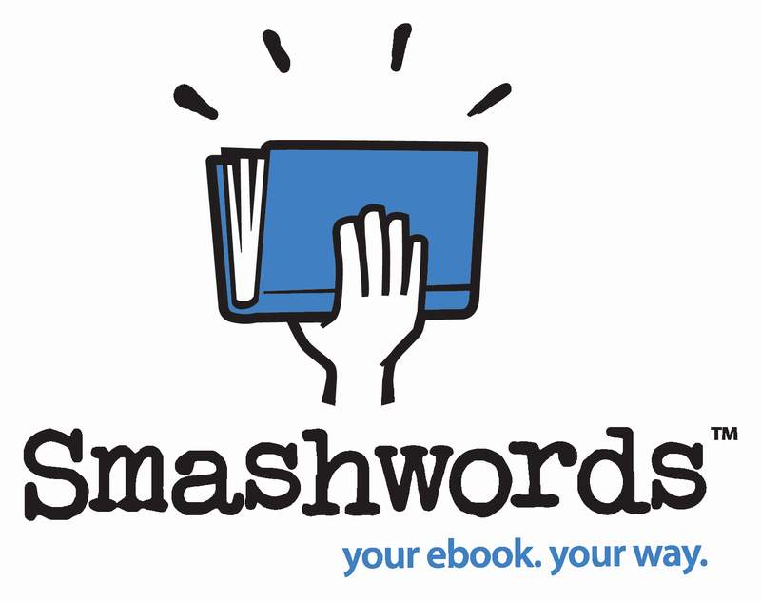

The Smashwords Style Guide
By Mark Coker
rev 6.16.12

Copyright Mark Coker 2008-2012

Smashwords Edition License Notes:
This free ebook may be copied, distributed, reposted, reprinted and shared, provided it appears in its entirety without alteration, and the reader is not charged to access it.

Also by Mark Coker, Published at Smashwords:
Smashwords Book Marketing Guide (how to market any book)
The Secrets to Ebook Publishing Success (ebook publishing best practices)
The 10-Minute PR Checklist - Earn the Publicity You Deserve (PR strategy for entrepreneurs)
Boob Tube (novel about soap operas)

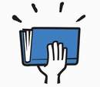

Table of Contents

GETTING STARTED

Welcome to Smashwords!
Do-it-yourself, or hire help?
Good formatting examples
What Smashwords publishes, what we don’t publish
Five common formatting mistakes to avoid
How Smashwords publishes books
How Smashwords distributes books
How ebook formatting is different from print formatting
How we convert your book into multiple ebook formats
The three secrets to ebook formatting
How to avoid (and fix) AutoVetter errors
Introduction to Meatgrinder conversion system
Your required source file
Understanding the different ebook formats

FREQUENTLY ASKED QUESTIONS

FORMATTING

Pre-Prep
Making Word Behave
Step 1: Make a back up
Step 2: Activate Word’s Show/Hide
Step 3: Turn off Word’s “AutoCorrect” and “AutoFormat” features
Step 4: Eliminate text boxes
Step 5: The Nuclear Method

Formatting
Step 6: Unify Manuscript around Normal paragraph style
Step 7: Managing and modifying paragraph styles, fonts
Step 7a. How to choose the best paragraph separation method (first line indent or block?)
Step 7b: How to implement your chosen paragraph separation method
Step 7b-a: How to define a proper first line indent
Step 7b-b: How to define trailing “after” space for block paragraphs
Step 7b-c: Special tips for poetry, cookbooks and learning materials
Step 7b-d: How to define proper line spacing
Step 8: Check your normalized text
Step 9: Why you should never use tabs or the space bar for indents
Step 10: Managing paragraph returns
Step 11: Managing hyperlinks
Step 12: Designating chapter breaks, page breaks, section breaks
Step 13: Working with images
Step 14: Text justification
Step 14a: Centering text
Step 15: Managing font sizes
Step 16: Style formatting, symbols and glyphs
Step 17: Headers and footers
Step 18: Margins, page sizes and indents
Step 19: Add the Heading style to your Chapter headers (optional)

Building Navigation
Step 20: Building navigation into the manuscript
Step 20a: Creating the NCX
Step 20b: Creating the linked Table of Contents
Step 20c: Advanced link building (Footnotes, Endnotes)
Step 20d: Troubleshooting and testing

Front Matter
Step 21: Front matter
Step 21a: Blurbs (optional)
Step 21b: Title and copyright page (required!)
Step 21c: Add a Smashwords license statement below copyright page

The End of Your Book
Step 22: The end of your book

POST-FORMATTING
Step 23: Preparing your cover image
Step 24: Review requirements for Premium Catalog distribution

Uploading Your Book to Smashwords
Step 25: How to upload your book
Step 26: How AutoVetter works
Step 27: After you publish – check your work
Step 27a: Check for EPUBCHECK compliance (important!)

How to Market Your Book
Step 28: Read the Smashwords Book Marketing Guide (how to market any book)
Step 29: Read the Secrets to Ebook Publishing Success (best-practices of successful authors)

Helpful Resources
Send Feedback
About the Author

APPENDIX
Keyboard shortcuts

GETTING STARTED

Welcome to Smashwords!
Welcome. Smashwords is the world’s leading ebook publishing and distribution platform for indie ebook authors and publishers. The Smashwords Style Guide has helped over 45,000 authors and publishers around the world collectively release over 130,000 ebooks. By following this Style Guide, you’ll learn how to quickly produce, publish and distribute a high-quality ebook at no cost.
The Style Guide is written for non-technical readers. No prior experience with Microsoft Word is assumed or required. It presents simple, step-by-step instructions to help you format your book to retailer requirements.
Don’t be intimidated by the length of this guide. It has a lot of pictures.
Books formatted to the Smashwords Style Guide earn inclusion in the Smashwords Premium Catalog, which is the collection of books Smashwords distributes to major ebook retailers such as the Apple iBookstore (32 countries), Barnes & Noble, Sony, Kobo, Diesel, Baker & Taylor (the Blio.com e-reading app and the Axis360 platform for public libraries) and others. Your book will also be available as a multi-format ebook at our own fast-growing retail store, Smashwords.com, where customers can discover and purchase the book for enjoyment on any e-reading device.
All you need to publish at Smashwords is a finished manuscript, a computer, an Internet connection, Microsoft Word or similar word processor, an ebook cover image, and the time and patience to follow this Guide. Patience is key. If you try to take short cuts and skip over the sections that follow, you’ll only frustrate yourself and delay distribution.
To learn some simple, time-saving keyboard tricks before you get started, see the Appendix at the end of this guide.
Do-It-Yourself, or Hire Help? – If you don’t have the time, patience or skills to properly format your masterpiece to Style Guide requirements, or you find yourself cursing and swearing (never good!), consider hiring a fellow Smashwords author to help you. I maintain a list called “Mark’s List” with the names and contact information of several Smashwords authors who have volunteered to provide low-cost Smashwords Style Guide formatting services for around $40 and up. The list also includes low-cost cover designers ($40-$100). If you want a referral (we don’t earn a referral fee), send an email to list@smashwords.com and you’ll receive it via instant autoresponder. Please note: if you utilize one of these formatting providers, you’re hiring them, not Smashwords. By hiring them you will not receive any preferential customer support or fast-tracked approval. However, because they’re Smashwords formatting experts, they’ll give you a clean file that will usually earn you Premium Catalog approval on the first attempt.

Good Formatting Examples - Below are two examples of well-formatted Smashwords books. You can download the free RTF which you can open and view in your word processor.
1. The Mating by Nicky Charles - https://www.smashwords.com/books/download/10394/3/null/0/0/the-mating.rtf
2. The Unsuspecting Mage: The Morcyth Saga Book One by Brian S. Pratt - https://www.smashwords.com/books/download/1444/3/null/0/0/the-unsuspecting-mage-the-morcyth-saga-book-one.rtf
This Smashwords Style Guide is a living document. As you learn formatting tips not presented in this guide, please forward them to Mark Coker at first initial second initial at smashwords dot com.

What Smashwords Publishes, What We Don’t Publish

Back to top

Smashwords publishes only original and legal works, direct from the author or the exclusive digital publisher. We do not publish public domain books. We also don’t publish incomplete or partial books, or books that appear elsewhere on the Internet under other authors’ names, as is common with Private Label Rights scams. If you write erotica, all your characters must be adults. And finally, we strongly discourage any book that advocates get-rich-quick “systems” for making money on the Internet. Smashwords is a professional publishing and distribution platform for serious writers only.

Back to top

Five Common Formatting Mistakes to Avoid:
1. Improper Indents - Don’t use tabs or space bar spaces to create first line paragraph indents (instead, code your paragraph style to define a special first line paragraph indent: see step 7b-a below)
2. Repeating Paragraph Returns - Never use more than four consecutive paragraph returns (A.K.A. “hard returns,” created by hitting the ENTER key) to arrange text on the page (this creates blank ebook pages on small-screened e-reading devices)
3. Improper Paragraph Separation - Paragraphs require either first line paragraph indents or the block paragraph method. Otherwise your paragraphs run together and it becomes unreadable because your reader’s eye can’t distinguish where one paragraph ends and the next begins. Use one method or the other (indents are best for fiction and much non-fiction, blocks are usually only for non-fiction), but don’t use both. If you’re aiming for the block style, do not add paragraph returns between paragraphs on empty lines (to create the blank line). Instead, modify your paragraph style to add a 6 pt trailing “after” space following each the paragraph (see the Step 7 below, managing and modifying paragraph styles).
4. Font and Style Mistakes - Don’t use fancy non-standard fonts, colored fonts (colors often disappear on some e-reading devices), kerning, compressed or expanded fonts, large font sizes over 16pt, and don’t go overboard with multiple paragraph styles (makes your ebook look ugly, and amplifies odds of unexpected problems). Modify your paragraph styles so they don’t define fonts larger than 18pt.
5. Copyright Page Mistakes - Don’t forget to include the required “front matter” (required for acceptance into the Premium Catalog), described in tip 21b below.

How Smashwords Publishes Books:

Back to top

After you carefully implement the formatting instructions in this Guide, your book is ready to upload to Smashwords. Simply click “Publish” from any Smashwords web page and follow the instructions to upload your book.
Smashwords takes your original Microsoft Word .doc source file and converts it into multiple ebook formats such as .EPUB, PDF. .RTF, .PDB, .MOBI, LRF and TXT, as well as into online HTML and Javascript formats. By publishing in multiple formats, your book will be readable on any e-reading device, including the Amazon Kindle, Apple iPad, personal computers, the iPhone (via the popular Stanza e-reader app), Sony Reader, Kobo Reader, Android smart phones, etc.
From the Publish screen, you can designate a percentage of your book that you want to make available as a free sample. Most authors choose between 15-20%. If you don’t make a free sample available, your book will not be distributed to some important outlets.

Back to top

How Smashwords Distributes Books:
Smashwords distributes your book via two primary mechanisms:
1. Standard Catalog: This catalog contains all the books for sale at Smashwords.com. These books are also automatically listed in the native catalogs of Stanza on the iPhone, which is used by over 4 million people to discover and purchase ebooks; and Aldiko, an e-reading app for Google Android devices; and Word-Player, another e-reading app for Android devices. To qualify for distribution on Smashwords.com and in the Standard feed, an author or publisher is simply required to abide by the Smashwords Terms of Service and follow the instructions in this Guide.
2. Premium Catalog: This special catalog of Smashwords ebooks is distributed to major online retailers, libraries and other distribution outlets. There’s no cost for inclusion, but your book must satisfy higher mechanical standards required by the retailers such as having a quality book cover image, good formatting, a proper copyright page, and other requirements clearly outlined in this Style Guide. If you're a serious author or publisher, you want your books included in Smashwords Premium Catalog because it offers your book greater sales exposure at no cost.

Back to top

How Ebook Formatting is Different from Print Formatting
Ebooks are different from print books, so do not attempt to make your ebook look like an exact facsimile of print book, otherwise you’ll only frustrate yourself by creating a poorly formatted, unreadable ebook.
With print, you control the layout. It’s a fixed format. The words, fonts and font sizes appear on the printed page exactly where you want them to appear.
With ebooks, there is no “page.” By giving up the control of the printed page, you and your readers gain much more in return.
Page numbers are irrelevant with ebooks. Your ebook will look different on every e-reading device. The text of your Smashwords ebook will shape shift and reflow and look good on multiple screen sizes. Most e-reading devices and e-reading applications allow your reader to customize the fonts, font sizes and line spacing. Your customers will modify how your book looks on-screen to suit their personal reading preference and environment.
By transforming your books into digital form, you open up exciting possibilities for how readers can enjoy them.
At Smashwords, our motto is “your book, your way,” and this means a reader should be able to consume your book however works best for them, even if that means they like to read 18 point Helvetica with blue fonts, lime background color, and triple spaced lines. Many e-reading devices and e-reading apps support some or all of these strange different tastes.
In order for us to prepare your words to be stirred up and reconstituted in this digital soup, it’s important your Smashwords source file is formatted to liberate the words in digital form.
The book’s formatting will be and must be different from its paper-based formatting and layout (for some works like poetry, the formatting is integral to the reading experience, and we can work with that too).
Most readers want your words, not your fancy page layout or exotic type styles. This is especially important for your ebook customers, because you want your book to display well on as many digital reading devices as possible so the reader can have their book their way. Some of your buyers may want to read on the Amazon Kindle, others may prefer to read on the iPhone or Sony Reader or Barnes & Noble nook, or even read the same book across multiple devices. Others may want to just read it on their personal computer using one of the several e-reading applications, such as Adobe Digital Editions, Kindle for PC or FBReader.

Back to top

How We Convert Your Book into Multiple Ebook Formats
This Style Guide helps authors and publishers tweak their original source files to obtain the best possible reading experience across multiple ebook formats and e-reading devices.
Print publishing companies spend millions of dollars each year to convert their print books into digital formats. It’s a tough job, and often these conversions involve hiring hundreds of overseas cubicle laborers who painstakingly re-key and reformat texts into different formats.
At Smashwords, we operate differently. Our Meatgrinder technology automates the process.
The advantage of this automation, especially if you carefully format your book to the Style Guide, is that Meatgrinder will allow you to instantly publish a high-quality, multi-format ebook, ready to be enjoyed on any e-reading device. This automation also allows us to offer this conversion and publishing service at no cost to you. You can update your book at any time at no cost.
Meatgrinder creates reflowable ebooks that look great on any e-reading device. “Reflowable” means that the text of your ebook will easily flow across all screen sizes, whether your book is read on a small screen like an iPhone or a larger screen like an iPad. Reflowable books enable your customer to click a button and instantly enlarge the font size for more comfortable reading.
Meatgrinder does well with straight-form narrative, and narrative + images, so we excel at fiction, narrative non-fiction, poetry and other books that are mostly words. Luckily, straight narrative comprises probably 75% of all books purchased by readers, and for most of the other 25%, with some proper tweaks, flexibility and patience, many of these books can work as well.
Meatgrinder also supports custom styling, which helps you create professional-quality ebooks your readers will enjoy.
Smashwords supports pictures and images, but here we lack the precision of print on paper. With some Smashwords formats (such as plain text), page breaks will appear where you don’t expect them. Images may not appear in the exact position you intended, or the print-quality image that looks great on glossy paper may not look so great on a black and white e-reading device, or a small cell phone. In other words, you should expect that your ebook will look different from a print book. With patience, experimentation and an open mind, you can make it work. Remember, good quality is the goal, not perfection.
Some format outputs have limitations. For example, a picture book or manga that’s all images is impossible to convert into plain text (it wouldn’t be a picture book anymore!). Other books may look great in .RTF or PDF, but not so great on one of our online readers.
Meatgrinder has some limitations. It doesn’t support tables or columns. It doesn’t take full advantage of some of the capabilities of formats such as EPUB and .MOBI. We’re aware of the limitations, and you should be too.
In the meantime, the benefits of such minor compromises outweigh the downside. By giving up a little, you gain a lot by making your book accessible to millions of potential readers across our ever-growing distribution network. If you follow this Style Guide, you’ll make an ebook that looks as good as or better than most ebooks from large publishers.
Some folks who read the paragraphs above come to the conclusion that Smashwords wants a plain text book without formatting. Not true! As you read on, you’ll discover that Smashwords still gives you great control over formatting, styling and navigation.
We care about quality, and you should too. If you ever hear an author or reader complain that their Smashwords book looked like [insert your favorite expletive], it means the author didn’t follow the Style Guide. Please take the time to follow the guide. You’ve invested years – possibly even a lifetime – to write your masterpiece, so take 30 minutes or an hour to study the Guide and learn how easy it is to create a great-looking multi-format ebook that will make you and your readers proud.

Back to top

The Three Secrets to Ebook Formatting:
(1) Keep it Simple. (2) Keep it Simple. (3) Keep it Simple!
The secret to ebook formatting success is “Keep it Simple!” Unnecessarily complex formatting or layout will hinder the readability of your ebook. If you attempt to make your ebook an exact facsimile of your print book, you will cause yourself – and your readers – unnecessary frustration. It may also cause your ebook conversions to fail.
Re-envision your book as free flowing text with only the essential formatting. Restrict your formatting to Normal paragraph style for the bulk of your book, one paragraph return at the end of each paragraph, proper first line paragraph indents (see tips below on how to create), italics, bolds, a Heading style only for your chapter headings, and very few if any additional custom paragraph styles beyond that.
Simple doesn’t mean you can’t use formatting, or you can’t use styles. It just means that if your current formatting includes 15 or 30 different custom paragraph styles, you’re asking for trouble.

Back to top

How to Avoid AutoVetter Errors:
AutoVetter is Smashwords’ automated technology that inspects your book the moment you publish it and provides you instant feedback on potential formatting problems. You’ll find your errors documented in the Dashboard after you publish, underneath the “Premium Status” column. If the link reads, “requires modification,” click the link. We’ll also email you any AutoVetter errors when we complete your conversion.
AutoVetter is your friend.
If you receive AutoVetter errors, fix them immediately. Otherwise, the errors will prevent or delay your book’s acceptance into the Smashwords Premium Catalog. The moment AutoVetter tells you about the errors, you can fix them and then upload a new version via your Dashboard’s “upload new version” link.
The following errors may prevent your book from gaining inclusion in the Premium Catalog:
- more than 4 consecutive paragraph returns in a row (creates blank ebook pages)
- tabs (eliminate all tabs, which you created by hitting the “Tab” key)
- extra paragraph returns between paragraphs in an attempt to create a blank lines
- exotic fonts (instead, stick with Times New Roman, Garamond and Arial)
- large font sizes (11 or 12pt is best, 14pt is a recommended maximum)
- indents made with space bar spaces or tabs (a common bad habit of all authors)
- text in columns (we don’t support columns)
- text in tables (ebooks don’t handle tables. Import tables as images)
- text in text boxes (Ugh, the horror! We don’t support text boxes.)
- multiple text or paragraph styles for your body (for example, don’t mix Normal style with Body Text style)
- automatic footnotes (not supported, may cause the conversion to fail)
- text wrapped around floating images (instead, right mouse click on image, click Format Picture: Advanced: In Line with Text, then use Word’s center button to center)
- and finally, to avoid the copyright error, carefully follow tip 21b below
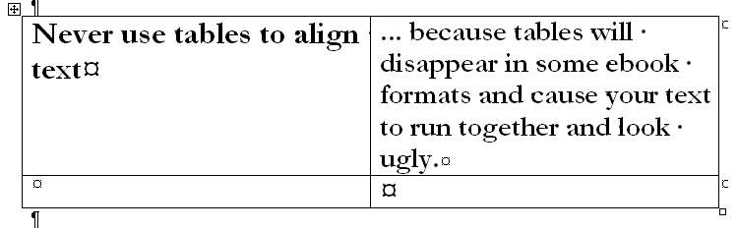

Back to top

Introduction to Meatgrinder
We affectionately call our file conversion system Meatgrinder. Don’t let the name scare you. In the last four years, we have continually enhanced it to produce high quality ebooks. The most recent major upgrade was October 2011, where we made a series of great improvements to our EPUB and MOBI files.
You upload your manuscript to Smashwords as a Microsoft Word .doc document and Meatgrinder converts it into multiple DRM-free digital book files that make your book readable on any e-reading device, including the Amazon Kindle, Barnes & Noble nook, Sony Reader, iPhone, iPod Touch, Apple iPad, a computer screen or virtually any other device with a screen.
If you ignore the formatting requirements of the Smashwords Style Guide, Meatgrinder will turn your book into hamburger. Please follow the instructions! If you make a mistake, don’t worry. You can always click “upload new version” from your Dashboard to correct any errors.
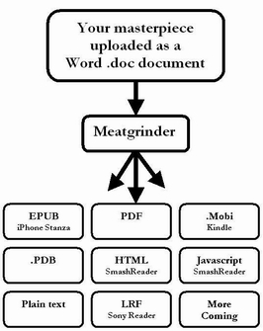

Back to top

Your Required Source File
The file you upload into the Meatgrinder should be a Microsoft .doc file (the default). If you’re a screenwriter, scriptwriter and playwright and you work in a program called Final Draft, save your document as an RTF file (however, you will need to manually correct the margins), and then open it in Word, save it as a Word .doc, and clean up from there.
PDF Source Files (Not allowed): You cannot upload a source file as a PDF. If you only have your book in PDF form, here’s a free online service that will convert your PDF into a Word doc: http://www.pdftoword.com/ You upload your PDF to them and then they email it to you as a Word file. But be warned, the output it gives you will *not* be ready to publish on Smashwords. You will still need to perform clean-up. To save time, you’re better off contacting whoever converted your original manuscript into PDF and ask them to forward you the original source file, saved as either a Word .doc or .RTF file.
If You Only Have a Print Book: Many authors only have print copies of their books. How do you bring your book to life as an ebook? It’s easier than you might think. Consider this cool service called Blue Leaf Book Scanning, which uses optical character recognition technology to convert your book back into digital form. For around $25.00, they will scan your print book and send it to you as a Microsoft Word file. I’ve seen the raw files they produce, and they’re remarkably accurate. However, the service is not infallible. The Word file they send you will still require careful proofing, editing and reformatting. http://www.blueleaf-book-scanning.com/book_scanning_service_order.html
InDesign Source Files: InDesign is a common layout application used by professional publishers. Smashwords does not accept InDesign files. However, from InDesign, you can export your book to .RTF format. Once it’s in RTF format, you can reopen the file in Microsoft Word, save it as a Word .doc, and then remove all the garbage introduced by InDesign (you’ll have tabs in random places, and other ugly formatting). The fastest way to clean up an RTF from InDesign (or any file, for that matter) is to use what I call the Nuclear Method. With the Nuclear Method, you open your file in Word, copy and paste it into Windows Notepad (or some other simple text editor that strips out all formatting), close Microsoft Word, then reopen Word to a fresh new Word document, then copy and paste the book from Notepad back into Word, and then carefully re-apply the minimal necessary formatting by following the Style Guide.
HTML Source Files: We previously allowed HTML file uploads, but now we no longer allow them because most HTML files provided to us contained serious corruption as defined by the WC3 HTML Validator at http://validator.w3.org/check and as a result didn’t upload properly. If you only have your source file as an HTML file, follow these instructions: 1. Open the HTML document in a browser. 2. Copy and paste the entire document into a new Word doc by clicking "Edit: paste special" within the Word menu, then selecting "unformatted text" as the output. 3. From here, you'll find that you've got a consistent number of spaces, such as four spaces, making up your indents. This won't work, so do a CTRL+H (press the CTRL key and the H key at the same time) search and replace and search for ^p space space space space (a paragraph return followed by four taps on the space bar) and replace with only ^p. This will eliminate the leading spaces at the beginning of each paragraph. 4. Next, CTRL+A the document, right mouse click, click paragraph, and then under “special” do a first line paragraph indent of .25”. 5. Next, clean up the remaining minor issues, like manually removing the indents from your title and copyright pages, and, using Word’s center button, center those sections.

Back to top

Understanding the Different Ebook Formats
One of the important benefits of Smashwords is that we take your single file and convert it into multiple ebook formats. Why is this so important to the success of your book? Because customers read on many different devices, and the more formats you offer, the more books you’ll sell. In early January 2010, we did a survey of the most popular ebook formats for Smashwords customers. The results were interesting. Although PDF is the most popular ebook format, two thirds of customers preferred formats other than PDF. You can read the survey yourself at http://blog.smashwords.com/2010/02/most-popular-ebook-formats-revealed.html.
You should publish your book into as many digital formats as possible (even if certain formats translate less well than others) because this expands your potential audience of readers. Review the outputs of each format for acceptability after you publish.
Here’s a summary of the formats offered:
EPUB - This is your most important format! EPUB is an open industry ebook format. This is the format we distribute to Apple, Barnes & Noble, Sony, Kobo, Diesel eBooks, and others. If your book is available in epub, it can be read on the most popular ebook readers and ebook reading software applications (Like Stanza on the iPhone or Aldiko on Android devices), and will gain the widest distribution via Smashwords’ distribution outlets (EPUB is a requirement for inclusion in Smashwords’ Premium Catalog, and it’s what we distribute to every retailer except Amazon).
Mobipocket (Kindle) – Mobipocket, A.K.A. MOBI, allows your books to be read on the Amazon Kindle, so this is an important format for you. Mobipocket is supported on many handheld devices and e-reading applications. Mobipocket is a requirement for distribution to Amazon.
Palm Doc (PDB) - PalmDoc is a format primarily used on Palm Pilot devices, but software readers are available for PalmOS, Symbian OS, Windows Mobile Pocket PC/Smartphone, desktop Windows, and Macintosh. Be sure to turn off “smart quotes” in your source file, otherwise they may appear garbled in your PDB file. Our PDB is little more than ugly plain text.
PDF - Portable Document Format, or PDF, is a file format readable by most devices, including handheld e-readers, PDAs, and personal computers. It’s a good format if your work contains complex layout, charts or images. Odds are, if your work looks good in Microsoft Word it will look good in PDF. PDF is also a good option for readers who may want to print out your book on their home computers. On the negative side, PDF is a rigid, inflexible format because it’s not reflowable, so it’s horrible for reading novels. Your customers can’t easily change the font size or style to match their preferences, the text isn’t reflowable, and the reader is forced to read page by page.
LRF - This is the old (mothballed) format for the Sony Reader. Sony has moved to the EPUB format, so LRF is less important than it once was, though it’s still useful to users of the older generation Sony Readers.
RTF - Rich Text Format, or RTF, is a cross-platform document format supported by many word processors and devices. It’s usually pretty good at preserving the original formatting from Word documents. It is not efficient with lots of images.
Plain Text - Plain text is the most widely supported file format. It works on nearly all readers and devices. It lacks formatting, but will work anywhere. For best results with plain text, your source document should not contain images or fancy formatting.
HTML SmashReader – This is our online reader that allows customers to sample or read your book from their web browser. Your sample pages will be indexed by Google, which will increase the ability for potential customers to find your book, even if they didn’t know your book is what they were looking for. Think of it as serendipity on steroids. If your book looks good in our HTML reader, it will probably also look good in EPUB and MOBI. Linked tables of contents (ToCs) don’t work in the HTML reader.
Javascript SmashReader - This online reader isn’t indexable by search engines like the HTML reader, but it does allow your readers to customize their reading experience. They can increase or decrease the fonts, change the line spacing, change the font, change the font color or the background color. Our Javascript Reader has always been a bit buggy, so if you see strange characters along the top of the page, ignore them. Linked ToCs don’t work here.
More options coming - In the future, we’ll add support for other formats based on author requests. If there’s a particular format you want, drop us a note.
***~~~***

Back to top

Frequently Asked Questions

Q: How long will it take for me to format my book for Smashwords?
This depends on your knowledge of Microsoft Word. The average author, if they take the time to carefully study and implement the Style Guide, can successfully complete their formatting in under two hours. Most Smashwords experts can complete a book in under one hour. Novels are easiest. If you decide to skip the Style Guide because you already have decades of experience in publishing, then you’ll frustrate yourself and waste time. Don’t be discouraged by the length of this Guide. It has a lot of pictures to help guide even computer novices down the path to formatting success, and it’ll save you money in the process. We created Smashwords so you shouldn’t have to pay anyone a penny to publish with us. If you don’t have the time, skills, or patience to follow the instructions, and you’d rather hire someone to help you, email list@smashwords.com to request “Mark’s List” of low cost formatters (fellow Smashwords authors), who for around $40 to $75 can make your life simpler and help you get in the Premium Catalog faster.
Q: Can you share time-saving tips?
Yes! You’ve already taken the first step, which is to read this Style Guide. It will save you a lot of time, prevent frustration and help you get your book distributed more quickly. Other tips: 1. Jump down to my Keyboard Shortcuts section in the Appendix if you want a quick refresher on some keyboard tricks that will save you time and reduce errors. 2. Take a look at the sample files above. 3. Use Microsoft Word because you’ll get the best, most predictable results. 4. If your book has been touched by multiple word processors during the writing, revision and editing, consider using the Nuclear Method below to clear out the formatting gunk and start fresh because these other programs have a habit of introducing hidden anomalies into your file.
Q: What types of books work best on Smashwords?
Straight form narrative and narrative + images. This means we work well with fiction, biographies, memoirs, poetry, essays, narrative-heavy non-fiction, scripts, screenplays and plays. Yes, the book can contain images. Follow the instructions below. We don’t work well with books that are only images.
Q: How many books will I sell?
Any book, ebook or print, is difficult to sell. Some Smashwords authors haven’t sold a single book. Others have sold thousands. The latter group is not the norm, so you should keep your sales expectations modest. Read the free Smashwords Book Marketing Guide to understand what we do to help you sell your book, and what you must do for yourself. Also read The Secrets to Ebook Publishing Success (also FREE!) to learn the best practices of the most commercially successful Smashwords authors. You are responsible for writing a book that resonates with readers, and for marketing that book. Our responsibility is to help you get your book published and distributed. Approximately 80 percent of your sales will come from Smashwords’ rapidly expanding network of ebook retailers, thus the urgency for you to follow the Style Guide so we can quickly distribute your book. All your sales originating at Smashwords.com, our small retail operation, will be reported instantly to you. Sales reporting from our retail partners is time-delayed. Learn more about how Smashwords royalties are calculated and paid by reading our Royalty FAQ.
Q: What types of books are most difficult to format for Smashwords?
The most challenging books at Smashwords include coffee table photo books, and books where the words are part of the image. If complex layout is essential to the enjoyment of your book, you’ll need to reformat it to achieve readability as an ebook. Restrict formatting to paragraph returns at the end of every paragraph, indents, headings, and a little bold or italicized text here or there. With some special care, you can modify most types of books to work fairly well on Smashwords. If you cannot separate the complex formatting and layout from the content of your book, then consider restricting your ebook output formats on Smashwords to only PDF and RTF, because these formats will most closely match the form of your original Word file. The downside of restricting your book to PDF and RTF, however, is that you’ll reduce the potential readership for book because EPUB is the most commonly distributed format at Smashwords.
Q: Can I upload a work in progress?
No. Smashwords is only for books that are complete and ready for public consumption.
Q: Can I upload only a sample chapter or two?
No. We only publish complete books. If your story doesn’t represent a complete reading experience, you can’t publish it at Smashwords, because our customers expect a complete story. However, when you upload your complete book, you can designate a certain percentage of the book, starting from the beginning, that you make available as a free sample.
Q: Can I upload public domain books?
No. We do not publish public domain books.
Q: Can I upload “Private Label Rights” articles to Smashwords?
No, never. If you do this, we will delete your account without warning and you will forfeit all earnings. We have a zero tolerance policy on PLR. If you’re not the 100% author of the book, or the sole exclusive distributor or publisher, we don’t want it. Learn more in my guest blog post for Writer Beware at http://accrispin.blogspot.com/2010/03/guest-blog-post-scam-of-private-label.html
Q: Can I take my Smashwords ebook conversions and sell them elsewhere?
No. The ebook conversions at Smashwords are not to be re-distributed or re-sold elsewhere, per the Terms of Service. Why? Our free conversion services, for which we have invested hundreds of thousands of dollars to build and continually improve, are provided to authors and publishers as a benefit of our ebook distribution services. It's bad karma to take the files we create and upload or sell them elsewhere. Of course, you can do anything you want with the Microsoft Word source file you create. Just as our books are DRM-free and you're trusting readers to honor your copyright, we trust our authors and publishers to respect our terms of service.
Q: Do I put my book cover in the manuscript file?
It’s best to not include your cover image inside the manuscript. Our EPUB and MOBI formats will automatically insert the cover image into your ebook file, though our PDF and RTFs will not. If you want the image in the PDF and RTF formats, you can import it into the top of your Word file. However, if you do this, it’ll appear twice in your EPUB and MOBI versions.
Q: Do you edit my book prior to publishing?
No. It is your responsibility to upload a completed, professionally written, edited and proofread book. Although Smashwords makes it easy to publish, your potential readers expect you to produce a quality, well-written professional work.
Q: How important is it that my book has been proofread and copy edited?
Extremely important! Don’t publish your book at Smashwords until it has been thoroughly proofread for grammar, spelling and typos. One of the biggest criticisms leveled against self-published authors is that their work is not professional quality. Don’t perpetuate this stereotype. Take pride in your work and invest the necessary effort to have others proofread and copyedit your book prior to publishing it on Smashwords or anywhere else. Your readers will thank you and your book will be more successful.
Q: Will Smashwords format my book to make it look perfect?
No. If we did that, our service would not be free. Our technology is completely automated. We provide you the free tools. All file conversions are automated by our Meatgrinder file conversion system.
Q: Does Smashwords provide professional formatting and text design services?
No. Smashwords does not provide paid services of any kind. This guide provides guidance on how to prepare your book for quality ebook conversion through Meatgrinder. If you decide you require assistance, send a blank email to list@smashwords.com to obtain my list of low-cost formatters and cover designers.
Q: I’ve already formatted my book perfectly into separate versions for PDF, EPUB, Mobi and others. Can’t I just upload my books and bypass the Meatgrinder?
No, sorry, we don’t accept this, and for good reason. It’s important that books come to us in a common format so we can ensure the files are virus-free, free of DRM, and free of strange permutations that could cause unexpected problems for our customers. One of our retailers, Sony, requires us to create a specially modified EPUB file for them, so this is another benefit of having Smashwords perform your conversion. We also need the file as a Word document so we can reliably convert it into all the different formats, as well as future formats. But don’t fret; after you read this guide you’ll realize it’s easy to format your book for Smashwords! If you only have your manuscript in PDF form, read the section below, entitled, “Your Source File,” for tips on how to get your PDF back into Word format.
Q: Will Smashwords one day allow authors and publishers to replace Smashwords-generated files with files generated by the author or publisher?
Eventually, yes. In the past, we’ve referred to this as the Meatgrinder Bypass. It’s a planned feature, but the implementation of this feature has been delayed in favor of focusing on higher priority projects such as building out our distribution channels. The current thinking is that this feature will be rolled up in a new future service called Smashwords Direct, due by the end of 2012.
Q: Can I use “drop caps” at the beginning of a paragraph or chapter?
A drop cap is the large initial capped letter you may see in the first paragraph of a chapter in a print book. A drop cap usually extends down three or four lines. You cannot use drop caps in Smashwords, so eliminate all usage of them. Some authors will make the first letter of the first paragraph of a chapter a larger font size, and bold. This is a good, attractive alternative.
Q: Will my finished Smashwords digital book look like my original print manuscript?
Often, it will look different. Don’t try to make your ebook look like an exact carbon copy of your print book. Such an objective is ill-conceived. You want your ebook to be reflowable, which means it’ll read well on any device or screen size. If you carefully follow the Style Guide, you’ll get good results.
Q: I don’t use Microsoft Word. Can I still publish on Smashwords?
Yes, though Microsoft Word is your best option. If you want to ensure the best results for your ebook, and you don’t use Microsoft Word, consider investing in a copy. You can usually find it for around $150 or less. Word will give you the greatest control over your formatting by allowing you to follow the Smashwords Style Guide. If your time is valuable to you, and you plan to publish multiple ebooks with Smashwords, Word is a good investment.
If your word processing software allows you to save a file as a Microsoft Word .doc file, then it might work for you. There are numerous free Word processors that emulate Microsoft Word or will convert files into Microsoft Word format, but keep in mind they’ll make formatting more difficult, they might introduce corruption into your Word document, and we can’t coach you on how to use them. One free option popular with many Smashwords authors is Open Office (http://www.openoffice.org/), which is available for the PC, Mac and other platforms. You can also use Apple Pages to output a Word .doc file. We do not recommend WordPerfect because it caused our authors headaches, which causes us headaches (see next question).
Q. I use WordPerfect. Can I save my manuscript as a Word .doc or .RTF and upload it?
Smashwords authors who try to convert their WordPerfect files into Microsoft Word .doc format are often frustrated beyond belief. Based on our experience, WordPerfect does not reliably export to Word .doc and RTF. It inserts tabs instead of proper first line paragraph indents, and it introduces corrupted data and strange control characters. If you use WordPerfect, we recommend saving your file as plain text, and then reopening it in Microsoft Word. Next, follow the recommendations in this Style Guide.
Q. Is there a maximum size file I can upload?
Yes. The source file you upload must be smaller than 5 megabytes. If your file is larger, it usually means it contains large images, or multiple images. Ask yourself if the images are really necessary. If you’re using images for chapter headings or similar artistic flourishes, for example, remove them and replace them with text. For essential images, reduce the file sizes (see the next tip for how to do this).
Q. How do I reduce the file size of my images?
First, if your file is an RTF, save it as a Word .doc. Word .doc files handle images much more efficiently. If you’re using Microsoft Word 2003 or later, Word has a GREAT feature that will compress your images without visibly harming quality. Just right mouse click on any image in the document, select format picture, then under the picture tab in the lower left hand corner you'll see a link for "compress". This will compress many images 80% or more. You can also use a photo editing tool such as Photoshop, or a free utility such as Paint.net at http://www.getpaint.net/ or Picasa by Google at http://picasa.google.com/. Please note: It doesn’t impact the file size to simply click the corner of an image and drag it inward.
Q. What’s the best way to format poetry?
For best results, present your poetry left justified, or, if it’s meant to be centered, centered. Don’t use indents to arrange the text on the page, because the indents could cause your poems to appear too far to the right of the screen (or worse, word-wrapped) on small-screened devices. This is why we suggest left justified. For additional poetry tips, see our special poetry tips section (Step 7b-c) in this Style Guide.
Q. Should I worry about piracy?
No. The biggest risk faced by every author and publisher is obscurity, not piracy. If you price your ebook reasonably, and you make your book available for purchase at as many retailers as possible, it’ll be easier for readers to purchase a legal copy than it is to obtain an illegal copy. On the off chance a fan gives your book to a friend and tells them to read it, consider it low-cost marketing. That new fan will seek out and purchase your other books. Books live and die based on reader word of mouth. The most successful authors don’t limit their book’s distribution for fear of piracy. Some best-selling authors are even known to upload their own books to pirate sites, simply because they view pirating as cheap marketing.
Q. [Advanced] How do I eliminate Word’s Indexing Field Codes?
Smashwords does not support indexing, so if your source document uses Word’s field code for indexed words or phrases, you’ll want to eliminate the field codes before you upload to Smashwords. The field codes become visible when you activate Word’s “show/hide” command (as we mention below, you NEED to activate “show/hide” to expose your hidden formatting). Although you could strip them out manually, it would take hours and will introduce errors. Here’s a quick tip that takes only seconds: See our Keyboard Shortcuts section learn how to use Word’s “Find and Replace” feature (type CTRL+H) and then in the find field enter ^d xe ^? and leave the ‘replace with’ field empty. Then click ‘replace all’. Below is an image of what the indexing field codes look like.
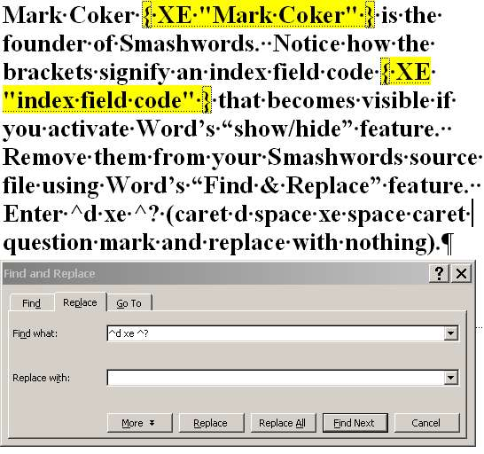

Back to top

FORMATTING

Pre-Prep
Making Microsoft Word Behave
Before you upload your book to Smashwords, follow the steps below to ensure proper formatting of your book. The first steps focus on making Word behave.
A note about all the different versions of Word: You can use any version of Microsoft Word, even the old versions like Word 2000 (my personal favorite), Word 2003 (I like this one too), Word 2007 (Steep learning curve, but a great program once you learn it), and the newer ones. Luckily, although the user interface changes (tell me, Microsoft, why do you make Word more difficult to use with every version?), the inner guts of Word are have remained remarkably similar across all versions for nearly 20 years. If, for religious reasons you’re hesitant to use Microsoft Word, please reconsider. If you plan to publish frequently with Smashwords, it’s a smart investment because you’ll gain better control over your ebook’s formatting and you’ll save yourself time. If you’re stubborn and want to use Open Office (a good free word processor popular with many Smashwords authors) or Apple Pages (also popular), you can still use the Style Guide if you’re careful to implement the intent of the instructions, though you should understand up front that you might be creating more work for yourself.
Step 1 - Make a Back Up
This goes without saying but I’ll say it anyway. Don’t make the formatting modifications below on your original document. Instead, open your final manuscript within Microsoft Word, and create a copy of it by going to File: Save As: and then enter a new file name, such as MySmashwordsMasterpiece, and save as a .doc file (the default in Word 2003 and earlier. In later versions, go to Save As: Word 97-2003). By making a backup, if you make any mistakes as you follow my advice you won’t screw up your original. Also make sure you’ve turned off Word’s “Track Changes” feature, also known as “markup mode.” This is what your book looks like in Markup Mode:
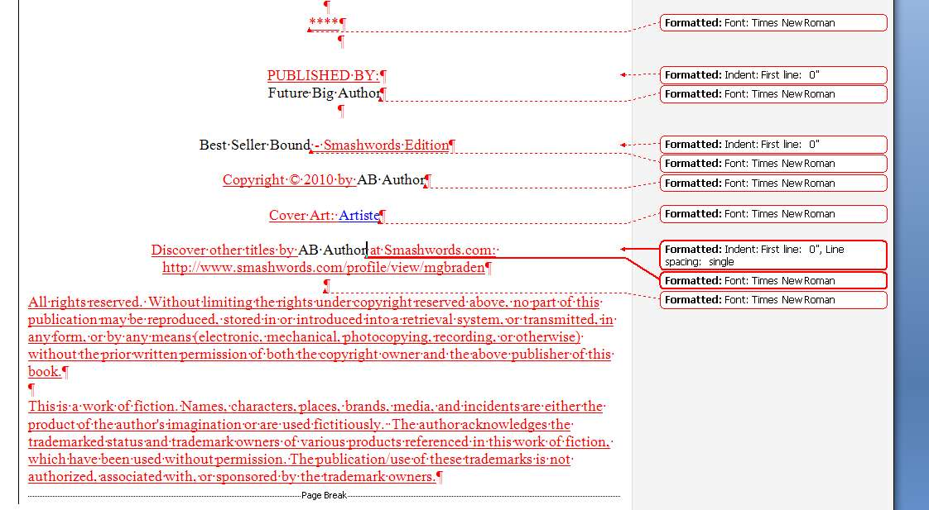

Back to top

Step 2 - Activate Word’s Show/Hide
Do this now, BEFORE you start formatting, otherwise you might as well blindfold your eyes. This is one of my favorite editing features in Word. The show/hide feature is designated by the “¶” mark in the toolbar (I’ve always thought of it as the “reverse P thingy,” but for you typography purists out there, you know it as a “pilcrow.”), as shown below.
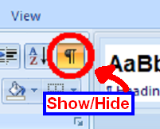
The show/hide button helps you view the guts of your formatting
When clicked, it exposes your paragraph returns, extra spaces, tabs, field codes or strange formatting. It’s a great tool to help polish your document for the cleanest possible conversions. If it’s not in your toolbar, you can usually find it in Tools: Options: View and then under Formatting Marks click All.

Back to top

Step 3 - Turn off Word's AutoCorrect: AutoFormat As You Type and AutoFormat features
I’ve always found Word’s AutoCorrect and AutoFormat-As-You-Type to be Word’s most annoying features. If you have them engaged, Word will try to guess what type of formatting you want based on how you write the paragraph, how you manually format the paragraph, or by how you formatted something before it. If you upload a Word file to Smashwords with paragraphs formatted inconsistently, like some paragraphs formatted as “Body Text” and others formatted as “Normal Text,” the book will look horrible as an ebook. To turn off the features, in Word 2000 & 2003, go to “Tools”: “AutoCorrect,” then click on the “AutoFormat As You Type” tab and then uncheck most of the boxes, and then click on the “AutoFormat” tab and uncheck the four boxes under “Apply.”
The reason we want to turn off these AutoFormatting options is because later in the Style Guide, you’re going to try to simplify and normalize your text to prepare it for conversion. If you don’t turn off AutoFormatting, Word will cheerfully and automatically mess things up again as you make the corrections below.
To access the same screen in Word 2007, click on the round Microsoft Office button (upper left) then click Word Options, then click Proofing, then click the button at right for AutoCorrect Options. See the screen shot below, which is similar for most versions of Word.
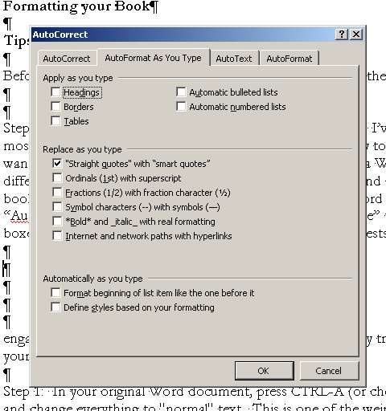

Back to top

Step 4 - Eliminate Text Boxes
Text boxes can corrupt your formatting, and they’re often difficult to find. Unfortunately, Word doesn’t make it easy to find them. To learn if you have text boxes, from your Word menu choose View: Print Layout, then click on your pages and if the shaded dashy lines appear around your text, that’s a text box. Text boxes will corrupt your ebook conversions by inserting a paragraph return at the end of every line, or awkwardly shifting your text. Be sure to check your headers and footers, because you’ll often find text boxes hiding there, surrounding paragraph returns, or surrounding the auto-page-numbering. Remove them. We have seen instances where a simple auto-page-numbering textbox in the header will cause some file conversions to become corrupted.
Here’s a screenshot:

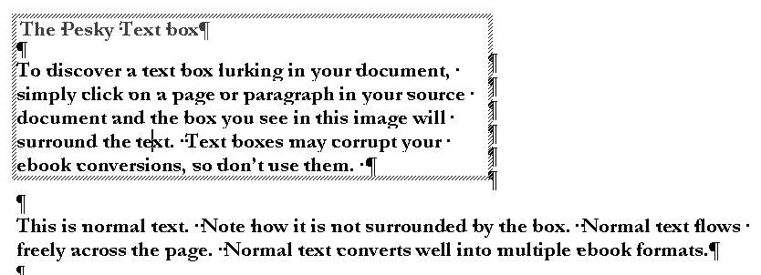
The most reliable method of eliminating text box is called the Nuclear Method, mentioned above, and described in greater detail in the next section below.
If you already suspect your formatting is screwed up, or if your manuscript originated from a PDF file, or if it has touched multiple word processors over the years, it’s not a bad idea to use the Nuclear Method now, because it gives you a fresh clean document. As you’ll see later when I discuss the topic of EPUBCHECK (an industry-standard validation your EPUB must pass in order for us to ship your book to Apple), the Nuclear Method is the last-resort solution to fix files that can’t pass EPUBCHECK. If you go Nuclear now, you won’t have to do it later.

Step 5 - THE NUCLEAR METHOD (HOW TO PURGE HIDDEN CORRUPTION)

Back to top

Your Microsoft Word document can become corrupted if it has been touched by multiple word processors, or if it originated in a program such as InDesign or WordPerfect, or if it originated in PDF and then was converted to Word.
The Nuclear Method purges all your formatting and allows you to start with a fresh Word document, free of hidden formatting or corrupted styling. The Nuclear Method is optional but recommended. Most formatting professionals on Mark’s List employ this method because it maximizes your odds of a good clean multi-format conversion.
The Nuclear Method is also recommended if previous versions of your manuscript failed to convert, or if you’re struggling with EPUBCHECK errors, text boxes or tables you can’t find, or if you suspect your book is corrupted.
First, make a backup of your manuscript (VERY IMPORTANT!) and set it aside in case the Nuclear Method fails you. Next, copy and paste your entire manuscript into Windows Notepad (usually found in Programs: Accessories) or any other text editor. This will strip out all your formatting. Close Microsoft Word. Then reopen Microsoft Word so it’s showing a fresh empty document. Next, in Notepad, type CTRL+A (press the CTRL key, hold it down, then press the A key at the same time) for “select all” then CTRL+C for “copy,” then paste into the empty Word document using either CTRL+V (for paste) or Edit: Paste (in Word 2000 and 2003) or Home: Paste (Word 2007). From here, reformat the book per the Style Guide. Remember to make sure you complete the previous steps, such as turning off “AutoFormat as you type” and “AutoCorrect as you type” covered above in Step 3.
***~~~***

Step 6 - Unify Manuscript around Normal Paragraph Style
In your raw Microsoft Word document, (especially if you didn’t use the Nuclear Method above) you probably have a mishmash of conflicting and inconsistent paragraph styles. You might have Normal paragraph style, or other paragraph styles such as Body Text, Plain Text, or multiple Heading styles. You probably don’t even know you’ve got these styles (often because of Word’s annoying habit mentioned above in Step 3 of changing your formatting to what Word thinks you want, rather than what you really want).
CHANGE EVERYTHING TO NORMAL PARAGRAPH STYLE: If you change your entire book the Normal paragraph style, right now, you’ll save yourself a lot of time and headache (you can add other styles back in later) and you’ll get a cleaner conversion.
***~~~***
Here’s quick sneak peek flash forward of where I’m taking you: You’ll change everything to Normal paragraph style, then you’ll modify Normal to define what you want it to define based on whether you want first line indents or the block method, then you’ll judiciously add in additional paragraph styles if necessary (such as maybe the Heading style for chapter headings), then you’ll add your bold and italics, then you’ll do clean up and then you’re done.
***~~~***
If you ignore the Normalization step, then you’ll receive complaints from customers that your font size and font style changes erratically from one paragraph to the next. Such inconsistent style usage can also prevent you from gaining access to the Premium Catalog, or, if your inconsistent styling slips past our reviewers, retailers will reject your book for the same reason.
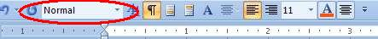
To unify your text around the Normal paragraph style, in Microsoft Word press CTRL+A (press the CTRL key at the same time you press the “A” key, or choose Edit: Select All from the menu) to highlight all your text, and then select "Normal" from your option bar up above. This will allow you to standardize on a single font, single font size, the same line spacing, and the same text justification (we recommend left justified, a.k.a. “ragged right” by its detractors). Note that depending on your formatting, when you change the text to Normal you may lose some formatting (what was centered previously may become left justified or your italics may disappear, for example, as well as other changes, so be sure to carefully re-apply necessary elements later).
In Word 2007, if you're trying to make the pull down box pictured above appear in your Word 2007 menu, click the round Office button upper left, then click Word Options, then click Customize, then scroll down the left column and click "style," then click "Add" in the middle column and that will put in on your menu bar. Or, you can access via Step 7 below.
Although we recommend changing everything to Normal paragraph style at this step, you can still add additional styles later (in fact, we recommend you add additional styles later), and you can also modify the Normal paragraph style to reflect the font size, style and other paragraph characteristics you want (learn how in the next section!).

Back to top

Step 7 - Managing and Modifying Paragraph Styles, Fonts
Word comes with many pre-defined paragraph styles. You’ll see in this Style Guide we recommend you unify as much of your book as possible around the Normal style, at least to start, to minimize conflicts and complexity. Once you learn how to manage your Normal style (or any other style for that matter), you’ll gain much greater control over the quality of your ebook’s formatting. You’ll also save a lot of time and headache. For example, you can define special first line indents within your style, or you can define spacing around your paragraphs (more on this later in the section that follows).
You can even create your own custom paragraph styles. For example, it’s often a good idea to create a custom style you can apply to text or images you want centered. In Step 14a later, I’ll show you how to do this.
What You See is (not always) What You Get. Just because your manuscript on screen in Microsoft Word looks like it has a font of 12pt Times New Roman, the book may appear in some of the Smashwords ebook formats as 10 pt Courier or some other font (this happened to me with my own book, Boob Tube). How does this happen? The answer is in Word’s underlying paragraph styles. If Word thinks the default font size for the “Normal” paragraph style is 11pt Courier, even if you manually changed your document to be 12pt Times New Roman on screen, the book it passes on to Meatgrinder will be 11pt Courier if the underlying style defines Courier.
This has important ramifications. To control how your text behaves as an ebook, you want to learn to control your underlying definitions of your paragraph styles.
To ensure you pass to Smashwords what you intend to pass, follow these instructions: Within older version of Word (pre-Word 2007), click Format: Style, then on the left click “Normal” if it isn’t already highlighted. In the center pane of the window, under “character preview,” Word will show you sample text and tell you the default font style for “Normal” text. If it’s what you want, then you’re good. However, if it’s different (as it was in my case when I uploaded my novel), then click Format: Font: and then select the font and font size you want. We recommend Times New Roman. Don’t use exotic fonts because they will not translate well, and they could even cause your conversions to fail.
If you’re using Word 2007, click the Home tab, then click the little arrow under “Change Style” (see image below)
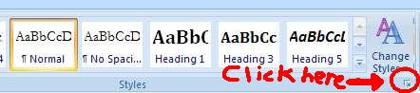
… then you’ll see…
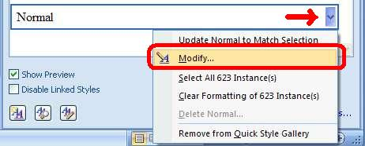
… click Modify above, then the following will appear…
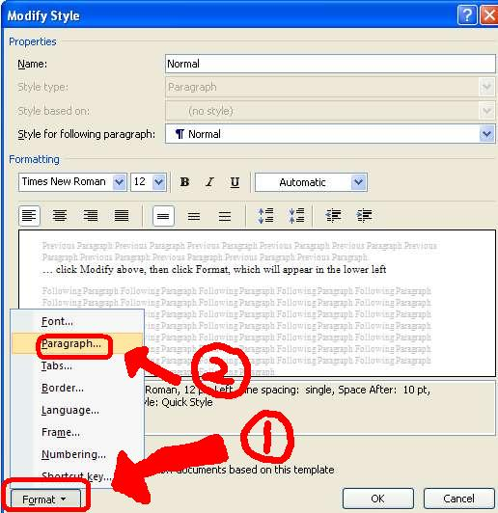
… click Format in the lower left, then click Paragraph to modify the paragraph style.

Back to top

Step 7a - Choose a Paragraph Separation Method: First Line Indent or Block Method
It's important you provide your readers visual cues to separate one paragraph from the next, otherwise paragraphs blend together and create a horrible reading experience. For the body of your book (everything after the title and copyright page), either use first line indents at the beginning of a paragraph, or use the block paragraph method. Don’t use both.
This Style Guide uses the block paragraph method, which is common for some non-fiction. The first line paragraph indent method is best for fiction and narrative non-fiction.
Don’t mix the two methods in the body of your book. For reference, pick up virtually any printed novel. Novels almost always use first line indented paragraphs, with no separation between one paragraph and the next. One paragraph ends on one line, then the next paragraph begins on the next line.
The image below further illustrates the difference between block and first line indent:
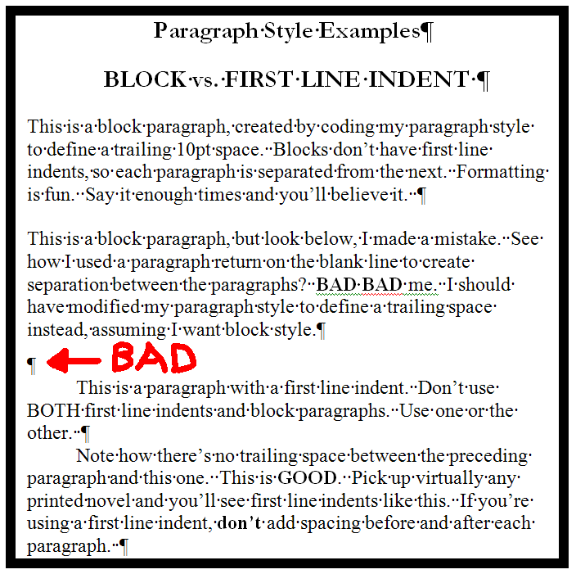

First line paragraph indents are preferable for fiction and also work well with a lot of narrative non-fiction. Block paragraphs work well for other non-fiction, especially if you’re managing multiple sections, or the layout is more complicated. DO NOT USE both first line indents and the block style. Use one or the other only. Yes, I know I’m repeating myself here (it’s one of the most common errors our authors make).
Also, avoid separating blocks of paragraphs using a paragraph return on an empty line. Instead, modify your paragraph style to define a trailing space. The next few sections below, along with their accompanying images, will help you learn how to modify your paragraph style to define a trailing space after each block paragraph

Back to top

Step 7b - How to Implement Your Chosen Paragraph Separation Method (First Line Indent or Block)
If you use Word 2000 or 2003, click Modify: Format: Paragraph, and then view the contents (see example below). Make sure the numbers under both left and right “indentation” are set to 0”.
For Word 2007, click the Home tab, then click the little arrow, as shown in Step 7 above, then click the down arrow for Normal style (assuming you’re using the Normal style for your body, as we recommend), then click Modify, then click Format in the lower left corner, then click Paragraph.

Back to top

Step 7b-a - HOW TO DEFINE A PROPER FIRST LINE INDENT
Once you’re at the screen to modify your paragraph style (this screen is essentially the same for all versions of Word), you can define a first line paragraph indent for the body of your book by selecting Special: First line: By: [enter .25 or .3 inch. Don’t do indents greater than .5 inch]. Make sure the Spacing section, marked by the red oval below, doesn’t define a Before or After space. They should be set to 0pt. Once your settings match the image below, click OK then Apply.
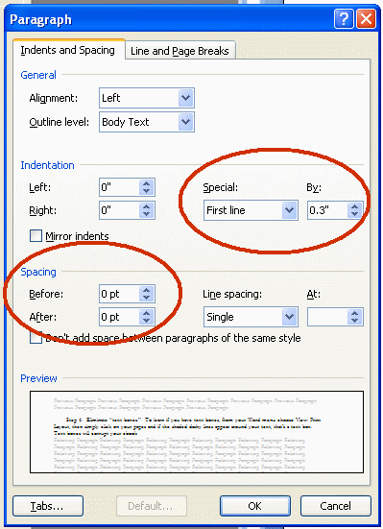
After you apply first line indents to the entire document, review your document to clean up any anomalies. If you apply the indent to the entire book, be sure to go back to your title and copyright page and remove the first line indents and then center the text for a good-looking title/copyright page. You may also need to manually remove the first line indent from other paragraphs or lines that don’t need them, such as chapter headings.
Kindle tip: The Amazon Kindle and its associated apps (Kindle for PC, Kindle for Mac) automatically insert a preceding first line indent, even on block paragraphs. If you want to enforce the block method across all formats and devices, including the Kindle, define a first line indent under “Special” above of 0.01”. The indent will be imperceptible to most eyes, and it should prevent Kindle and its apps from inserting the first line indent where you don’t want it.

Back to top

7b-b - HOW TO DEFINE TRAILING “AFTER” SPACE FOR BLOCK PARAGRAPH METHOD
Reminder: Do not follow this step if you already created a proper first line indent in step 7b-a above. Under “Spacing,” set the “after” spacing to 6pt or 10pt. For plays, scripts and screenplays, 4pt is pretty good. We generally don’t recommend less than 4pt or more than 10pt. Then click OK and then APPLY (or, OK for Word 2007)
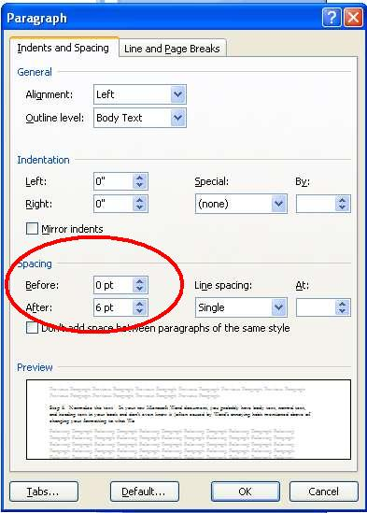

Back to top

Step 7b-c - SPECIAL TIPS FOR POETRY, COOKBOOKS AND LEARNING MATERIALS
As we mention elsewhere in this guide, we recommend you don’t use paragraph returns on empty lines to create separation between two paragraphs. However, this isn’t a hard and fast universal rule, and there are times when exceptions make sense. For example, poetry has some special requirements. With poetry, you want your stanzas tight, yet you need each poem separate from the next. If you code your Normal paragraph style to define a trailing “after” space, the poem won’t look right.
Other content categories that might benefit from this exception include learning materials, such as the multiple choice example below, or cookbooks.
For poetry and non-fiction that require this more complex layout, below are two options for your consideration (IMPORTANT: You need to have Word’s Show/Hide feature activated so you can implement this formatting):
1. You can use paragraph returns (don't code them for trailing space. Instead, code them for single spaced lines).
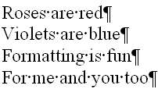

The poem above uses simple paragraph returns at the end of each line, with the paragraph style coded for no trailing space.

2. Use manual line feeds plus a paragraph return coded for a trailing "after" space. This option is a little more complicated, but will get you great results. To create a manual line feed, click Shift and Enter at the same time. A manual line feed creates a line break without invoking the styling of your paragraph style, which in the example below is coded for a trailing 10pt space after each paragraph return. Note how only the question and the last answer have their lines terminated with a paragraph return (created by hitting the Enter key). Use this trick for poetry as well.
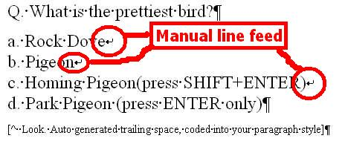

Back to top

7b-d - HOW TO DEFINE PROPER LINE SPACING
See how the line spacing in the image above in 7b-b is set to single and the “At:” field is blank? This is good. Line spacing of 1.5 is also acceptable. Don’t set it to double (will make your book look ugly), and NEVER NEVER NEVER set it to read “Exactly” or “At Least” followed by a point size specification under the “At:” box.
Line spacing of “at least at” or “exactly at” will usually render your book unreadable because it can cause lines to overlap on top of one another, or prevent an e-reading devices font size customization to work. The error is most commonly introduced when you use a word processor other than Microsoft Word (such as Open Office). More on the next item below on line spacing error.

AVOID THIS COMMON LINE SPACING ERROR: The image below shows an example of a common line spacing error mentioned above that will cause your sentences to overlap and become unreadable. Whether you use the first line indent method or the block method, make sure the “Line Spacing” is set to “Single” or “1.5” and under the “At:” heading it should always remain blank. As I mentioned in the paragraph above, NEVER NEVER allow any entry into the “At:” field, otherwise your book may become unreadable in the HTML reader and in the EPUB. If this error slips through our review process, retailers will remove your book when their customers complain. To determine if this error might be affecting your document, right mouse click on any paragraph, click Paragraph, and then you’ll see the box below. As mentioned above, this error is most commonly caused when you create your manuscript in a program other than Microsoft Word, and then the non-Word program fails to convert the file into a proper Word .doc.

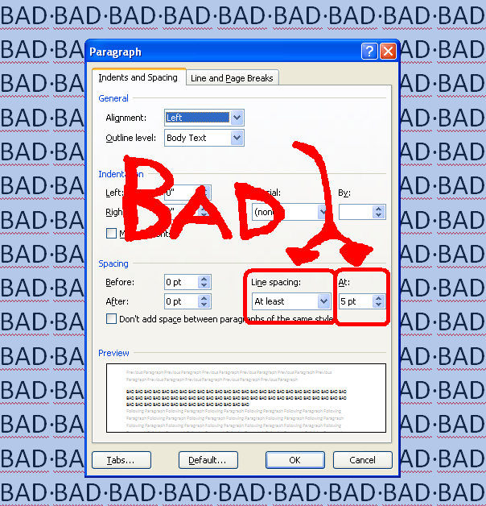

Back to top

Step 8 - Check Your Normalized Text
After you have successfully changed everything to Normal paragraph style above, and you coded your Normal paragraph style for either first line indent or block, you'll need to go through and re-check the formatting. Some items may have shifted because of the steps above. Bolds may disappear, centered items may become left justified, font sizes may have changed, and spaces between paragraphs may have disappeared. Just go back and fix, but make sure everything is Normal paragraph style and make the font sizes, line spacing and text justification consistent. If you find you change the text and suddenly Word labels it something other than Normal style, then it means you didn’t successfully disable Word’s nasty auto-format features above in Step 3.

Back to top

Step 9 – Why you Should Never Use Tabs or the Space Bar to Create Indented Paragraphs
An indent is the space in front of the first line of every paragraph. As I mentioned earlier in this Guide, indents serve as an important visual cue to help guide the reader’s eye from one paragraph to the next. If you use tabs (created by hitting the Tab key) or space bar spaces (created by hitting your space bar) instead of a proper first line indent, you’ll generate an AutoVetter error and our HTML and Javascript online readers will automatically remove the leading spaces or tabs from your text, thereby causing the indent to disappear. To create a proper first line indent, follow the section above on How to Create a First Line Paragraph Indent. NEVER NEVER use tabs or space bar spaces. Always make sure you have “show/hide” activated, per instructions above, otherwise you won’t see these tabs and spaces. The image below will help you spot them.
-----------------------------------
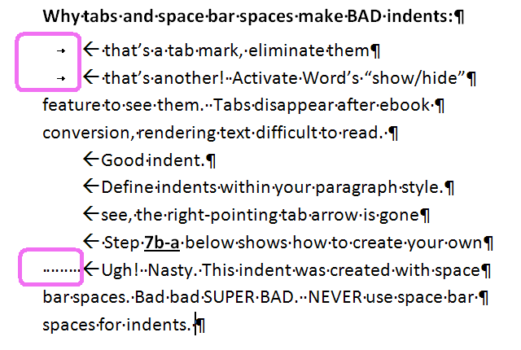
-----------------------------------
How to automate the removal of tabs and spaces - If you try to manually remove, one by one, the tabs and space bar spaces that comprise your improper indents, it can take hours and you’ll make mistakes. Luckily, Word’s search-and-replace feature takes mere seconds (see image below). If you used tabs, press CTRL+H (hold down the CTRL key and the H key at the same time) to "find and replace,” or from the menu select Edit: Replace. Then for the “find what” line enter ^t (the “caret t” is the symbol for tab) and then in the Replace space don't enter anything (If instead of tabs you have multiple spaces, then determine the number of spaces you use, then click your mouse to the “find what” field, and hit your space bar by the same number of spaces you’re currently (improperly) using for your indents, and then hit “replace all”).
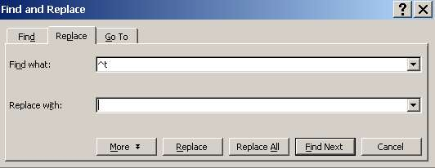
To eliminate all your tabs, enter ^t in “find what” and in the “replace with” line, leave it blank.

Then click the “Replace All” button. After you zap all your tabs, remember to modify your Normal paragraph style to define a “Special First Line Indent.” .2” or .3 inch is a good indent. Don’t go more than ½ inch.

Back to top

Step 10 - Managing Paragraph Returns
Make sure you only have paragraph returns at the end of a paragraph, not at the end of each sentence or every line (unless of course you’re doing poetry). A paragraph return, created by hitting the “Enter” key on your keyboard, tells the reading device it’s the end of the paragraph. They look like this: “¶” you have Show/Hide activated (see Step 2 above). If you do not have the show/hide feature activated now, stop what you’re doing and activate it, otherwise you’re editing blind.
Do not use multiple consecutive paragraph returns to force page breaks or to arrange text on the screen, because they’ll create a poor reading experience by creating blank pages or unsightly gaps in small-screened e-reading devices. They will also disqualify your book from distribution in the Premium Catalog. Never use more than four consecutive paragraph returns at a time to arrange text on the page.

Back to top

Step 11 - Managing Hyperlinks
Hyperlinks can point outside your book, like to a web address, or inside your book, using the bookmark feature (more on this later when I show you how to create a hyperlinked Table of Contents!). Web addresses become clickable hyperlinks in our HTML and Javascript readers, and in our EPUB, MOBI and PDF versions.
Use hyperlinks judiciously. If your book contains too many hyperlinks, the hyperlinks can backfire by becoming landmines if the reader accidentally touches them. This is especially true with mobile devices such as the iPhone or iPad, where the reader is most likely to scroll through pages by swiping the screen with their finger.
Also, short attention spans are common on the Internet, so if you give your reader too many chances to slip out of your story and read something else, you’ll lose them.
To place a proper external hyperlink within Microsoft Word, highlight the text you want to hyperlink, then right mouse click on the highlighted text, then click hyperlink, then enter a full web address such as http://www.smashwords.com. Be sure to include the http:// portion, otherwise your hyperlink won’t work and it’ll cause errors in EPUBCHECK (more on that later). After you add a link, click on it to test it.
To place an internal hyperlink to a bookmark, after you highlight the text and right mouse click and select hyperlink, select the “Place in this Document” option that will appear on the left pane of Word’s window.
NO AFFILIATE LINKS: If your hyperlinks link to affiliate marketing pages (common in “get rich quick” books), we will delete your account without warning because this is a violation of our Terms of Service.

Back to top

Step 12 - Designating Chapter Breaks, Page Breaks and Section Breaks
If you insert page breaks into your Word document (Insert: Break: [choose one]), the PDF and .RTF versions will honor them, but these commands will be lost in most other formats, which strip page breaks and section breaks. Loss of page breaks is okay in an ebook, because you can’t predict the font size or screen size the reader is using, and you want to have continuous reflowable text anyway. The worst thing that will happen is paragraphs may become artificially close or too separated.
If you use page breaks, be sure to enter a paragraph return or two before and after the break so that if your manually-inserted break disappears in some formats, your paragraphs don’t smash together.
Remove all section breaks from your document. For some reason, they create unnecessary blank space in your ebook.
If you want to separate chapters, insert a consistent number of paragraph returns (maybe three or four), or use a combination of a couple paragraph returns, followed by centered text characters such as “~~~~” or “* * * *” followed by a couple more paragraph returns and possibly chapter headings if you have them. Do not use solid separator bars.
The general rule for formatting is “simpler is better.” DO NOT use a long series (more than four) paragraph returns anywhere in your book to try to arrange words on a page, or to designate page breaks, because not only will this cause your book to be rejected from the Premium Catalog, it’ll also create a lot of awful looking blank space in your ebook. Many ebook reading devices such as the Kindle and iPad will add extra padding after each paragraph return, so if you add multiple paragraph returns this can create excessive spacing between paragraphs.

Back to top

Step 13 - Working with Images
If you have images, they should be embedded in your Word file with the Insert: Picture: As File option. If the images are critical to your book, then when you publish your book uncheck the checkbox ebook option for “Plain Text” because photos and charts don’t translate into plain text. If the images are a nice-to-have but not a need-to-have, then go ahead and allow the Plain Text option.
You can insert .JPEG or .PNG images. We find that .PNG works best.
File Upload Limit, 5MB. The source .doc file you upload must be less than 5 megabytes in size. To determine your file size, right mouse click on your Word .doc file and click properties. If your file is greater than 5MB, users of Word 2003 and later can use Word’s awesome Compress feature, which will dramatically reduce the file size without visibly harming quality. Simply right-mouse click on an image, click Format Picture, and then click the Compress button. Next, click the All pictures in document radio button, then click Web/Screen (selects the 96dpi compression), then click OK.
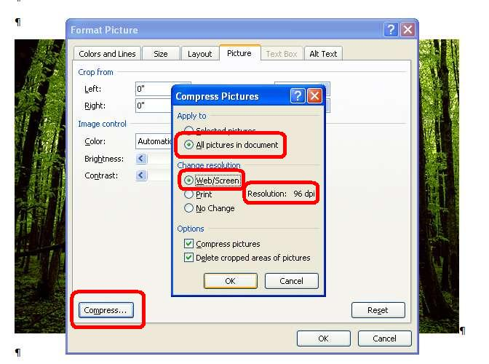
High resolution images? If your images are high resolution or print quality, this high resolution will be lost on e-reading screens because screens don’t support print resolution. When you downgrade to 96 dpi, you won’t visibly harm quality and you’ll create an ebook that downloads faster.
Resizing images: If you reduce the dimensions of an image by clicking the corner and dragging it inward, some ebook file outputs will respect the new dimensions, though Kindle may not. If this is an issue in your testing, resize the images before you import them into the Word .doc.
No floating images: Do not use floating images (if you can click on the image and drag it, it’s floating) because your image may appear in unpredictable places after the conversion. To anchor floating images, right mouse click on the image, then click Format Picture, then click Layout, then click In Line With Text, then click save, then click Word’s center button.
Images with embedded text: Avoid embedding text within the image, as is common with some children’s picture books. It’s best to remove text and place outside the image as reflowable text. This ensures that readers can resize the text to meet their reading preferences, and it also ensures that the text is readable and reflowable across all screen sizes.
Cover image inside Word .doc?: It’s not necessary to insert your cover image into the Word .doc. Meatgrinder automatically inserts your cover image into your .epub and .mobi files, so if you already insert the cover image it’ll cause the cover to appear twice in these file formats. For more instructions regarding cover images, see Step 23 later in this guide.
Open Office users only: Open Office users often have trouble with images, because OO defaults to floating. If you’re an Open Office user, try entering a paragraph return on a blank line where you want the image to appear, and then click in front of the paragraph return and go to Insert: Picture: From File, then select the image to import it, then right mouse click on the image in Open Office, then select Anchor: As Character, then click your mouse to the right of the image, then click OO’s center button to center the image.
We’ve also found that images work best if you keep their dimensions small. If your current image runs the length of a 6 inch wide page, it may not display properly on the smaller screens of some ereading devices. Restrict interior images to widths of around 500 pixels or less. Before you import images into your manuscript, use a photo editing tool such as Photoshop or a free utility such as Paint.net at http://www.getpaint.net/ or Picasa by Google at http://picasa.google.com, to reduce the dimensions and file size. If you insert an image that reaches beyond the left or right perimeter of your page margins, it may cause some of your conversions to fail, or your image may not display properly. Also be sure to remove first line indents on images, because the first line indent could cause your image to shift off of the page.
If you want a page break inserted before an image, try clicking on the image and coding it as a Heading style. This should insert a page break in EPUB and MOBI.
If you try to upload a 15 megabyte manuscript to Smashwords because you didn’t reduce the image sizes, Meatgrinder will not accept your book for conversion and you’ll receive an error message. Compress your images first.

Step 14 - Text Justification
I’ve found that text converts most cleanly if it’s all left justified. Centered text works well, especially for your title and copyright page. I don’t recommend using Word’s “Justify” command, which attempts to spread your words evenly from margin to margin without leaving spaces at the end of each line. The PDF conversion can sometimes look odd for justified text. If you love justified text, then go ahead and try it - the results may still be acceptable to you.

Back to top

Step 14a - Centering Text
You may notice that even after you use Word’s button to center text, such as the title and copyright page, or *** separators, the RTF conversion doesn’t preserve the centering. Here’s how to force it to stick: Try creating a new custom paragraph style, based on Normal, that defines centering. That’s how Brian S. Pratt [the formatting example above] managed to keep their title pages centered).
Here’s how to create a custom paragraph style. Option 1. If you have the Style box in your main Word ribbon, then click the down arrow, then click Add.
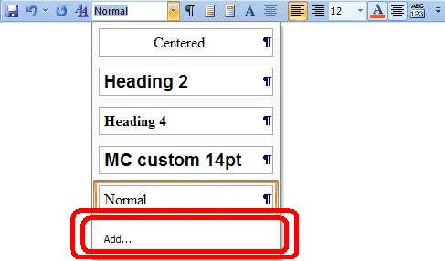

Option 2. In newer versions of Word, click Home: then under the “Change Styles” option, click the sideways down arrow.
… then in the lower left of the next screen,click the “AA” symbol
… After you do Option 1 or 2 above, the following screen appears. …
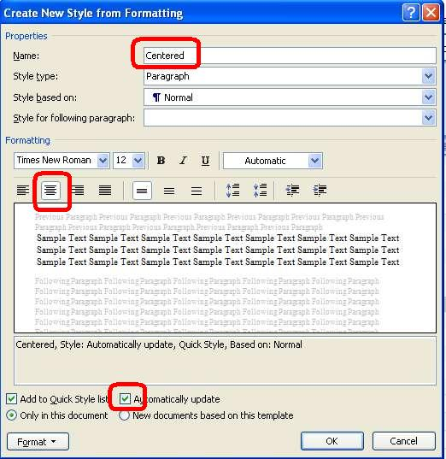
Give your custom style a name, such as “Centered”. Note that the style is based on “Normal”. This mean the style will inherit the default definitions of Normal unless you specify otherwise. Then click Word’s center button to define centered, and then click the box for “Automatically Update” if you want the changes you later make on screen to automatically modify the underlying paragraph style for usage of this style in your manuscript. Click OK when you’re finish. Later, to apply the style, simply highlight the text you want centered, and then select the style from either the style box in your menu.

Back to top

Step 15 - Managing Font Sizes
Minimize font size variation in your book, otherwise your book can look ugly. Some of the best-looking books on Smashwords use 12pt for the body and 14pt for the book title on the cover page, and for headings. If you must use different font sizes, minimize the range of their variance. For example, if your Normal paragraph style defines 12 point, don’t use a 20 point header. We recommend you keep your largest font size to 14. Frequent and/or dramatic font size variations are jarring to your reader’s eye and can reduce readership, because each time you change the font size their eye must refocus. Dramatic variations in font sizes can also cause unwelcome glitches in some of the conversions, such as causing the large point text to bleed onto the smaller point text. Most of our ebook formats support multiple font sizes, but our Javascript online reader makes everything the same font size (though it has other great online reading qualities so you’ll want to offer it to your readers).

Back to top

Step 16 - Style Formatting, Symbols and Glyphs
Italics, underlines, and strikethroughs work well. Some symbols (such as é î ® © Ω ∑) may translate, but test your book in EPUB to ensure they work properly. Rather than using the © (circled c for copyright), just use the word ‘copyright’, because some e-reading devices and formats will turn it into a question mark. As a general practice, avoid symbols (created by “INSERT: SYMBOL”) because they may turn into question marks in some ebook formats. If you observe what appears to be empty vertical rectangle boxes in your Word file when you have Show/Hide activated, this is often a form of corruption caused by bad conversions from one word processor to another. Delete them, otherwise these characters may turn into question marks.
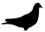
Glyphs are little graphical touches used to separate sections of the book. Let’s say I like pigeons (because I do), and I’m writing a book about their amazing ability to find their way home. I might decide to separate my sections with a glyph of a pigeon (above, below).
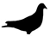
If you decide to upgrade your book with glyphs, choose an image that fits the theme of your book. If you’re writing epic fantasy, it might be an image of a magical battle ax. Glyphs work best as small, simple black images or simple uniform illustrations. Use Word’s Insert: Picture: From File option to import your image. Use your custom centered paragraph style to ensure proper placement. Don’t go overboard with glyphs because you run the risk of ruining a perfectly good ebook. If your glyph distracts from the story, you’re overdoing it.

Back to top

Step 17 - Headers and Footers
These generally remain in the PDF and RTF versions but disappear in the other versions. We recommend you remove headers and footers. Definitely remove auto-page numbering because it can trigger a text-box error.

Step 18 - Margins, Page Sizes and Indents
Try to format your book to adhere to Word’s standard margins for printing, otherwise your PDF and RTF files won’t print well or present well on screen. Authors often ask if they should format for American-style pages (8.5 X11 inch) or A4. About 60% of Smashwords customers are American, so it’s really up to you.
HOW TO FIX WACKY INDENTS: If your indents are pulled too far to the left or right, it will cause your text to flow off the page and become unreadable in some e-reading devices. It helps to have your ruler bar activated to detect this problem. To fix, do a CTRL+A on your entire document, then right mouse click on Paragraph, then set the Left: and Right: Indentation to 0”.
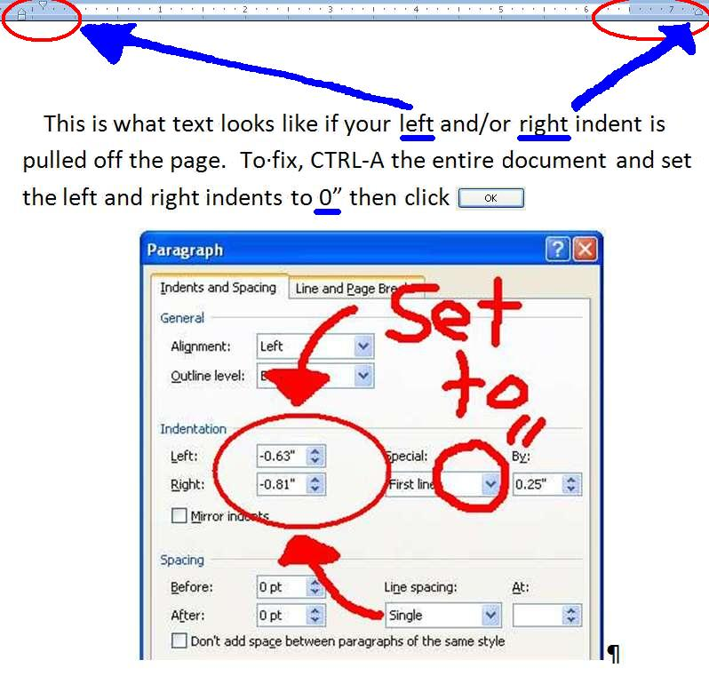

Back to top

Step 19 - Add the Heading Style to Your Chapter Headings (Optional)
Word offers various Heading styles, usually for use with the start of chapters or sections. Some of our ebook formats such as EPUB and MOBI will automatically insert a page break before each Heading, which is a nice touch because it allows your chapter to start at the top of the page on the e-reading device.
Warnings! Be careful with the Heading style, though, because if you use it too often or in the wrong place, the beneficial page breaks I mentioned above will become an annoying formatting error that makes your book difficult to read because it’ll create one line pages (annoying). Only apply the Heading style to a single sentence, and NEVER across more than two paragraph returns in a row, otherwise you’ll have one paragraph per page (Bad). Also don’t use the Heading style for body copy, or for your front matter or table of contents at the top of the book.
Are Heading Styles for You? As mentioned in the heading for this step, the Heading Style is optional. One advantage of using a specially defined paragraph style is that it gives you more control over the look of the text. For example, your Normal paragraph style might define 12pt Times New Roman, but maybe you want your headings to be 14pt Helvetica Bold Italicsand centered. Although you could manually alter each Normal heading to reflect the formatting you want, it’s time consuming, and also prone to error if you forget to implement everything consistently. By defining each heading with the Heading style, you can automatically apply the style to that heading, and then if you decide you want to change the style later, you can do it just once and it’ll update all your headings.
How to Implement Headings: To implement, highlight your chapter headings and then select a heading style, such as Heading 2. This can make ToC-building easier in step 20 below. If you want to modify your Heading to have different characteristics, such as a different font size, or alignment, see Step 7above which shows you how to modify your paragraph styles.

Back to top

Step 20 - BUILDING NAVIGATION INTO YOUR MANUSCRIPT
Smashwords makes it easy to build navigational elements into your manuscript so your book becomes more accessible and more valuable to readers. I’ll review three primary navigation elements in this step: the NCX file, the linked Table of Contents (ToC) and Non-ToC intra-book links (Footnotes/Endnotes/other).

Step 20a - Creating the NCX File
NCX stands for NCfile for X. I like to think of the NCX as a meta-ToC, since the file and the navigation actually reside outside the book, but point back into the book (What you know as an EPUB file is really a zipped combination of multiple files of which the .NCX is only one).
A well-formed NCX file adds useful navigation for your reader. Kobo requires a working, two-part NCX. Apple also prefers an NCX, especially for books with multiple chapters, headings or sections. Your readers, regardless of e-reading device, will appreciate a good NCX.
You have three options for creating an NCX at Smashwords:
1. If you name your chapters starting with the word “Chapter,” Meatgrinder will automatically detect the word and build NCX navigation links into your EPUB file. See the screen shot below.
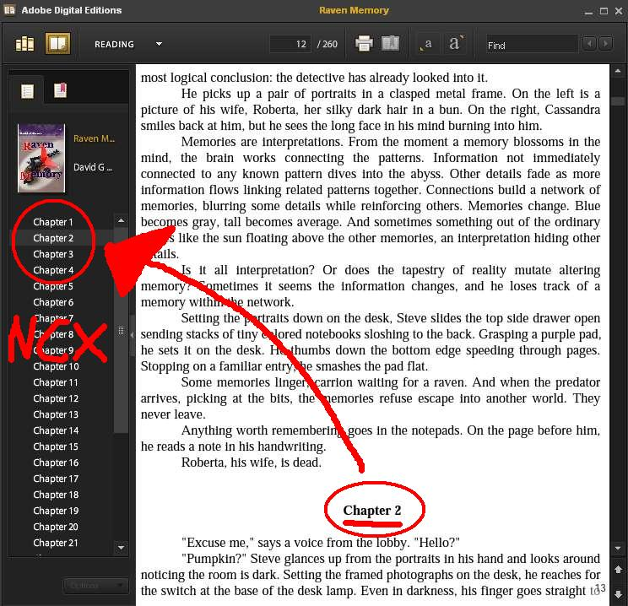
Simply by preceding your Chapter headings with the Word “Chapter,” Smashwords will generate useful navigation for your EPUB file
The book above is Raven Memory(a well-formatted book, by the way) from Smashwords author David G. Shrock, and the screen shot shows his book in Adobe Digital Editions, a popular and free e-reading app I encourage you to download so you can test your own EPUB files (Get it at http://www.adobe.com/products/digitaleditions).
On the left side of ADE’s screen above, you can see the automatically created table of contents (the NCX). Mr. Shrock used the Normal paragraph style and centered it for his chapter heading. Although he didn’t do it in this example, he could have easily named his chapter something such as, Chapter 2: The Joys of Ebook Formattingand this (more descriptive) text string would have appeared in the NCX file instead.
2. Your second option is to create a linked Table of Contents (Step 20b below). This is actually my favorite option, because it gives you greater control over the NCX entries. If you create a linked Table of Contents, then Meatgrinder will use the linked ToC to automatically guide its generation of your NCX. This is a good option if “Chapter” designations don’t work for your book. See the step 20b below to understand if the linked ToC is right for you, and how it’s different from the .NCX.
3. If Meatgrinder determines it cannot build you a working two-item NCX using one of the two methods above, then Meatgrinder will automatically create a two-item NCX for you. The first item on the NCX will be labeled the title of your book, and will point to the first line at the top of your book. The second item will be labeled “Midpoint,” and this will point to the approximate halfway point in your book. This third option, which was introduced the second week of May, 2011, was implemented to satisfy Kobo’s requirement for a two-part NCX.

Step 20b - Creating a Hyperlinked Table of Contents
A Table of Contents (ToC) makes it easy for your reader to see, at-a-glance, the major chapters and sections of your book. You will manually build your ToC inside your manuscript immediately following your title/copyright page and immediate preceding the start of your book. As mentioned in the preceding section, your linked ToC will assist Meatgrinder when it automatically generates your NCX.
Once you make your ToC a Linked Table of Contents, readers can click the links and jump straight to the linked section. This is a cool feature of ebooks not possible in print books.
Before you begin:
1. If you already have a ToC, make sure it doesn’t have page number references. Page numbers are irrelevant to ebooks because the page count of your book will change based on the size of the screen, the size of the font the reader selects, or even how the reader holds their ereading device (on the iPhone, for example, a book might be 200 pages in portrait mode [holding vertically] and 350 pages if they hold the phone horizontally in landscape mode).
2. For your Smashwords ToC, you’ll use the Insert: Bookmark feature, and the Insert: Hyperlink feature. Warning: Make sure you didn’t previously build your ToC using Word’s auto-ToC generation feature, found in Word 2007 at References: Table of Contents, because it utilizes field codes and that’s not the right approach.
Do you need a linked Table of Contents? Most books can benefit from a linked ToC. If you write non-fiction, then yes, you should probably do a linked Table of Contents, especially if your book is organized into named chapters or sections. By adding a linked ToC, you make it easy for readers to navigate to different parts of the book.
Fiction can benefit from linked ToCs, especially if you have named chapters or sections, or if you’re publishing a collection of short stories (link to each story), or if you have sections at the end of the book such as “About [Your Author Name],” “Connect with [Your Author Name],” or “Other Books by [Your Author Name]” (we recommend your book include these sections because they offer you powerful marketing benefit). However, if your chapters are only labeled, “Chapter 1, Chapter 2, Chapter XX” and you don’t have additional sections at the end, then there’s little need for a ToC inside your book. In this case, let Meatgrinder automatically generate the NCX from your “Chapter X..” headings.
Understanding Meatgrinder’s TOC Generation: Between October and December, 2010, and then again during May and June, 2011, Smashwords made a series of exciting enhancements to the Meatgrinder ebook conversion engine that allows it to automatically detect linked Tables of Contents for our EPUB and MOBI files. If you build your own linked ToC in your book, Meatgrinder will detect it and use it instead of its auto-generated ToC. This provides you increased control over the contents of the NCX and the internal ToC.
If you follow the instructions below, your linked ToC will work in our most important formats of EPUB, MOBI and PDF. Linked TOCs of any form don’t work in our other formats such as the online HTML and Javascript readers, and of course it won’t work in our .txt files either.
Planning your ToC: If your book has dozens or even hundreds of individual sections, avoid the inclination to link to every single item. A ToC with too many items creates a dizzying experience for your reader. Sometimes, less is more. Consider linking only to major section headings. Also consider how the reader will read your book. Fiction is read serially, from word one forward. Although an NCX listing chapter numbers is moderately useful, consider adding other worthwhile links pointing to the end of the book such as “About the author,” “Other Books by this Author,” or “Endnotes.” If you’re including free sample chapters of your other books at the end of this book (often a good idea), link to the start of your free sample from your Linked ToC.

How to create a linked Table of Contents.
First, create your table of contents where you want it by typing it out. The ToC goes at the start of your book, immediately following your title and copyright pages, and preceding the start of your prologue, preface or first chapter. As you type out your ToC items, make sure your text is in the Normal paragraph style, just like the rest of your Smashwords document. DO NOT create your ToC in Heading style. Avoid adding empty paragraph returns between the lines to build separation between the TOC items, and only add items you intend to hyperlink.

Here’s what your ToC might look like:

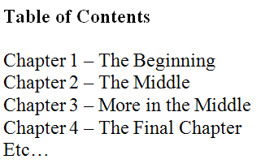
You can left-justify it (as I did above) or center it using Word’s center button (or better yet, follow the instructions in Step 14A to apply a custom paragraph style that defines centering). Never indent your ToC more than one inch.
Next, we are going to use Word’s Insert: Bookmark feature.
Think of the bookmark as your target – it’s what you want to link to. It’s the destination for the reader after they click the link in your ToC.
Later, after you add each bookmark you’ll link to it from somewhere else, and in this case that “somewhere else” is most likely the Table of Contents listing at the top of your book.
So, to review where I’m taking you here, first you’ll tag the chapter or section headings in your body as Bookmarks, and next you’ll return to your ToC and add the links to the bookmarks.

ADDING BOOKMARKS:
If prior to starting your ToC-linking adventure, you changed your chapter and section headings to one of the Heading paragraph styles, such as Heading 2, then these headings will probably appear as bookmarks with names starting with an underscore such as “_xxx” when you go to select a target during the hyperlinking process. Do not link to Word’s auto-generated Heading bookmarks. It’s better to create your own Bookmarks.
In Word 2000, 2003 and 2007 and later, the Bookmark function is under the Insert tab. Go through your document, and at each Chapter Start or section heading, you will highlight the words and then select Insert: Bookmark. Make sure you have show/hide activated so you can accurately apply the bookmark. As mentioned above, DO NOT place the bookmark above or below the target, and NEVER apply a single bookmark across multiple paragraphs.
Name your bookmark corresponding to the Chapter/Indexed item and then click add. Use the first word of your heading or section you’re linking to, because later on, when you add the hyperlinks to these bookmark targets, Word displays the bookmark shortcuts in alphabetical order.
Bookmark names cannot have spaces or odd characters. Use only alphanumeric characters (the letters a-z or the numbers 0-9).
With my bookmarks, I found I didn’t label them properly the first time, so it was tough to link to the correct bookmark. If you want to link to a chapter named How to Publish Ebooks, I’d recommend naming your bookmark something like “HowToPublishEbooks” or “How_To_Publish_Ebooks” to make it easy to locate. If you instead name it, “ebooks,” you’ll frazzle your brain and make mistakes, especially if you’re linking to a lot of bookmarks.
Repeat the process above for every Chapter heading or major section in your body as well as for other matter in the book like index, bibliography, epilogue, prologue, etc. I didn’t link to every section in the Style Guide, because otherwise the ToC would have been three pages long. This is your call.
Next, return to your table of contents at the top of your book and highlight the phrase “Table of Contents.” Click Insert, Bookmark, and label this last bookmark something like “ref_TOC” (by preceding the bookmark name with “ref_” you’ll help prevent Meatgrinder from duplicate NCX items). This will allow you to link all your Chapter headings in the body of your book back up to the top of the Table of Contents. DO NOT highlight your phrase, “Table of Contents” and link it to the bookmark of itself. This can cause problems, and it’s not necessary because there’s no value for the reader to link to where they’re already at.

LINKING TO BOOKMARKS (AKA “Targeting your bookmarks)
Next, you will create your hyperlinked ToC by linking your ToC items to your target bookmarks. Highlight the text of your ToC item, such as “Chapter Five: My Amazing Formatting Journey,” then right mouse click, click Hyperlink, then in Word’s Hyperlink menu on the left hand side, click “Place in this document.” You will now see your bookmarks listed in the main window. Remember, if you applied Word’s Heading paragraph style earlier, it will present you Word’s auto-generated bookmarks, which usually begin with an underline, such a “_X…” Don’t link to those.
Select your bookmark and then click ok. Repeat this procedure for every bookmarked chapter or item in the ToC for which you want to create a clickable link.
Tips: 1. All items in your TOC should be hyperlinked. 2. The text string you select and hyperlink in the ToC is the same text string that will appear in your NCX.

LINKING BODY PARTS BACK UP TO THE TOP
Now you can link your chapter and section headings in your body back up to the table of contents. This makes it easy for the reader to jump back up to the top of book.
Some authors prefer to link the text their chapter or section headings (such as “Chapter 6: How the Style Guide Made Me a Super Fabulous Formatter”) back up to the ToC. Other authors prefer to insert other text as their linkable item, such as, “back to top.” I chose the latter option for the Style Guide because the text string clearly tells the reader what will happen if they click the link. The former, however, is faster and simpler and more common.
Here are the steps to link back up to the ToC:
1. From your ToC, click on the link to jump to your chapter or section heading target. In Word 2000, you just click, but in later versions you must press on the CTRL key at the same time you click the hyperlink.
2. After you click from your ToC to the target item’s bookmark, highlight the text of item with your mouse (remember, don’t allow your highlight to span across multiple paragraphs. You want to highlight only a single word or phrase, whatever you want to appear like a clickable item).
3. Next, click Insert: Hyperlink, and then select “Place in this document.”
4. The bookmarks will appear in the main window. Select the bookmark labeled “ref_TOC,” assuming that’s what you named your Table of Contents in the step above.
5. Repeat the above for each and every location where you want to provide the reader a clickable path back up to the ToC.

Step 20c – Advanced Bookmarking: Footnotes, Endnotes and other Intra-book links
You can link any part of your book to any bookmark. Above, I showed you how to link from your ToC down to your target bookmarks in the body of your book. In this section, I’ll show you how to create other types of “intra-book” hyperlinks.
Warning: If you don’t name the bookmarks properly you can corrupt your NCX. This section will show you how to do intra-book links the right way.
Intra-book hyperlinks makes it possible to link between sections, or to manually create linked footnotes, endnotes or indexes, or to create “name your own adventure” books where the reader decides what happens next in the story. Don’t go overboard with bookmarks and internal hyperlinks. If you place too many links in your book, they can act like landmines if the reader accidentally touches them.
As mentioned earlier, when Meatgrinder sees hyperlinked text in your linked ToC, it places the highlighted text in your NCX file, and this what your reader will see when they view your NCX. However, if you create non-ToC intra-book links within your book, such as footnotes/endnotes in the body hyperlinked to down your footnotes/endnotes sections, Meatgrinder may misinterpret that link as something you want added to your NCX file (and you don’t want footnotes/endnotes and other non-TOC links showing up in your NCX). To prevent your NCX from picking up these elements, you can neuter the bookmark by starting the name of your bookmarks with “ref_” (remove the “ “ marks).
So, for example, let’s say your have several endnote references, and they link to endnote bookmarks named 1, 2, 3, 4, etc. By renaming the endnote bookmarks to ref_1, ref_2, etc, Meatgrinder will know to not to slurp the link into the NCX. Your endnotes or bibliography at the end of your book may also hyperlink back up to the origin of the referenced footnote/endnote, so be sure to name those bookmarks starting with “ref_” as well.
Bottom line, if you don’t want your NCX to include a link pointing to a specific bookmark, then neuter the bookmark by starting it with the “ref_” name.
In the ToC-building section above, I recommended naming your Table of Contents bookmark as ref_TOC. Why? We’ve noticed that in some instances, Meatgrinder will create corrupted NCX files that include duplicate NCX entries at the end of the NCX. In some cases, if your Table of Contents bookmark starts with ref_ it’ll prevent this problem.

Step 20d – Testing and Troubleshooting Linked ToCs and links

TESTING: WALKING THE WALK WITH YOUR TOC
After you finish the links, all your links will be underlined. Carefully test every link in your book to make sure they’re operating properly. As I mentioned above, in some old versions of Word you can just click your mouse on the link, and in other versions you press the CTRL key at the same time you click.
There are two good methods of testing:
1. Click on each linked item in your ToC. Does it go to the proper destination? If it jumps you to the top of your book and not to your Table of Contents, it means you’re not linking to a valid bookmark. Make sure it doesn’t link you above or below the target destination.
2. Click Insert: Bookmark, and the Bookmark window will appear. Click on a Bookmark item, then click GoTo. This is a fast method of ensuring your bookmarks go to the right destination and that they DO NOT span multiple paragraphs (make sure you have show/hide activated).

REMOVE HIDDEN BOOKMARKS
After you’ve completed your testing, do this step last. Word has the bad habit of inserting “Hidden” bookmarks into your document, and in some cases these hidden bookmarks can corrupt your NCX. Once you’re finished hyperlinking the guts of your book, and testing the accuracy of your links, check for and delete hidden bookmarks. To find them, click Insert: Bookmark, then try clicking and unclicking the checkbox beside “Hidden Bookmarks.” Hidden bookmarks start with an underline, such as, “_Hlt29XXXX” Click the name of the hidden bookmark, which always look like gibberish, then click the Delete button at right. See screen shot below.
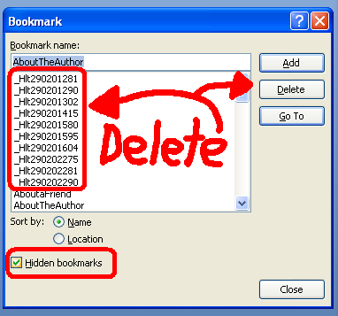

Final Tips and Reminders:
Warning: After you create your bookmarks and link to them, if you edit the names of the bookmarks, or edit the linked text, you might damage the viability of your links (I made this mistake multiple times in earlier Style Guide revisions!). Even if the links work in your Word document, they may not work in the final ebook. If you discover this to be the case after you publish, then you may need to remove all your intra-document hyperlinks, delete your bookmarks, and then recreate the bookmarks and retarget your links to the bookmarks.
Troubleshooting Reminders: Did you delete your hidden bookmarks as your last step? If you click Insert: Bookmark to open the window above, and you click a link at left and then click “Go To” on the right, does it take you to the proper destination? Does it show your bookmark appropriately applied to only the target phrase, and not overlapping to paragraphs above or below?
Reminder: Word has an automatic ToC generation feature under the reference tab that uses field codes. Do not use this. It uses automated headings and formatting to generate the ToC and this will un-normalize your text and cause font conversion issues in your Smashwords files.
Tip: Just because your links work in your document doesn’t mean they’ll work in your ebook outputs. Be sure to test your EPUB version after you publish (use Adobe Digital Editions. Download it for free at www.adobe.com/products/digitaleditions/ .

Kudos: My thanks to Smashwords author Cheryl Anne Gardner for conducting the initial research which served as the foundation for our section above on how to create a Linked Table of Contents.

Back to top

Step 21 - Front Matter (Important!!!)
Front matter is stuff that goes on the first and second page of your book.

Step 21a - Blurbs (optional)
Note: Front-of-the-book blurbs (testimonials) are not required for inclusion in the Smashwords Premium Catalog. In fact, there’s a potential downside to this step. If you add too much testimonial content to the front of your book, it can actually decrease readership because the reader doesn’t want to flip multiple pages to start reading. If you add blurbs, keep them brief. Also remember that many retailers have less generous sampling percentages than Smashwords, so if you add too much blurb content up front, a sample of your book won’t include any of your book.
If you add blurbs, put them at the very front of the book, before the Title & Copyright page (see below). If your book has received rave reviews from readers, consider adding a couple short snippets on the first page, so readers who sample your book will feel more inclined to purchase it. These should be real, honest reviews. If you falsify the reviews and your reader feels tricked, they may seek retribution by giving you a bad review on Smashwords or at the retailer’s store. Nothing kills a book faster than bad reviews.
Here’s how self-publishing guru Dan Poynter begins his Smashwords book, “Dan Poynter’s Self-Publishing Manual Volume 2” (view it at https://www.smashwords.com/extreader/read/607/1/the-self-publishing-manual-volume-2):

What Others are Saying about The Self-Publishing Manual

“Poynter is at his best when discussing such specifics as starting one’s own publishing house; dealing with printers; establishing discount, credit, and return policies; promoting, advertising, and selling a book; and order fulfillment.”
-- Publishers Weekly
“As usual, our self-publishing guru, Dan Poynter, is on the cutting edge of the New Book Publishing Model. Volume II couldn't come at a better time...when we so desperately need it!”
--Ellen Reid, www.bookshepherding.com

Back to top

21b - Title and Copyright Page (REQUIRED)

On the first page of your book (unless you add the blurbs above), insert a title and copyright page. This page will look best if you center it.
This page is required to publish at Smashwords. The copyright portion should be in English, even if the rest of your book is written in another language (it’s okay to list it in the book’s language too).
This page is where you identify yourself as the author and claim copyright ownership of your book (if you’re not the original author, or you’re not the exclusive publisher or distributor of this book, your book does not belong on Smashwords. Public domain books are not allowed unless you are the original author. Private Label Rights articles and other similarly scammy works are not allowed).
Tip: Your title/copyright page is the first impression you make on your reader. Make it look professional. Center the title and copyright page by following the tips above in Step 14A. Although you can use Word’s center command (the button is in your toolbar) to center text, it’s not as reliable as applying a custom style that defines centering. If you’re centering the text on this page, do not use any first line indents. Also base your text on the “Normal” paragraph style (or a custom paragraph style based on Normal), and don’t use more than two different font sizes (looks ugly).
Your ebook is published by you (the author or publisher) at Smashwords. It should say either Smashwords Edition on the copyright page, or "Published by [Authorname] at Smashwords," (remove the quote marks), or, if you’re a multi-author publisher, Published by [the name of the publisher publishing it on Smashwords] at Smashwords. Although some Smashwords authors consider Smashwords their publisher, we consider you the publisher. Smashwords is your ebook publishing and distribution platform.
Avoid long copyright pages. Shorter is better because it allows the reader to start reading your book faster.
A title/copyright page requires the following:
Book Title
Authorname

Published by Firstname Lastname [or PublisherName] at Smashwords
(or, alternatively, if you don’t want to use the “Published by...” line, add the words, Smashwords Edition on the next line. No need to do both.)

Copyright 2010 Authorname

(optional:)Discover other titles by [insert your author name] at Smashwords.com (or, link to your author page at Smashwords).
(Optional: if you have multiple titles at Smashwords, write:)

Discover other titles by Authorname at Smashwords.com:
Title 1 – hyperlink to your book page *
Title 2 - hyperlink to your book page
Title 3 –hyperlink to your book page

* Remember to make the hyperlinks “live” by highlighting the text you want to hyperlink, right-mouse click on the text, then follow the steps to insert the hyperlink. Remember, all web addresses here must begin with http://otherwise the address won’t be clickable. Link directly to your book page. Make it easy for your readers to learn more about you.

***~~~***
Here’s the world’s shortest Smashwords title/copyright page:
***~~~***

Formatting is Fun
Published by Mark Coker at Smashwords
Copyright 2011 Mark Coker

***~~~***
Here’s another good one
***~~~***

Formatting is Fantastically Fun
By Mark Coker
Copyright 2011 Mark Coker
Smashwords Edition

Do not write "Kindle Edition” or “Ebook available in the Apple iBookstore;” otherwise it won’t qualify for the Premium Catalog. This is your Smashwords Edition. Also don’t write, “Printed in the United States,” because this is your Smashwords ebook, not your print edition. Don’t confuse readers.
As a courtesy to ebook retailers who promote and sell your Smashwords Premium Catalog titles, please restrict your hyperlinks to only your Smashwords author page and book pages, or your personal home page or blog. Do not add hyperlinks to online ebook retailers that may compete with current or future Smashwords retail distribution partners. It’s not considerate, for example, if to advertise your Kindle or Apple ebook in your ebook sold at Barnes & Noble. Such advertising will only alienate your retail partners, confuse your customers, and will cause a retailer to remove your book from their catalog.
It’s not necessary to place your ISBN inside your ebook. Instead, it’s VERY IMPORTANT you attach your ISBN via your Dashboard’s ISBN Manager at Smashwords. If you don’t attach the ISBN via the ISBN Manager screen, your book cannot ship to Apple and Sony.
If the book is also available in a print edition, rather than naming retailers, just write, “This book is available in print at most online retailers.” Also remember that once your book is listed on Smashwords, you can add hyperlinks within your Smashwords book page to online outlets where the book can be purchased in print, assuming you still employ that quaint method of publishing (I love print books, but some of the best-selling indie authors are selling over 1,000 ebooks for every print book. This is probably why some indie authors are starting to skip print altogether).

Back to top

21c - Add a Smashwords License Statement below Copyright Page
All Smashwords books are sold DRM-free, without copy protection or encryption. This means you’re trusting your customers not to pirate your books. In our experience, the vast majority of customers are honest. Yet without proper education and reminders, a well-intentioned customer might feel inclined to share your book with someone else.
To minimize this accidental piracy, we encourage Smashwords authors and publishers to add the Smashwords License Statement to their book. Feel free to modify the Smashwords License Statement to suit your preferences. Or, for authors and publishers who prefer a Creative Commons license, that’s acceptable too.
The Smashwords License Statement is an original creation of Smashwords, and it has been widely adopted by thousands of ebook authors and even some competitors. The Smashwords License Statement acts as a friendly Trojan horse. Even if your book is accidentally copied or shared, the recipient of the book is gently reminded of their legal and ethical obligation to compensate you for it.
To use it for your book, add the following text to the title page or copyright pages of books that carry a price:
Smashwords Edition, License Notes
(Note: if you copy and paste this into your manuscript, be sure to remove the paragraph returns that may appear at the end of each line)
This ebook is licensed for your personal enjoyment only. This ebook may not be re-sold or given away to other people. If you would like to share this book with another person, please purchase an additional copy for each recipient. If you’re reading this book and did not purchase it, or it was not purchased for your use only, then please return to Smashwords.com and purchase your own copy. Thank you for respecting the hard work of this author.

If your book is free, it should still have a license statement. It’s up to you. Do you want to grant readers the right to redistribute the book for non-commercial purposes, or do you want to restrict the book to their enjoyment only and invite them to ask others to download the book on their own at Smashwords? Here are two potential suggested license statements for free books:
Smashwords Edition, License Notes
Thank you for downloading this free ebook. You are welcome to share it with your friends. This book may be reproduced, copied and distributed for non-commercial purposes, provided the book remains in its complete original form. If you enjoyed this book, please return to Smashwords.com to discover other works by this author. Thank you for your support.

Smashwords Edition, License Notes
Thank you for downloading this free ebook. Although this is a free book, it remains the copyrighted property of the author, and may not be reproduced, copied and distributed for commercial or non-commercial purposes. If you enjoyed this book, please encourage your friends to download their own copy at Smashwords.com, where they can also discover other works by this author. Thank you for your support.

Back to top

Step 22 - The End of Your Book
Many authors end their book with a period, and then give the reader nothing more. Don’t squander this opportunity. If your reader makes it to the end of the book, reward them!
First, add a ### centered on the next line to signify the end.
###

Next, consider adding a personal message. Put yourself into the mind of the reader. They just finished your book. They loved it. They think the author (that’s you!) is absolutely fabulous. They want to read more of your material. This is an opportunity to connect with the reader. You have various options. How about adding:
About the author:
[Insert a short bio, possibly even your picture]
Discover other titles by Authorname at Smashwords.com:
Title 1 - hyperlink *
Title 2 - hyperlink
Title 3 -hyperlink
* Remember to make the hyperlinks “live” by highlighting the text you want to hyperlink, right-mouse click on the text, then insert the http:// hyperlink. Link directly to your personal book page at Smashwords. Make it easy for your readers to learn more about you.

Connect with Me Online:
[add links to…]
Twitter: http://twitter.com/[insert your twitter address]
Facebook: http://facebook.com/[insert your facebook address]
Smashwords: http:// [link to your author page] (to find the address for your author page, simply click on My Smashwords [that’s it!])
My blog: http://

Next, consider providing a few sample chapters of another one of your books. This is an especially powerful marketing technique if you write series fiction. Provide the reader the first few chapters of the next book in the series and get them hooked now!

Back to top

POST FORMATTING

Congratulations! You’ve carefully studied and implemented the formatting instructions above, and now your formatting fun comes to a close. Now you turn your attention to final preparations as you prepare to unleash your masterpiece upon the world.

Step 23 - Prepare Your Cover Image
Your ebook cover image is the first impression you make on your prospective reader. Book covers are one of your best marketing tools (other than Smashwords, of course!). When you upload your manuscript, you’ll be asked to attach your book cover as an image file. An image file usually ends with the file extension .JPG or .png.
Unlike print books which have a front cover, back cover and spine, ebooks only have a front cover.
Unless you are a professional cover designer or graphic artist, we recommend you hire a professional cover designer. Send an email to list@smashwords.com to receive my list of low cost cover designers via instant autoresponder. I don’t earn a fee for the reference, and I can’t guarantee their work, though I will only suggest designers who have done good work for other Smashwords authors. Their rates usually range from $40 to $100, which I consider very reasonable. Most have online portfolios so you can check out their work first.
Book cover images are required if you want to gain inclusion in our Smashwords Premium Catalog (and yes, you want to be in the Premium Catalog to receive distribution to major ebook retailers). Book covers must be shaped like a book cover (a vertical [upright] rectangle, not a square) and should include your book title and author name. Keep your cover image tasteful and avoid obscenity. 1,600 pixels wide by 2,400 pixels tall is generally a good dimension, or such similar ratio. The image must be at least 1,400 pixels wide, and the height should be greater than the width. A good guideline is to make the height between 1.3 and 1.6 times greater than the width. I think 1.5 to 1.6 usually looks best, though you and your cover designer have some flexibility here.
Book covers cannot contain nudity, a price, or a web address (Apple, for example, will reject your book if they see a hyperlink on the book cover image), or advertisements of items not already included in the book. It must include the book title and author name, and the title and author name must match the title and author name inside your book and in the metadata (Metadata is what you enter on the Publish page, such as the book title, author name, book description. Metadata = data about something else, and in this case the “something” else is your book). The cover cannot be grainy or pixelated. Pixelation occurs when you start with a small image and expand the dimensions.
Make the text crisp and clear. Remember, your cover will be shrunk to the thumbnail size, so you want all the cover elements to look good in a small image. This means, if you make your title or author name too small on the cover, it’ll be invisible in the thumbnail.
Your image must be in RGB color, not CMYK (at the risk of getting too technical, most image files are RGB [stands for red, green, blue], which is what’s supported by computer monitors. CMYK is a format for printing ink on paper. Most image processing applications will give you RGB automatically. If your image is in CMYK, it will be rejected by Smashwords [assuming we catch it, and if we don’t catch it, the retailer will reject it]. Note that it is not easy to tell if your image is in RGB or CMYK. If your image opens in a Firefox browser, it’s RGB. If it doesn’t, then it’s probably CMYK. Your cover designer will understand.)
If you want to create your own ebook cover, one free and popular graphics application is Paint.NET (www.getpaint.net). I like Paint.NET and use it myself, but I don’t design covers with it. Unless you’re a professional cover designer or graphic artist, it’s usually much smarter to hire a professional to design your cover.
A good cover image makes a promise to the reader by capturing the feeling or substance of your book. To learn more tips about the importance of covers, and what distinguishes a great cover from a poor cover, download my free best practices ebook, The Secrets to Ebook Publishing Success.
Tip: Don’t upload your book to Smashwords until you have a good looking cover image, otherwise you’ll make a bad first impression on readers. We also require a cover if you want your book listed on the Smashwords home page immediately after you upload (all new books receive feature promotion – usually ranging from 15 minutes to an hour – on the Smashwords home page, so you don’t want to miss this by forgetting your cover image).

Back to top

Step 24 - Before You Publish, Review Requirements for Premium Distribution
Distribution is important. Think of it as virtual shelf space. To gain inclusion in the Premium Catalog, read the Smashwords Distribution page at http://www.smashwords.com/distribution and double check you have satisfied all the requirements.

Common Errors that will disqualify your book from the Premium Catalog:
If you carefully studied and implemented the Style Guide, you’ll have no problem gaining inclusion in the Premium Catalog. Here are some common issues that prevent inclusion:
1. Book cover is missing, or doesn’t satisfy dimensional requirements (should be vertical rectangle, not a square, and not a sideways rectangle), or needs to be cropped, or is missing the title of the book and author name. Book cover should be at least 1,400 pixels wide, and for the height, a good guideline is to make it 1.5 to 1.6 times taller than the width. For example, if your width is 1,600 (I recommend doing slightly larger than the minimum 1,400), your height would be 2,400 pixels if you’re aiming for the 1.5 ratio (1.5*1,600=2,400) or 2,560 pixels tall for the 1.6 ratio (1.6*1,600=2,560).
2. Your author name in the metadata is lower case when it should be Initial Caps, such as: Jane Smith. If you list your name as jane smith in your metadata, we’ll reject it. To fix, go to Account: Edit Account Information at https://www.smashwords.com/account/edit
3. The book description or book title you enter on the Publish page is ALL CAPS. We strongly discourage ALL CAPS. ALL CAPS=SCREAMING on the Internet.
4. Poor paragraph construction. Don’t mix block paragraphs with first line indented paragraphs. Don’t use tabs or space bar spaces to create indents.
5. Read all the guidelines for Premium Catalog distribution at http://www.smashwords.com/distribution
6. Missing an ISBN in the Dashboard’s ISBN Manager. Although we don’t require an ISBN for inclusion in the Premium Catalog, if you don’t attach an ISBN in your Dashboard’s ISBN Manager then we cannot distribute your book to Apple, Sony and Kobo.

Back to top

Step 25 - How to Upload Your Book!
Once you’re convinced your book is properly formatted and you have your awesome-looking cover image prepared, click the “Publish” link from the main menu, anywhere on the site. Do not click this link if you want to upload a new version of a book you previously uploaded (instead, go to Dashboard: “Upload new version”).
On the Publish page, you’ll fill out all the data associated with your book, and you’ll attach your book file and your cover file. Before you click the [publish] link at the bottom of the page, triple check that you filled out all the options above.
If you price your book at “Reader Sets the Price,” this option is available for customers who purchase at Smashwords.com, but is not supported by our retailers. Barnes & Noble will not accept Reader Sets the Price books. If you choose this option, your book price will default to $4.95 for other, non-B&N retailers. You can modify this default retailer price by clicking to Dashboard: Settings afterward and select a different default price for retail distribution only (though the book will still not ship to B&N).
Choose a price that ends in $.99, because Apple requires all prices to end in $.99 (although free is acceptable as well). If you provide a price that doesn’t end in $.99, Smashwords will raise your price to the nearest $.99 when we ship to Apple, and for Apple only. Therefore, if you give us a price of $1.20, it’ll become $1.99 at Apple.
After you click the [publish] button at the bottom of the Publish page, your browser will pause for several seconds as your file uploads to Smashwords. If you have a slow internet connection, it may a pause for 60 seconds or longer. While it’s paused, do not click your browser’s reload button, because it could cause you to double-publish the book. Next, you should progress to the conversion page with a spinning wheel. You do not need to watch the spinning wheel. Conversions are near-instantaneous, usually only two to five minutes.
If you click the [publish] button and it bounces you back to the previous page, carefully read the error messages before proceeding. If you’re having problems uploading, visit the Smashwords Support center at https://www.smashwords.com/about/supportfaq#Uploading for troubleshooting tips.
Once your book is finished converting, it will immediately go live on the site and will automatically be considered for Premium Catalog inclusion. You’ll also receive an email confirmation.

Back to top

Step 26 - How AutoVetter Works
AutoVetter is your friend.
The moment your upload completes, our AutoVetter technology will analyze your book and immediately tell you if your formatting has any glaring errors that will prevent you from gaining inclusion in the Premium Catalog. This will allow you to quickly fix the most common problems so you can fast track your book for the Premium Catalog.
Your publish confirmation email will also contain a summary of the AutoVetter errors, if any, along with helpful tips on how to fix them.
Just because AutoVetter flags a potential error doesn’t mean Smashwords is “rejecting” your book. You’d be surprised how often authors email us to complain that Smashwords keeps rejecting their book. AutoVetter analyzes your book for several potential problems, and its analysis is usually accurate.
The AutoVetter error that tends to be erroneous most often is the “Printed In” error. If those words appear in the body of your book, and not in the title/copyright pages, then you can ignore the Printed In error. However, if your copyright section says something like “Printed in the United States,” you should remove that phrase because this is your Smashwords ebook, not your print book.
If AutoVetter flags your book with a possible copyright error, it will delay your inclusion in the Premium Catalog. It means you didn’t follow the instructions in Step 21b above. HINT: AutoVetter wants to see a proper copyright statement, plus at least one of the following phrases within your title or copyright page:
Smashwords Edition
or
Published by [your name] at Smashwords
If AutoVetter is reporting errors related to tabs, space bar spaces, textboxes and tables, and you cannot locate the source of the error, activate show hide and see the Appendix below for keyboard shortcuts. For text boxes, be sure to check your headers and footers. These are all critical errors that will prevent your inclusion in the catalog.
How to Check Your Premium Catalog Status - To check your Premium Catalog status, visit your Dashboard and look under the “Premium Status” column. If it says “pending review,” it means you’re waiting for Smashwords to manually approve your book for the catalog. The process can take up to a week or two, depending on the backlog.
If it says “modifications required,” click on the link to see what modifications are required. Make these corrections immediately so you increase your odds of gaining inclusion in the Premium Catalog the first time our vetting team looks at your book.
If it’s waiting for you to submit your book for consideration, click the link in your Dashboard then click the resubmit button on the next page.
Each time you make a change to your book, the status may change to “Needs Submission” until you click the resubmit button. The resubmit button, which you’ll see after you make any change other than price, is your way of telling our review team that your new changes are ready for review. After you click the resubmit button, your status will change to “pending review.” Don’t worry, if your book was previously approved for the Premium Catalog, the previously approved version will continue to ship in the meantime. We also fast track reviews when earlier versions of the same book were already approved for the catalog.
Once your book is approved for the Premium Catalog, it will ship to participating retailers in the next shipment. We typically ship once every week, usually on Thursdays and Fridays. You can check shipment status by clicking on the Channel Manager link in your Dashboard. After your book ships, it may take anywhere from a two days to two weeks for your book to appear at each retailer. This is determined by the retailer, not Smashwords.
Learn more about the Premium Catalog and its distribution outlets at http://www.smashwords.com/distribution

Back to top

Step 27 - After You Publish: Check Your Work
After your book appears on the site, check the formats for quality. The more formats you offer, the better your ability to serve your readers. If a certain format doesn’t do your book justice, you can deactivate it. For example, if you publish a picture book for children, our .TXT and .PDB formats won’t show images, so you might want to deactivate them. If the images are nice-to-have but not need-to-have, then it’s probably okay to leave those formats in place because more formats open you up to more readers.
EPUB is your most important format, because this is what we distribute to the retailers. It is a requirement for inclusion in the Premium Catalog. The MOBI format is very popular for the many Kindle owners who shop at Smashwords. Even if you already distribute to Amazon on your own, many Smashwords customers prefer to buy Kindle books at Smashwords.com so DO NOT deactivate your MOBI format. At present, we only distribute a limited number of titles to Amazon, pending Amazon creating automated systems to support the bulk ingestion of Smashwords ebooks. See http://smashwords.com/distribution for our current criteria for Amazon distribution.
To check the quality of your EPUB file (very important), download and install the free Adobe Digital Editions reader software from Adobe. Once you install it, simply visit your book page and click on the link to download your full EPUB.
To check the MOBI format, which is used by the Amazon Kindle customers, download the free Kindle for PC software or if you’re on a Mac, Kindle for Mac. Once you have this installed, you can click on the MOBI version of your book and it’ll instantly open in this helpful Kindle app. If you have a Kindle, you can also download it to the Kindle (see instructions in the Smashwords FAQ).
Usually a quick look at the HTML reader version will help you spot obvious formatting problems, because it acts like a canary in a coal mine. If things aren’t right, it’ll let you know! Don’t worry if page breaks aren’t where you expected them (this is normal and okay!). After you correct any problems, go to your Dashboard and then click Upload a New Version next to your title. From there, you can re-upload your file.

Step 27a – Check for EPUBCHECK Compliance
If you want your book distributed to the Apple iBookstore, the EPUB file we generated for you must pass EPUBCHECK, which is an industry standard compliance validation tool. We’ve built a lot of magic into Meatgrinder that automatically repairs many EPUBCHECK problems without your intervention, but we can’t fix them all.
If your book doesn’t pass EPUBCHECK, it means there’s a problem with the source file you uploaded to Smashwords, and your book won’t ship to Apple. If your book fails EPUBCHECK, AutoVetter will tell you. We’ll notify you via email, and you’ll also see other on-screen messages at Smashwords.
If your book fails EPUBCHECK, here’s how to learn more: Click to http://smashwords.com/epubcheck to view our tips on how to identify and repair EPUBCHECK errors. Take another deep breath. No, you’re not stupid! The confusing errors are stupid. Welcome to the early days of the ebook revolution. We’re confident these tools will continue to get better over time.
As the link above will suggest, there’s a free online validator that will help you learn more about your EPUBCHECK errors. Simply download your EPUB file to your computer’s desktop, and then upload the file to this free validation service: http://validator.idpf.org/ . Click [browse] to locate your file on your desktop, then click [validate] to run the test. If your book passes, it’ll tell you. Congratulations! Go celebrate.
If it fails, it’ll toss up (mostly) incomprehensible spaghetti language telling you why your book failed. Take a deep breath (Very important). Try to study and understand the messages, but don’t pull out too much hair if it’s confusing, because it is SUPER-CONFUSING.
If the tips below don’t help you, or you find they drive your EPUB-addled brain to the breaking point, one of the most effective methods to repair the problem is to reformat your book using the Nuclear Method described above in this guide, because the Nuclear Method will clear out all the gunk you cannot see (it’ll also remove all your formatting, so use it carefully). Or, if you’d rather pay someone to fix the problem for you, send an email to list@smashwords.com hire a low-cost emotional life preserver (an ebook formatter).
Common Reasons for EPUBCHECK Failure:
Missing the “http://” in Web Address - If your book contains improperly formed hyperlinks, it’ll fail EPUBCHECK. For example, if you right mouse click on a hyperlink, and you see the link points to www.website.com instead of http://www.website.com, it’ll fail.
Missing the “mailto:” in front of an email address - If you’re linking to a live email address, the email address underneath the hyperlink (right mouse click then click Edit Hyperlink to see) should begin with “mailto:” so it looks like mailto:emailaddy@email.com where, of course, you’ll replace emailaddy@email.com with the actual email address.
HTML and Styling errors – This is a catch-all for “that which we mere mortals cannot understand.” Microsoft Word often contains the remnants of old or hidden styling that you can’t see with the naked eye, especially if your book originated in a program other than Microsoft Word, or if your book was once in HTML form. Unless you’re a geek or HTML expert, these errors, even after studying the EPUBCHECK error reporting, are very difficult to decipher and identify. If you can’t figure it out on your own, you may need to reformat your book from scratch by implementing the Nuclear Method, which will purge all the hidden corruption. The Nuclear Method will also purge all other formatting.
Misidentified Image Files - If Word thinks your image is a Gif file when it’s really a JPEG, for example, this can cause an EPUBCHECK error. To fix, delete the image along with a couple paragraph returns above and below the image, and then re-import the image.
Properties Error - If you examine the Properties in your Word file (In Word 2000 & 2003, go to File: Properties; in Word 2007 click on the round Office button at the upper left of the screen, then hover your mouse pointer over Prepare, then click Properties) and you see strange HTML characters in there, remove them.
PlayOrder Error – If you see “playorder” in the spaghetti messages, try deleting your table of contents and retype it, following the step by step outlined in the ToC section above. Make sure you created your linked ToC using the bookmark method, and not Word’s ToC field codes.
You’ll find more troubleshooting tips at http://smashwords.com/epubcheck

Back to top

Step 28 - How to Market Your Book
Although Smashwords makes it free and easy to publish and distribute an ebook, it’s your responsibility to promote your book. Read my free companion guide, The Smashwords Book Marketing Guide at http://www.smashwords.com/books/view/305 for a complete overview of how to use Smashwords to promote and sell your book. I provide over 30 book marketing and author platform-building tips, all free to implement.
Step 29 – Learn the Best Practices of the Bestselling Smashwords Authors
In March 2012, I published The Secrets to Ebook Publishing Success. This free ebook examines nearly 30 best-practices of the most commercially successful Smashwords authors. Learn how to maximize your success as an indie author and publisher. Even if you don’t yet publish and distribute with Smashwords, this free resource will help you become a more professional, more successful author or publisher.

Helpful Resources:

Smashwords Support Center - FAQs, troubleshooting
https://www.smashwords.com/about/supportfaq
Glossary of E-Publishing Terminology:
http://www.smashwords.com/about/supportfaq#glossary
The Smashwords Blog - Smashwords news and other ebook trends:
http://blog.smashwords.com
Smashwords operational updates, bugs, fixes, miscellaneous:
http://www.smashwords.com/about/beta
Smashwords Book Marketing Guide - 30+ marketing tips, all free
http://www.smashwords.com/books/view/305
The Secrets to Ebook Publishing Success – best practices of successful authors
https://www.smashwords.com/books/view/145431
How Smashwords Distributes Your Books
http://www.smashwords.com/distribution
Your Dashboard – Monitor Premium Catalog Status
http://www.smashwords.com/dashboard
###

Back to top

Send Feedback So I Can Improve This Guide!
I hope this guide was useful to you, and I thank you for taking the time to read it. Please send me your comments and suggestions. Your feedback will help me improve this guide for other authors.

Won’t you please take a moment to tell your friends about Smashwords?

Mark Coker
Founder
Smashwords, Inc.
first initial second initial at smashwords dot com

Follow me on Twitter - Smashwords news, trends in ebook publishing:
http://twitter.com/markcoker

About the author

Mark Coker is the founder of Smashwords. He’s also the author of the Smashwords Book Marketing Guide (how to market any book - FREE), The Secrets to Ebook Publishing Success (best practices of the most successful ebook authors - FREE), The 10-Minute PR Checklist – Earn the Publicity You Deserve (helps entrepreneurs develop and implement strategic PR programs - $5.99), and Boob Tube, a novel he co-wrote with his wife Lesleyann ($2.99). The titles are available at most leading ebook retailers.

Connect with Mark

Smashwords author page: http://www.smashwords.com/profile/view/mc
Smashwords blog: http://blog.smashwords.com/
Twitter: http://twitter.com/markcoker
Facebook: http://www.facebook.com/markcoker
LinkedIn: http://www.linkedin.com/in/markcoker
Huffington Post: http://www.huffingtonpost.com/mark-coker

Connect with Fellow Smashwords Authors/Publishers

The Official Smashwords Facebook Page: http://facebook.com/Smashwords
Directory of Smashwords authors on Twitter: https://smashwords.com/twitterbuzz/smashwords_authors_on_twitter

Directory of Smashwords authors on Facebook: https://www.smashwords.com/socialbuzz/smashwords_authors/latest/facebook

Back to top

Appendix
Keyboard Shortcuts:

If you take the time to learn some special keyboard shortcuts, you can dramatically reduce the time it takes to format your book.
Meet Mr. Pilcrow: As I remind you up above, before you attempt any reformatting, activate Word’s “show/hide” feature, by click the pilcrow in your menu bar. Show/hide exposes your hidden formatting. Here’s what the button looks like:
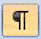

Power Keys: Often the keyboard shortcut involves pressing the CTRL key on the PC or the Command key on the Mac, followed by an F for “Find” or an “H” for “Find and Replace”. In the Style Guide, if I give you the command, CTRL+A, it means press the CTRL key (or the Command key for you Mac users) at the same time you press the letter key. Here and elsewhere, you may see the same command designated as CTRL-A (ignore the + or the -, they each mean “do this while you do that”).
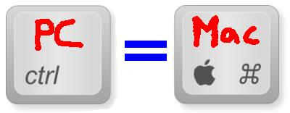

HIGHLIGHT ALL: CTRL+A - This key combination highlights the entire book, making it easy to apply a global change to the formatting. After you highlight everything by pressing CTRL+A, for example, a right mouse click anywhere, followed by a click on Paragraph, will allow you to globally modify your paragraphs, or your line spacing, or allow you to instantly apply a special first line paragraph indent.
COPY or CUT: CTRL+C or CTRL+X - Highlight any text string with your mouse (click and hold your mouse key, then drag your mouse to highlight), then click CTRL+C to copy it into memory. After you copy something into memory, the original text stays where it is. If you CTRL+X, or cut it, it removes the text from the screen and places it in memory.
PASTE: CTRL+V - This allows you paste text anywhere you want after you copy or cut it.
FIND AND REPLACE: CTRL+H - This is one of the most powerful features. Let’s say you accidentally used the Tab key to create first line indents in your original manuscript, and now you read in the Style Guide that Tabs are about as welcome as the stomach flu. But what if your 100,000 word novel has 2,001 paragraphs? It would take you five hours to zap all those Tabs one by one. With Search & Replace, you can zap ‘em all in about 5 seconds. Just press the CTRL key on your keyboard at the same time you press the H key. This will pop up the Find and Replace box below.
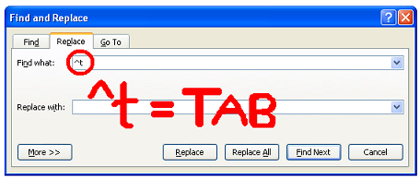
After you press either of these key combinations, you can use codes to search for, or to search and replace for, certain formatting marks. The formatting codes are preceded by a ^ (called a caret) and a letter. By combining ^ with t, for example (^t), you create the symbol for tab. ^p is the symbol for a paragraph return (a.k.a a “hard return”). ^l is the symbol for manual line feed. If you click the “More” button in the box shown above, you’ll see other Search and Replace options.
Let’s put the above tip to work to solve my challenge of how to remove 2,001 tabs in five seconds.
In the “Find what:” field enter: ^t
^t is the shortcut symbol for tab
In the “Replace with:” field, leave it blank (enter nothing), then click the Replace All button.
It’s always a smart idea to launch your Find and Replace command from the very top of your manuscript (click your mouse to the top of the document). Word executes the Find and Replace from the place you launch it in your document forward (or downward, depending on your perspective).

How to Eliminate Space Bar Spaces: If your document improperly uses space bar spaces instead of indents, you can use a variation of the FIND AND REPLACE tool as well. Activate show/hide, and take a look at the space bar spaces. Maybe you’re using what looks like two, three, four or five space bar spaces. In fact, if you used space bar spaces, you might find it varies. Again, if you had to manually remove these it would take hours. Find and replace does it in seconds. Follow these steps:
1. In the Find what: field, enter a ^p immediately followed by five taps on the space bar. ^P is the symbol for a paragraph return. By entering ^p first, preceding the space bar spaces, you’ll ensure you’re only zapping the space bar spaces you’re using for first line indents.
2. In the Replace with: field, enter ^p only.
3. Repeat step 1, but this time search for ^p followed by four taps on the space bar. Then replace with ^p and then click Replace All. Then repeat it all over again for ^p followed by three spaces, then two, and finally one.
Remember, after you purge the bad first line indents that you originally created with a Tab or space bar spaces, be sure to add either proper first line paragraph indents, or implement the block paragraph method, described in step 7a above.

THE QQQ TRICK - Have you ever copied and pasted something into Word, only to discover it inserts paragraph returns in odd places? This commonly happens when you copy and paste text from an email into Word, or from a Web page into Word. If you have a lot of text facing this problem, try what I call my QQQ Trick. Do a CTRL+H, search for ^p^p and replace with QQQ then search for ^p and replace with nothing. Then search for QQQ and replace with ^p^p and voila, you have reflowable text again. This trick has other uses with other variations. Essentially, you’re using a wildcard - QQQ - as a temporary placeholder for something. I chose QQQ because the letters are unlikely to ever appear in natural language.
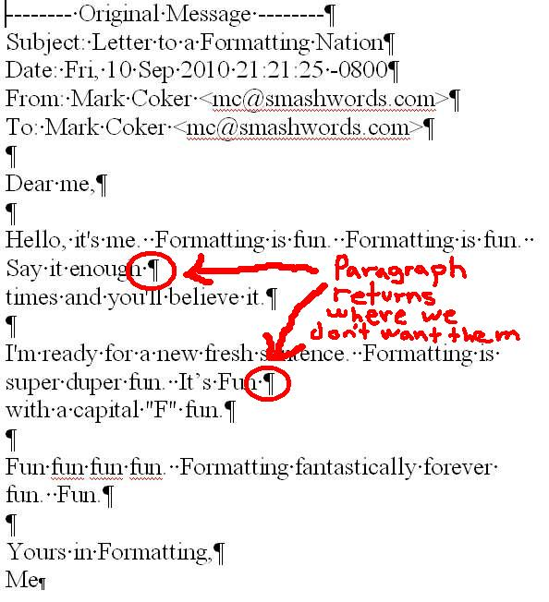
###

Back to top

You’ve reached the end of the Smashwords Style Guide. Thank you for reading. If you found this guide useful, please share it with a friend!

