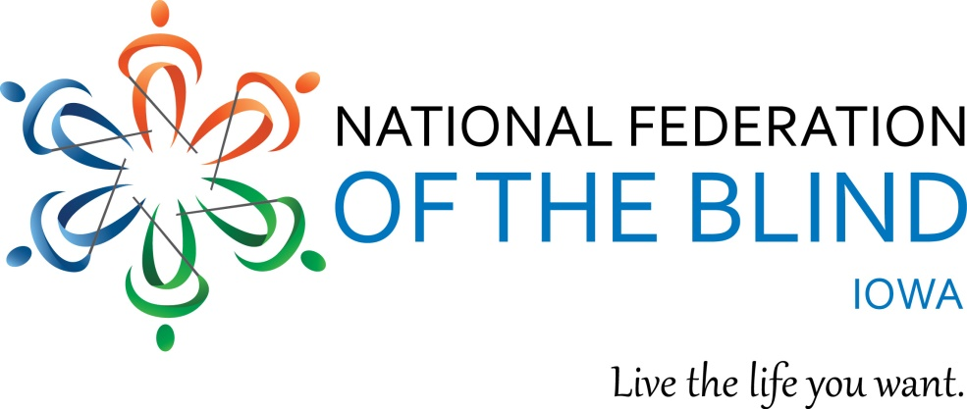

***FEDERATION FOCUS***

A Bimonthly eNewsletter of the National Federation of the Blind of Iowa

Vol. 1 March-April 2017 No. 2

Affiliate President: Jerad Nylin

Editor-in-Chief: Sandi Ryan

Editors: April L. Enderton; Cindy Ray

### *From the President*

Greetings fellow Federationists,

I’m surprised it’s already the middle of March! The weather has had us on a roller-coaster lately. I hope you’re all faring well as this winter comes to a close.

Since the first issue of the Federation Focus, there is much to report.

Our Washington Seminar was a huge success (see article). We are proud to have Third District Congressman David Young’s support on two of our issues. The congressman will be the champion sponsor of the Access Technology Affordability Act. The Des Moines Chapter, located in the Third District, invited Representative Young to their February meeting. I also attended, and was humbled to show my gratitude alongside the chapter members. Janae Burgmeier presented the congressman a framed picture of the 2017 Iowa Washington seminar delegation.

Prior to Washington Seminar, I had the privilege of attending a retreat held for affiliate presidents at our national office in Baltimore, MD. We gathered to share ideas that will continue to build the Federation. Newer affiliate presidents suggested ideas, and More seasoned presidents mentored us with advice and support. This event gave me a chance to meet and network with other leaders in our movement. I hope to grow as a leader by using what I learned from the retreat for the National Federation of the Blind of Iowa, and to attend similar events in the future.

The dates for our 2017 state convention are September 29-October 1, 2017, at the Holladay in Northwest on Merle Hay road in Des Moines. Look for details on room prices and how to reserve your room in the News Brief section.

We are working together to develop new ways of communicating within our affiliate. If you have not already done so, [Like the National Federation of the Blind of Iowa on Facebook](https://www.facebook.com/National-Federation-Of-the-Blind-Of-Iowa-372681823082570/posts), and [follow us on Twitter @NFB_Iowa](https://twitter.com/nfb_iowa) to keep up to date with what is going on. And don’t forget to sign up for [the tall corn list serve](http://nfbnet.org/mailman/listinfo/tall-corn_nfbnet.org).

I am committed to working with each of you. I look forward to hearing from you, and meeting you at affiliate and chapter events. Please contact me with your questions or ideas.

Your Affiliate President,

Jerad S. Nylin

President, National Federation of the Blind of Iowa

E-Mail: [jerad.nfbi@gmail.com](mailto:jerad.nfbi@gmail.com)

Cell: (319)535-3723

Website: www.nfbi.org

### *News Right Now!*

**NFB Scholarships**

If you are a legally blind high school senior or college student, there’s still time to apply for one of the NFB’s 30 scholarships between $3,000 and $12,000 and other gifts awarded at this summer’s national convention, but you need to hurry! This year’s application deadline is March 31, 2017! There are several steps in the application process. Two Iowans won scholarships last year. Maybe this year is your turn! For the rules of application, a Frequently Asked Questions document, and other information, visit

[**www.nfb.org/scholarships**](http://www.nfb.org/scholarships)**.**

Active NFB members, blind or sighted, who have not yet attended an NFB national convention because of lack of funding are eligible to apply for a grant from the Kenneth Jernigan Convention Scholarship Fund. Last year, 60 individuals received $400 to $500 toward convention expenses and attended their first convention ever. Application deadline is April 15, and the process has several steps. For details on how to apply, visit [The Kenneth Jernigan Convention Scholarship Fund](https://nfb.org/images/nfb/publications/bm/bm17/bm1701/bm170112.htm) article in the January 2017 [Braille Monitor](https://nfb.org/braille-monitor).

The Iowa affiliate is also offering financial assistance for convention expenses. If you need assistance, write a letter to President Jerad Nylin at jerad.nfbi@gmail.com, using the same instructions as for the Kenneth Jernigan Scholarship (see above). Funds will be provided based on need, on a first-come, first-served basis. The application deadline for state funds is April 30, and those applying will know if they received funds by May 15.

**REMEMBER!**

To stay in touch with the National Federation of the Blind of Iowa at all times:

[Like the National Federation of the Blind of Iowa on Facebook](https://www.facebook.com/National-Federation-Of-the-Blind-Of-Iowa-372681823082570/posts).

[Follow us on Twitter @NFB_Iowa](https://twitter.com/nfb_iowa).

Sign up for [the tall corn list serve](http://nfbnet.org/mailman/listinfo/tall-corn_nfbnet.org).

**An Iowa Court Case in the News**

Kristen Steele was told by the Federation of State Massage Therapy Boards that she's not allowed to take her licensing exam in Braille because it would give her an unfair advantage. The National Federation of the Blind is helping with her case, and released this press release on February 28th. [Read more here](http://bit.ly/2lyIeDs). Look for a feature story about this case in our next issue.

### *Member Spotlight*

*NOTE: Each issue of this newsletter will introduce one of our affiliate members. Enjoy getting to know others who share our Federation spirit and philosophy, and live the lives they want. Our featured member this issue is Christie Steele from Burlington, not Kristen Steele mentioned above.*

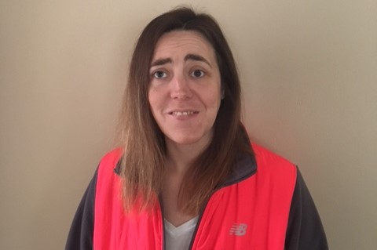

**Meet Christie Steele**

**Relatively new at blindness**

By Cindy Ray, Editor

Christie Steele, newly-elected president of the Southeast Iowa Chapter of the National Federation of the Blind of Iowa, has had a tough battle. Five years ago she lost her sight because of a rare disease, but she has faced the challenges of this loss with grace, dignity, and just a bit of a taste for adventure.

In March, 2012, Christi lost most of her sight. Now she has reached a point where she is totally blind except for a small amount of light perception. At first, life was difficult. She was sitting at home grieving and wondering what she would do with the rest of her life. Then she was introduced to someone from the National Federation of the Blind and attended her first meeting in May or June. “I liked what I saw,” she says. Soon she was hooked. Christi was a part of the Federation before she knew about or began receiving services from the Iowa Department for the Blind in 2013. She says that her introduction to the Federation and her becoming involved have been of major importance in her life. “Recovery has been quicker because I began to learn that my life was not over just because my sight was gone.” In 2013 she attended her first convention, partially funded by a Jernigan Scholarship.

Christi is attending school online at Western Governor’s University in Utah, majoring in special education for elementary students. She is in her final semester and will student teach in the fall. Currently Christie works part time helping children with special needs at Notre Dame School in Burlington, Iowa where she attended elementary school. She continues to work on her blindness skills, particularly braille, so that she will be prepared to more adequately serve the students next fall as a student teacher--and when she receives a contract, hopefully in the fall of 2018. Besides helping children who struggle with their particular disabilities, Christi wants to be supportive of and advocate for blind people, which she is already learning to do in the Federation.

Christi maintains friendships that were hers before losing her sight. “My friendships aren’t quite the same because my friends don’t really understand blindness yet. They tend to treat me as if I were a child. This is disheartening and frustrating,” she says “but I will continue to exercise patience and educate them.” She longs for them to learn what she now knows—that blindness is not a tragedy.

Christi has ideas for revitalizing the Southeast Iowa chapter. She is thinking of having trivia nights once a month for which each team would pay a $10 participation fee, though she hasn’t worked out where these events would be held. Right now the chapter is working hard on their July bike-a-thon.

Christi has applied to get a guide dog, but she doesn’t feel her success hinges on having one. She would like to go to Orlando this summer, but the trip isn’t an option right now--unless, of course, she wins a scholarship. How exciting that would be!

Christi is growing by leaps and bounds into her blindness and, with the help of her independent spirit and the National Federation of the Blind, she is envisioning and living the life she wants.

### *Reflections on the 2017 Washington Seminar*

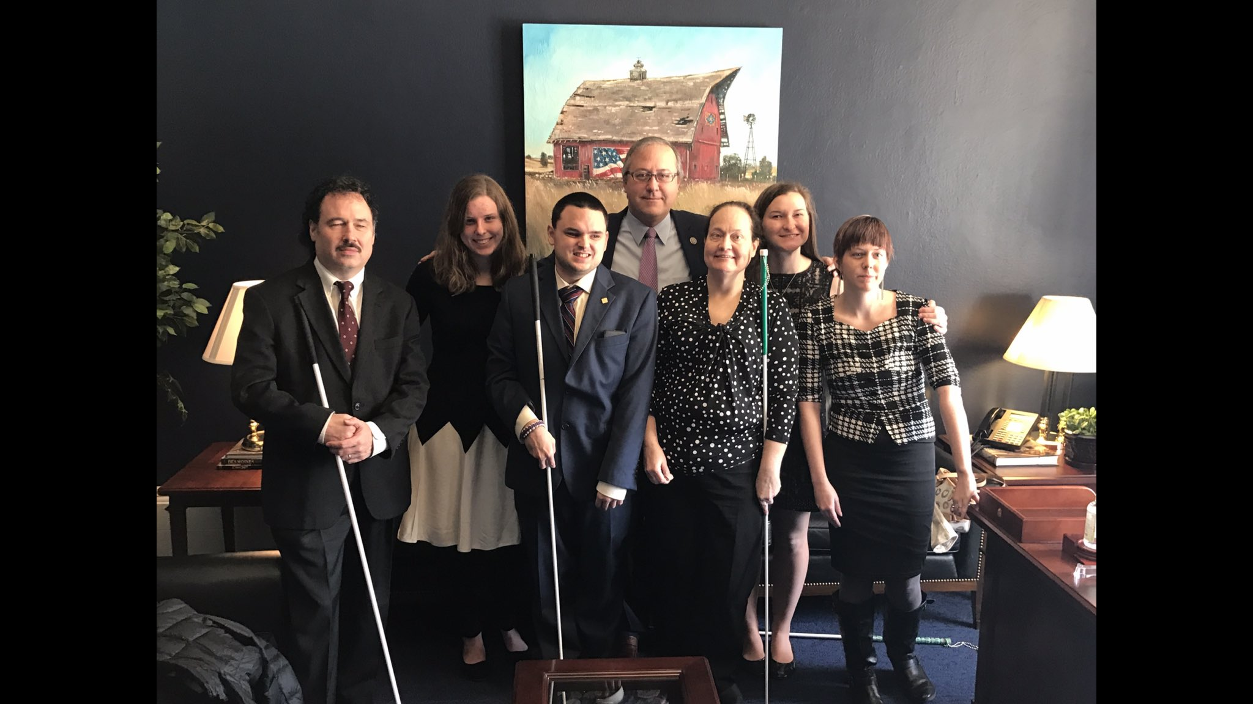

***Jerad Nylin:*** A team of five blind Iowans represented our state at this year’s Washington Seminar. Three of us have attended before, but two students had not! It was great to have a team representing each of Iowa’s political districts. I am proud of what we were able to accomplish and I want to thank the team for giving their finances and their time to attend and make a difference. I hope to see every member of this year’s team, and several more members, at next year’s Washington Seminar.

***Elizabeth Rouse:*** The 2017 Washington Seminar was a thought-provoking experience for me. I enjoyed meeting new friends in the Federation and growing close with some of my roommates. I love the feeling of being surrounded by my “Federation family.” It was awesome to form relationships and find mentors that can last for the rest of my life. I was proud of the Iowa team, learning from members of NABS was incredible, and I cherish the fact that I am no longer living my story alone. I now have friends who face similar challenges. This sense of community and unity will remain with me for a long time. I enjoyed meeting with Congressman. Although I was a bit nervous, each Representative and Senator was kind and seemed interested in the issues we presented. When Representative Young told us he would champion the Access Technology Affordability Act, I was thrilled to be part of the team that instigated the change. Washington Seminar 2017 was a positive experience, and I will strongly consider attending in coming years.

***Katy Olsen:*** Washington Seminar 2017 was such a great learning experience for me. Going into this event, I knew very little about the legislative process. Washington Seminar gave me the opportunity to be a part of something big and to learn about all the impact we were having on Capitol Hill. In most of our legislative appointments I outlined the details of AIM-HE. Since I am a current college student, this issue will directly affect me and if passed, it would improve educational accessibility for me and so many other blind students. I gained so much from Washington Seminar. I hope to go back in the years to come.

***Karen Clayton:*** I attended Washington Seminar this year for about the tenth time; my first time was in 1992.  I have grown and learned much each time.  I am more comfortable in presenting the issues.  I had two new experiences this year. We had a new proposal for a tax credit to purchase assistive technology.  At our first meeting, the Congressman was very interested but didn’t commit. As we left his office, though, he followed us and said he would sponsor the bill, and announced it at that evening’s reception.  The second was a student rally at Upper Senate Park for the AIM-HE bill we have worked on for about 5 years.  Many students spoke and used the rally call “Don’t deny. AIM- HE! It was a wonderful day outside.”

***Janae Burgmeier:*** Washington Seminar is always my favorite time of year, and this year’s Washington Seminar, my third, did not disappoint. I am always excited to meet new people and learn new things. Monday I participated in student activities, including meetings and a job fair. The Great Gathering-In was at 5:00 PM, and in the evening I helped with the National Association of Blind Students fund-raising auction, for which the Iowa students donated a box.

Tuesday, I was back with the Iowa delegation. We met personally with both senators and with two of the four representatives. We spoke with staff at the other two offices. Thanks to all who supported us from home by writing and calling their representatives. Beth Rouse and I spoke at the student rally Tuesday afternoon about our struggles with inaccessible technology. Following the rally, all Federationists came together for a reception to reflect on the day. Several representatives spoke, including David Young, who announced he will be the lead sponsor of the Access Technology Affordability Act.

### *Chapter Focus*

*NOTE: Each issue of this newsletter will examine one of our chapters or divisions in depth to help you learn what fellow Federationists around the state are doing.*

**The Des Moines Chapter: on the move**

by April L. Enderton, Editor

The Des Moines Chapter, NFBI, is on the move! On April 5th, the chapter will participate in Meals from the Heartland. Thirteen chapter members so far have volunteered their time to pack meals for those in need. The chapter is exploring other community-service projects, such as planting and tending a garden, then donating the produce to feed the hungry. In March, Roger Erpelding, our chapter’s own Master Gardener, gave us a timely course in gardening using blindness techniques.

The chapter’s fund-raising committee is working toward offering basic braille classes to interested adults in the community. Whether the classes net a lot of money or a little, Des Moines’s citizens will have a great opportunity to “Meet the Blind” this fall.

Game night at the Iowa Department for the Blind with the Des Moines Chapter begins its third year in April. On the third Tuesday of each month, chapter members prepare a meal which they share with orientation-center students. The meal starts at 6:00 PM, with board and card games following. In February, the students made brownies for the event.

Cindy Ray, Chapter President, often invites guest speakers on various topics from the community to share information at chapter meetings. In February, Representative David Young from the Third District, was invited to explain why he will be the champion sponsor for an NFB legislative priority, and to accept our heartfelt thanks. Rep. Young told chapter members he represents the entire district, and that he does not care whether members are Republicans or Democrats.

There's nothing like food and fellowship to top off a great chapter meeting. In March, 14 chapter members concluded their meeting with dinner at Christopher's Restaurant.

### *Chapter and Division Highlights*

***At Large:*** (April Enderton, [alenderton@gmail.com](mailto:alenderton@gmail.com)) Our chapter had the bittersweet task of appointing a new board member. We have selected Tom Davis to fill the rest of Allen Childs’s term. Tom has served as secretary and board member of the Des Moines chapter. He and his wife Lin have helped with fund-raisers and numerous Federation activities. The Davises live with their guide dogs, Daisy and Cole. We wholeheartedly welcome Tom to our At-Large chapter board.

***Cedar Rapids:*** (Sam Claassen, [blindsoul93@gmail.com](mailto:blindsoul93@gmail.com)) The newest member of our chapter is Wade Hemmelrick. Wade was President of the Cedar Rapids chapter in the 1990s. Welcome back, Wade! We are still working to grow our chapter and make our meetings fun and more interactive.

***Des Moines:*** (Cindy Ray, [cindyray@gmail.com](mailto:cindyray@gmail.com)) (See Chapter Spotlight).

***Old Capital (Iowa City):*** (Darrel Kirby, [kirbydarrel@gmail.com](mailto:kirbydarrel@gmail.com)) In April only, our regular meeting will be held on the 15th (third Saturday) to accommodate an art festival using all the rooms on our regular meeting date. Our chapter is focusing on plans for hosting and funding this summer’s BELL Academy. Currently we are working on a fund-raiser with the BELL Academy at Panera at the Sycamore Mall location in Iowa City.

On April 1, we will participate in Disability Awareness Day at the Coral Ridge Mall, outside the Children’s Museum. We will braille names and share information about our organization. We are also working with the Southeast Iowa Chapter on a Bike-a-Thon to be held in July. We encourage other chapters to get involved.

***Siouxland:*** (Karen Clayton, [Karen@sipco.org](mailto:Karen@sipco.org)) On April 5, our chapter will receive a donation from 100 Men Who Care, a group of business leaders who choose a nonprofit to support each quarter, with the stipulation that the funds stay in Siouxland. We are trying to reach out to more people in our area, and our May 20 meeting may be held in one of the surrounding towns for this purpose. Attend the April meeting to find out!

***Southeast Iowa:*** (Christie Steele, [steele.christiane@gmail.com](mailto:steele.christiane@gmail.com)) Our chapter is gearing up for a bike-a-thon in July. We will soon be selling baseball caps with the NFB logo and shirts that say “Southeast Iowa Chapter” with the NFB logo to raise funds.

***Bell Academy:*** (Donna Prime, [dprime27@gmail.com](mailto:dprime27@gmail.com)) We are currently working to raise funds for the BELL ACADEMY at Panera at the Sycamore Mall location in Iowa City. We are passing out fliers to everyone we know and asking that, on March 30, between 4:00 and 8:00 PM, they buy food at the Sycamore Mall Panera location using the fliers. We will receive a percentage of sales to use for BELL Academy expenses.

***Iowa Diabetes Action Network:*** (Michael Barber, [m.barber817@gmail.com](mailto:m.barber817@gmail.com)) We’ve had an interesting few months with scheduled speakers being unable to attend our meetings due to illness. We have used the time to discuss diabetes problems posed by our members. During our March meeting, our Secretary, Cindy Ray, spoke with us about her experiences and struggles with sleep apnea, a condition that affects many Americans. We will meet soon with the Iowa Diabetes and Endocrinology Research Center to discuss opportunities to teach them about the techniques blind diabetics use to manage our disease, and about how they can help us with our campaign to make diabetes tools and technologies accessible. Our national office reports they are still working to set up a meeting with diabetes equipment manufacturers.

Join us by phone the first Saturday of each month (see Upcoming Events)! Our dues are $5 and we are open to all blind people with diabetes, their friends and family.

***Student Committee:*** (Katy Olsen, [katyo.nfbi@gmail.com](mailto:katyo.nfbi@gmail.com)) The students have been talking a lot about legislation recently, since a few students attended Washington Seminar this year. We are focusing on the AIM-HE legislation, since it is most relevant to our lives as students. We are starting to brainstorm fund-raising ideas so we can hold more group events. In April, three of our students will travel to a spring seminar in Chicago, where they will learn from some incredible leaders and network with other blind students. We look forward to hearing about their experiences. Our next conference call meeting will be Monday, April 3 at 7:00 PM (see Upcoming Events for details).

### *News Briefs*

***In Memoriam***

*At-Large Chapter President, April L. Enderton, shared this tribute to member Allen Childs:*

We were all saddened to learn of the untimely death of Allen Frederick Childs. Allen and his wife Jenni have been members of the At Large Chapter since its inception in 2013.

Allen lost his eye sight at 34 due to diabetes. In 1995, he attended the Adult Orientation Center for the Blind where he met Jenni, the love of his life.

"It was love at first sight," Jenni recalls. "My mom was concerned about me marrying someone 15 years older than me and with so many health problems, but that didn't stop us. I think she just wanted to make sure that I knew what I was doing."

On Oct. 24, 1998, the couple were married in Allen's hometown of Red Oak, Iowa. Last September, they moved to Des Moines to be closer to Jenni's family.

Allen enjoyed listening to his police scanner and his two weather radios. He loved computers and hearing about the latest technology. He was a jokester and loved to make people laugh. He also liked Nascar.

Allen's can-do spirit helped him through many  rough times. He told Jenni that either he could sit there and scream and give up or he could choose to live. And, live, he did, through blindness, a kidney transplant, a pancreas transplant and so much more.

Allen was admitted to Methodist hospital on Jan. 6 with pneumonia. He passed away on Feb. 4 with Jenni by his side. He was 56 years old. Allen, you will be deeply missed.

**2017 State Convention**

The National Federation of the Blind of Iowa 2017 state convention will be held September 29-October 1, 2017, at the Holiday Inn Hotel & Suites Des Moines Northwest (4800 Merle Hay Road, Des Moines, Iowa 50322. Our convention room rate this year is $82 per night plus tax.

To reserve your room: Call the Hotel directly at 515-278-4755 and ask for the group block for the National Federation of the Blind of Iowa; or call the national reservations number, 800-465-4329, and ask for the group block for the National Federation of the Blind of Iowa. You can also make reservations online at: [www.holidayinn.com/desmoinesia](http://www.holidayinn.com/desmoinesia) and use the 3-letter code “NFB.” The Reservations Deadline is September 7, 2017

If you have questions about hotel reservations, contact Michael Barber at: [m.barber817@gmail.com](mailto:m.barber817@gmail.com) or by phone at: 515-284-1569.

More information about registration and convention programming will be shared as it is available

### *Recipe Corner*

*NOTE: In each issue we will feature a couple of recipes from our members. If you have recipes to share in this section, please e-mail them to Sandi Ryan, Editor-in-Chief, at* [*sjryan2@gmail.com*](mailto:sjryan2@gmail.com)*. This issue’s recipes are from April L. Enderton, Federation Focus Editor and At Large Chapter President.*

Crock Pot Chicken and Noodles

4 to 6 boneless, skinless chicken breasts

1 can cream of chicken soup

1 can cream of celery soup

1 stick (1/2 cup) butter, cut into pieces

1 (49.5 ounce) container chicken broth

1 (24 ounce pkg) frozen egg noodles

Salt and pepper to taste

Place chicken breasts in bottom of crock pot.  Spoon soup over chicken.  Place pieces of butter over soup.  Pour chicken broth over soup.  Place lid on top and cook on low for six hours.  Remove chicken and tear into pieces.  Return to pot.  Add noodles and vegetables if desired.  Cook for 90 minutes or until noodles are of desired tenderness, stirring occasionally.  (You may want to add more broth at the end of cooking as the noodles thicken the broth.)

Banana Nut Bread

1 large yellow cake mix

1 pkg. instant banana-cream pudding mix

¼ cup vegetable oil

4 eggs

1 cup water

3 ripe bananas, mashed

1 cup chopped nuts

Preheat oven to 350 degrees.  In large mixing bowl, combine first five ingredients.   Beat on medium speed for two minutes; stir in bananas and nuts.  Grease a 9 by 13-inch pan.  Pour batter into pan and bake 50-55 minutes or until a toothpick inserted in the center comes out clean; cool.

### *Upcoming Events*

March 30, 2017: 4:00-8:00 PM, BELL Academy fund-raiser (Panera, Sycamore Mall, Iowa City)

March 30-31, 2017: Jacobus tenBroek Law Symposium (Jernigan Institute, Baltimore, MD)

March 31, 2017: Deadline for [scholarship applications](http://www.nfb.org/scholarships)

April 1, 2017: 1:00 PM, Iowa Diabetes Action Network Meeting (712-432-8812, 87458#).

April 3, 2017: 7:00 PM, NFBI Student Committee meeting (712-432-8812, 87458#).

April 8, 2017: 12:00 PM, Southeast Iowa Chapter meeting (St. Paul United Church of Christ,

303 W Mt. Pleasant St, West Burlington).

April 8, 2017: 2:00 PM, Des Moines Chapter meeting (Iowa Department for the Blind).

April 9, 2017: 4:00 PM, affiliate board meeting (712-432-8812, 87458#).

April 15, 2017: 11:00 AM, Old Capital chapter meeting, (Iowa City Public Library).

April 15, 2017: 11:00 AM, Siouxland Chapter meeting (ElFredo’s Pizza, 523 W. 19th Street, Sioux City)

April 15, 2017: 11:00 AM, Cedar Rapids Chapter meeting, (Scottish Rite Temple, 616 A Ave NE)

April 15, 2017: Deadline for [Jacob Bollotin Award applications](https://nfb.org/bolotin-award-main)

April 15, 2017: Deadline for Kenneth Jernigan Scholarship Applications

April 20, 2017: 7:00 PM, At Large Chapter meeting (712-432-8812, 87458#)

April 30, 2017: Application deadline for affiliate travel assistance to national convention.

May 6, 2017: 1:00 PM, Iowa Diabetes Action Network Meeting (712-432-8812, 87458#).

May 9, 2017: 7:00 PM, NFBI Student Committee (712-432-8812, 87458#)

May 13, 2017: 11:00 AM, Old Capital chapter meeting, (Iowa City Public Library).

May 13, 2017: 12:00 PM, Southeast Iowa Chapter meeting (St. Paul United Church of Christ,

303 W Mt. Pleasant St, West Burlington).

May 13, 2017: 2:00 pM, Des Moines Chapter meeting (Iowa Department for the Blind).

May 14, 2017: 4:00 PM, affiliate board meeting (712-432-8812, 87458#).

May 18, 2017: 7:00 PM, At Large Chapter meeting (712-432-8812, 87458#)

May 20, 2017: 11:00 AM, Siouxland Chapter meeting (TBD)

May 20, 2017: 11:00 AM, Cedar Rapids Chapter meeting, (Scottish Rite Temple, 616 A Ave NE)

July 8, 2017: Bike-a-Thon in Southeast Iowa

July 10-15, 2017: National Convention (Rosen Shingle Creek Resort, Orlando, FL)

July 21-29, 2017: [Youth Slam](http://www.blindscience.org/nfb-youth-slam), Towson University, (Towson, MD)

July 31-august 11, 2017: National Federation of the Blind of Iowa BELL academy (Iowa City)

September 29-October 1, 2017: NFBI State Convention (Holiday Inn Northwest, 4800 Merle Hay Road, Des Moines)

**The National Federation of the Blind of Iowa knows that blindness is not the characteristic that defines you or your future. Every day we raise the expectations of blind people, because low expectations create obstacles between blind people and our dreams. You can live the life you want; blindness is not what holds you back.**